Food commodities: Fish and shellfish

Cooking with fish
Fish can be cooked in a variety of ways, such as being grilled, baked, sautéed, fried or barbequed.

Grilling and baking are usually healthier cooking methods and they can also help to bring out the flavour of many fish.
Some fish can be eaten raw (e.g. sushi).

Key terms
Oily fish: A fish that contain a type of healthy fat called Omega-3.
Omega-3: A type of polyunsaturated fatty acid found in fish.
Shellfish: An aquatic shelled mollusc or crustacean that is edible.
MSC: Marine Stewardship Council logo, a logo that means fish has been caught sustainably.

Oily fish
The UK Eatwell Guide states that one of the recommended two portions of fish a week should be oily.

Salmon and trout are classified as ‘oily fish’, which means they contain a type of healthy fat called Omega-3. Omega-3 is important for brain development and heart health.

Mackerel, herring and sardines are types of small oily fish that are mostly sold in cans. Kippers are herring that have been filleted, salted and smoked. The skin and bones of whole sardines are soft and edible and can provide extra calcium.

Catching fish at sea (trawling)
Most fishers go out to sea in boats and use nets to catch a large number of fish at one time.
When the boat is in the right position, the fishers drop their nets. Once dropped, the boat then tows the net around, scooping up fish. This is known as trawling.

Types of fish and shellfish
There are over 33,000 fish species in the world, but people often prefer to eat a few species that are easier to catch and eat.

The ‘big five’ are the most common seafood items that are eaten in the UK. They are:
- cod;
- haddock;
- tuna;
- salmon
- prawns.

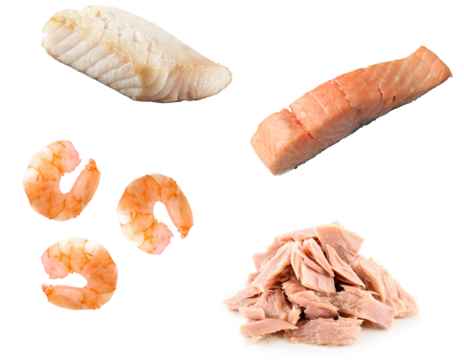
To find out more, go to: https://bit.ly/3DHagr9

Growing mussels
Mussels can be grown on ropes, so they can be easily collected in large numbers. ‘Seed’ mussels stick to the rope and grow in place before harvesting.
Preparing shellfish safely
Many shellfish are filter feeders. This means that they can gather up bacteria and viruses from their environment.
The best way to avoid illness is to make sure that shellfish are properly cooked.
When cooked in the shell, mussels, clams and oysters will open.
Raw shrimp and prawns will turn pink and firm up when properly cooked.

Wild fishing
Advantages
- Wild fish have a more varied diet than farmed fish and therefore may taste different.

Disadvantages
- Can be less sustainable due to overfishing and may become more expensive.
- Nets can damage the seabed.
Farming fish
Advantages
- Prevents wild fish from being overfished.
- Can provide fish to communities where wild fish is scarce.
- Can allow for fish farmed that are hard to catch.
Disadvantages
- Disease can be more common if many fish are kept close together.
- Farmed fish may harm wild fish if they escape.
- If waste from the fish farm is not disposed of correctly it can cause pollution.
Task
Create an infographic that highlights all the reasons we should eat fish. Include the recommendations, the nutrients in fish and how we can cook them in healthier ways.
White fish
Cod and haddock are the most popular fish in the UK. They are flaky, white fish when cooked.
Most of the cod and haddock eaten in the UK is breaded or battered.
Plaice, sole, halibut and turbot are all types of flatfish that are classed as white fish.
Tuna
Fresh tuna used to be classed as an oily fish but new research shows that there are not enough healthy Omega-3 fatty acids in tuna for it to be called oily.
Shellfish
Shrimp and prawns are a wide group of small shellfish. The words ‘shrimp’ and ‘prawn’ are used to describe many different species.

Mussels and oysters are ‘bivalve molluscs’. Bivalve means that they have two shells that close around the soft body inside. Cockles, whelks and winkles are small shellfish that are common around the UK.

Squid and octopus
Squid and octopus are not fish but cephalopods, along with cuttlefish and some other species. Squid is often called ‘calamari’ when it is used in dishes.

Preparing fish
Whole fish usually require preparation before they can be eaten.
This could include: descaling, gutting, filleting and pin boning.

To descale a fish, the knife should be run along the scales of the fish, in the opposite direction to the scales.
Gutting removes the entrails of the fish.
Filleting results in portions of fish that are separated from the head, tail and major bones.
Pin boning removes the remaining small bones.

Nutrients provided by fish
Fish provides a range of nutrients, including:
- Omega-3 fats (in some fish);
- protein;
- vitamin D (in some fish);
- B vitamins;
- iodine.

Recommendations
Fish is part of the Beans, pulses, fish, eggs, meat and other proteins food group in the Eatwell Guide.

Around one-sixth of the food that people consume should come from this group in the diet.
It is recommended to consume two portions (one portion is 140g) of sustainably sourced fish per week.

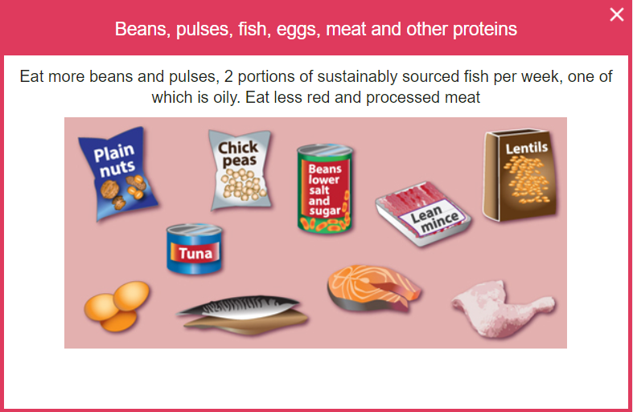
Marine Stewardship Council
The MSC logo means that this fish has been caught in a way that is more sustainable.
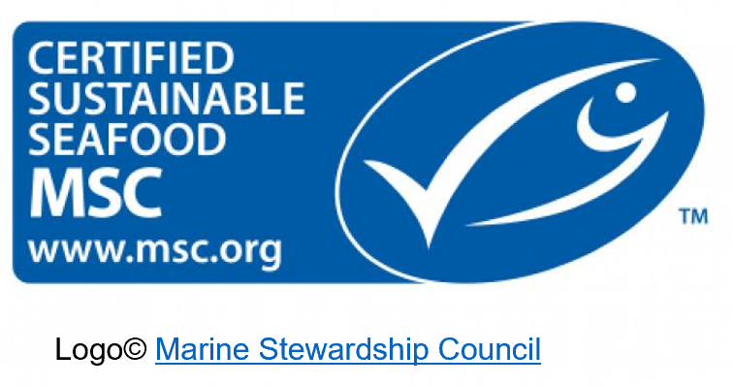
Catching fish at sea (trolling)
Some fish are caught on lines, rather than nets.
Some other fish, like mackerel, can also be caught on lines by a method called ‘trolling’.
Trolling is similar to trawling, but instead of dragging a net, the boat drags many lines with hooks to catch the fish.

