Be creative!
Making burgers is a fantastic way to use your imagination and be creative with ingredients. Combining ingredients from different cuisines and cultures is a great way to do this. State four ingredients that you could add to a burger (burger mix, bread or toppings) from each culture or cuisine.
© Agriculture and Horticulture Development Board 2016. This resource may be reproduced and used in all educational settings.

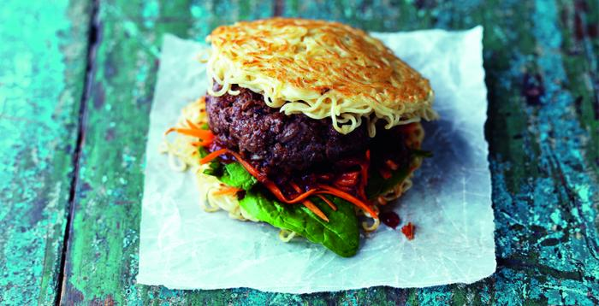
Italian
Indian
Chinese
Mexican

