Persian mini frittata (Kuku sabzi)

Ingredients
Complexity: medium

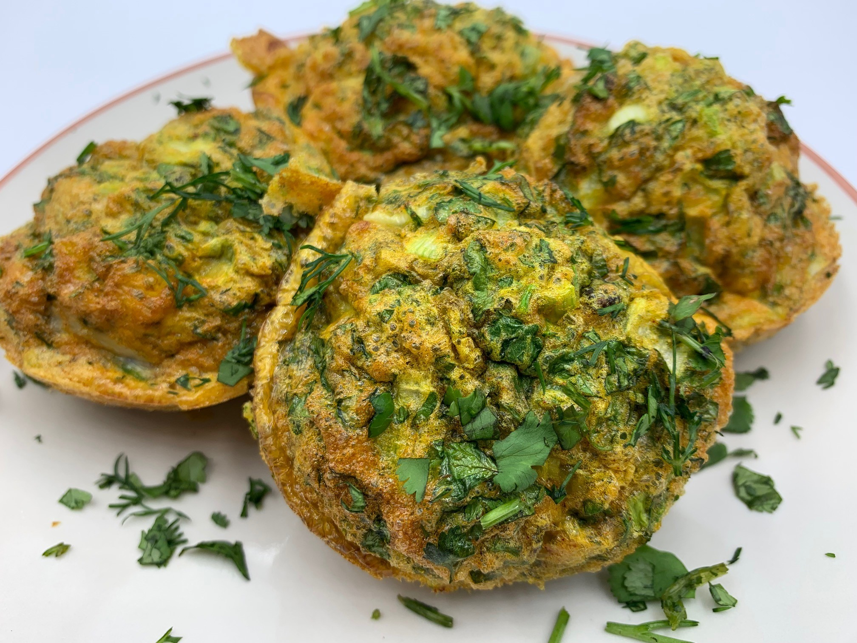
½ small pack coriander

½ small pack parsley

½ small pack dill

4 spring onions

3 eggs

½ x 5 ml spoon baking powder

¼ x 5ml spoon turmeric

Black pepper

1 x 15ml spoon currants or barberries

Spray oil

Equipment

Muffin tin, chopping board, vegetable knife, mixing bowl, fork, measuring spoons, mixing spoon.

Method

- Pre-heat oven to 180°C or gas mark 5.
- Spray the muffin tin lightly with oil.
- Prepare the ingredients:
- chop the coriander;
- chop the parsley;
- chop the dill;
- top and tail the spring onions and slice into thin circles.
- Crack the eggs into a bowl and whisk with a fork.
- Add the baking powder and turmeric, then season with pepper.
- Stir in most of the herbs, keeping a small amount for garnish.
- Add the spring onions and currants (or barberries if available).
- Divide the herby egg mixture equally in the muffin tin.
- Bake in the oven for 15-20 minutes, until the egg is cooked.

Top tips
- Traditional recipes usually include chopped walnuts.
- Dried herbs can be used instead of fresh. Use 1 x 5ml spoon each of dried parsley, coriander and dill.
- Trim thicker ends from coriander, parsley and dill so that only the leaves and tender stems remain. To chop a large amount of herbs, take a large handful at a time and roll into a tight ball. Use a sharp knife to cut through the ball to initially chop the herbs roughly, then continue to rock the knife back and forth through the pile of herbs until very finely chopped. Food scissors can also be used.

Food skills
- Chop
- Slice
- Mix
- Divide
- Bake

Did you know?
Barberries or in Persian, zereshk, are a tart and tangy dried red berry about the size of a currant. Most barberries are imported from Iran and are a frequent ingredient in Persian cuisine. Unlike cranberries, zereshk are sold with no added sugar and are therefore very sharp! Dried cranberries, sour cherries or currents can be used as an alternative but do not have the same tartness.

The frittata is traditionally cooked in a large ovenproof frying pan or cast iron skillet on the hob and then finished under the grill or in the oven.

In Iran, kuku sabzi is traditionally served at Nowruz, the New Year, as it symbolizes rebirth (herbs) and fertility (eggs).

Kuku Sabzi is traditionally served with flatbread and crunchy and acidic accompaniments such as fresh radishes, chopped aubergine pickles called liteh, and feta cheese.

