Pan fried gurnard

Served with a chickpea and chorizo stew

Ingredients
1/2 red onion
Complexity: medium-high
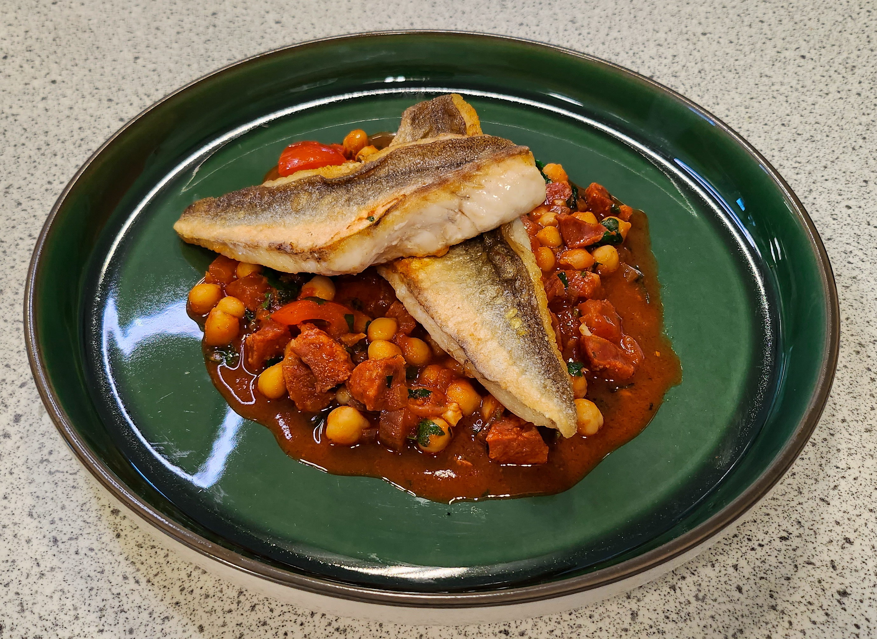
1 garlic clove
1 x 15ml spoon flat leaf parsley
1 x 15ml spoon coriander
50g chorizo sausage
100g canned chickpeas
1 large tomato
1 x 15ml spoon sunflower oil
½ x 5ml spoon smoked paprika
1 x 15ml spoon tomato purée
½ reduced-salt vegetable stock cube
2 gurnard fillets, skin on

Equipment
Chopping board, vegetable knife, sieve, 2 x bowls, can opener (if needed), measuring spoons, saucepan with lid, mixing spoon, measuring jug, kettle, non-stick frying pan, fish slice.

Method
- Prepare the vegetables and the chorizo:
  - peel and dice the onion;
  - peel and finely chop the garlic;
  - finely chop the parsley;
  - roughly chop the coriander;
  - roughly dice the chorizo;
  - drain and rinse the chickpeas.
- Score a cross in the top of the tomato. Blanch in hot water for 5 seconds. Refresh in cold water and remove the skin. Cut the tomato in half, deseed, and roughly dice to create a tomato concasse.
- Heat half of the oil in a saucepan and fry the chorizo, onion and garlic on a low-medium heat for 2 minutes.
- Add the paprika, stir and cook for 1 minute.
- Add the chickpeas, stir and cook for 2 minutes.
- Add the tomato purée, stir and cook for 2 minutes.
- Dissolve the stock cube in 100ml of boiling water from the kettle.
- Add the stock to the saucepan, stir and simmer for 5 minutes.
- Add the tomato concasse, parsley and coriander and stir. Place a lid on the saucepan and remove from the heat.
- Heat the remaining oil in a non-stick frying pan and cook the gurnard fillets (skin side down) for 2 minutes.
- Turn the fillets with a fish slice and cook for a further 2 minutes (or until the fish is cooked through).
- Serve the gurnard fillets on top of the chickpea and chorizo stew. Add the remaining herbs as a garnish.

Top tips
- For crispy skin ensure that the fish skin is really dry before pan frying.
- To avoid fish sticking to frying pan lightly oil pan place a round of grease proof paper on base of pan and then lightly oil grease proof paper and fry fish on the paper.
- Use spray oil to reduce the amount of oil needed in the recipe.
- You can use other meaty round fish for this recipe, e.g. bass or mackerel.
- Remove chorizo for a pescatarian recipe.

Food skills
Weigh and measure
Peel
Chop and dice
Drain
Fry and sauté
Stir
Boil and simmer
Garnish

his recipe was kindly donated by Food Teachers Centre, through their FISH (Fish in School Hero) Programme.

