Egg fried rice

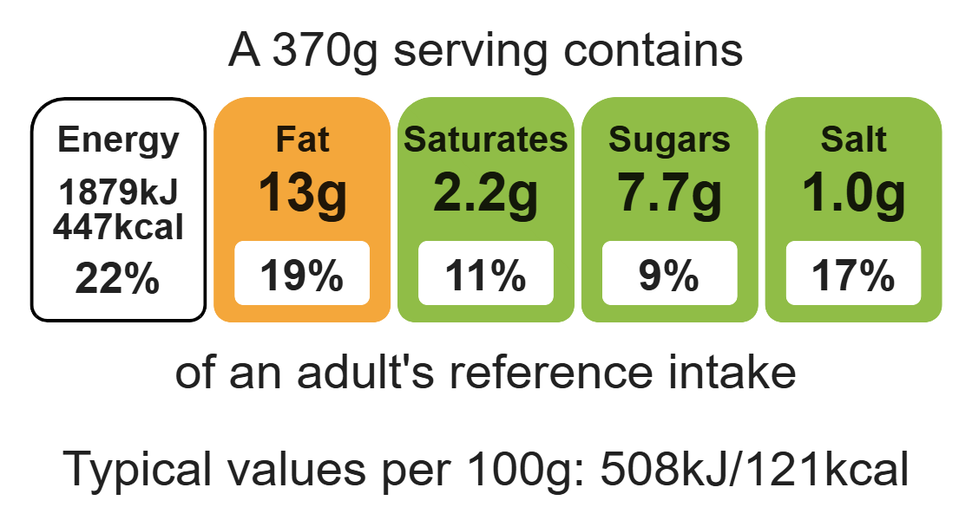
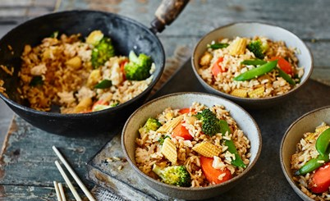

Ingredients (serves 2)
½ head of broccoli
½ onion
1 carrot
3-4 baby sweetcorn
50g sugar snap peas
1 garlic clove
1cm piece of fresh ginger
150g long grain rice
1 x 15ml spoon oil
2 eggs
Black pepper
1 ½ x 15ml spoons reduced-salt soya sauce
Complexity: medium – high

Equipment

Weighing scales

Chopping board

Sharp knife

Vegetable peeler

Garlic press

Large saucepan

Colander

Large frying pan or wok

Heat-resistant spoon

Plate

Measuring jug

Fork

Measuring spoons

Method
1. Prepare the ingredients:
- cut the broccoli into small florets;
- peel and dice the onion;
- peel and dice the carrot;
- cut the baby corn in half lengthways and then into even sized pieces;
- cut the sugar snap peas into small pieces;
- peel and crush the garlic;
- peel and grate the ginger.
2. Bring a large pan of water to the boil. Add the rice and cook for 10-12 minutes until tender.
3. When the rice is cooked, drain and rinse with cold water. Place on a flat plate and leave to cool.
4. Heat the oil in a large frying pan or wok over a medium high heat. Add the onion and fry for 3-4 minutes.
5. Add the broccoli, carrot, corn and sugar snap peas. Stir-fry for 8-10 minutes until the vegetables are starting to soften.
6. Add the cooked rice, ginger and garlic to the pan. Fry, mixing well with the vegetables, for 5 mins.
7. Crack the eggs into a jug and season with black pepper.
8. Move the rice and vegetables to one side of the pan. Spray the empty side of the pan with oil and pour in the egg.
9. Cook, stirring constantly, for 3 mins until the eggs are cooked through, then mix with the vegetables and rice.
10. Mix in the soya sauce and serve.

Top tips
- Reduce food waste: Vary the vegetable mix and use up any leftover vegetables. Try spring onions, peppers, courgette, peas as alternatives.
- Turn up the flavour: For extra flavour add a teaspoon of Five spice powder or Worcester sauce.
- Save your pennies: Use frozen vegetables instead of fresh to reduce the cost.

Food skills
Weigh, measure, peel, cut, chop, slice, dice and trim, crush, grate, melt, simmer and boil, drain, fry and sauté, stir-fry, mix, stir and combine.

