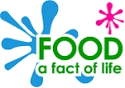

Sandwich planning sheet
This planner belongs to:
_____________________

Date: ________________________

Evaluating
Did you do everything on your checklist? ________

Explain what you did and anything that you did not manage to do.
_________________________________________________
_________________________________________________
_________________________________________________
_________________________________________________
Did your sandwich look like you expected? ______

Explain your answer.
________________________________________________
________________________________________________
________________________________________________
What did the person you made the sandwich for say about how it looked and tasted?
___________________________________________________________________________________________________________________________________________________
Explain how you would improve your sandwich
________________________________________________
________________________________________________
________________________________________________

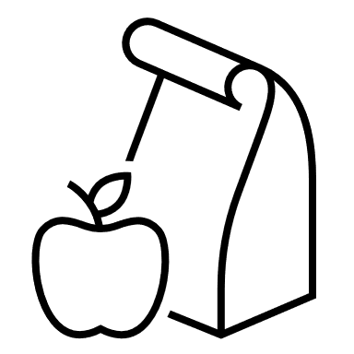

© Food – a fact of life 2023
Making
Here is the recipe for my sandwich and how it will look.
Ingredients:
____________________
____________________
____________________
____________________
____________________
____________________

Equipment:
_____________________________________________
_____________________________________________
_____________________________________________
Method:
_______________________________________________
_______________________________________________
_______________________________________________
_______________________________________________
_______________________________________________
_______________________________________________
_______________________________________________
_______________________________________________

Designing
My sandwich is for:

Here is a checklist of what I will do to make sure my sandwich is right for _______________________ .

Checklist (design criteria):
_______________________________________________
_______________________________________________
_______________________________________________
_______________________________________________
_______________________________________________
_______________________________________________
_______________________________________________
_______________________________________________
_______________________________________________
_______________________________________________
______________________________________________________________________________________________
_______________________________________________
_______________________________________________
_______________________________________________
_______________________________________________
_______________________________________________

© Food – a fact of life 2023

