Food commodities: Fish and shellfish

Preparing fish
Whole fish usually require preparation before they can be eaten.

This could include: descaling, gutting, filleting and pin boning.
Catching fish
Fish can be found in freshwater (rivers and lakes) or saltwater (seas and oceans).
Fish can be caught in the wild or farmed.
Fish can be caught in many different ways, using rods, lines or nets.

Types of fish and shellfish
There are over 33,000 fish species in the world, but people often prefer to eat a few species that are easier to catch and eat.

The ‘big five’ are the most common seafood items that are eaten in the UK. They are:
- cod;
- haddock;
- tuna;
- salmon;
- prawns.

Fish in the diet
Fish is a popular food in many cultures, although many people in the UK do not consume as much fish as is recommended.

Eating a wide variety of fish and buying fish from sustainable sources ensures there are enough fish to eat now and in the future.

To find out more, go to: https://bit.ly/3erbBIU

Cod is lower in Omega-3 and vitamin D than salmon, but still contains other nutrients, and is also higher in iodine.

Nutrients provided by fish
Fish provides a range of nutrients, including:
- Omega-3 fats (in some fish);
- protein;
- vitamin D (in some fish);
- B vitamins;
- iodine.
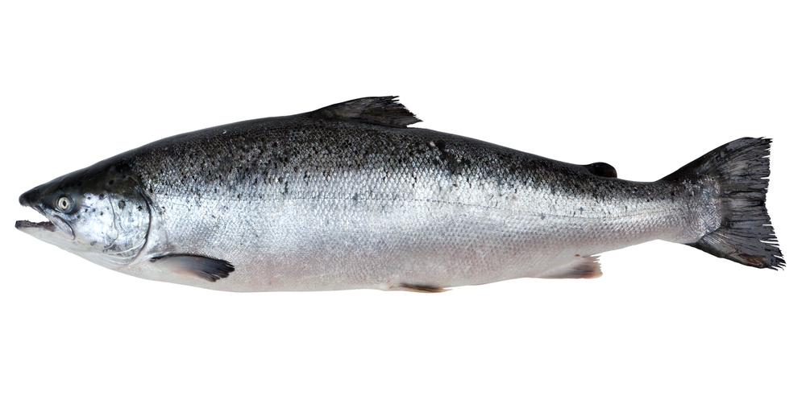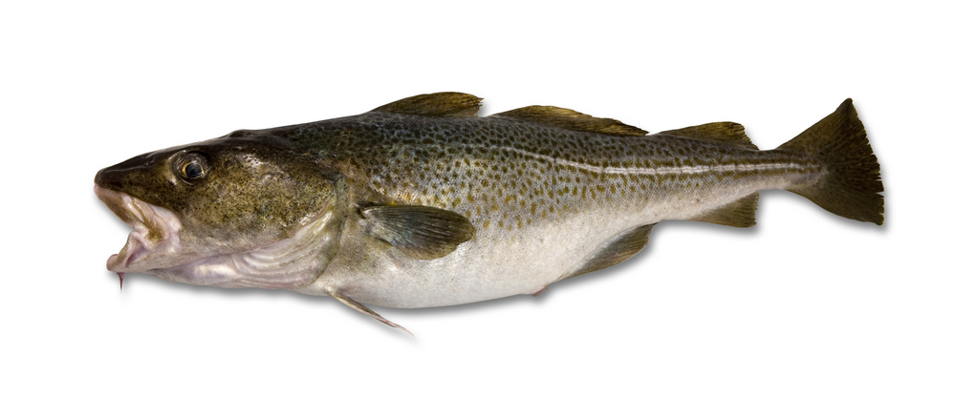
Salmon is high in Omega-3 fats and vitamin D, as well as protein and B vitamins.

Task
Create a poster featuring facts and figures about the ‘big five’. Include ideas about how they can be used in meals.
Recommendations
Fish is part of the Beans, pulses, fish, eggs, meat, and other proteins food group in the Eatwell Guide.

Around one-sixth of the food that people consume should come from this group in the diet.
It is recommended to consume two portions (one portion is 140g) of sustainably sourced fish per week.
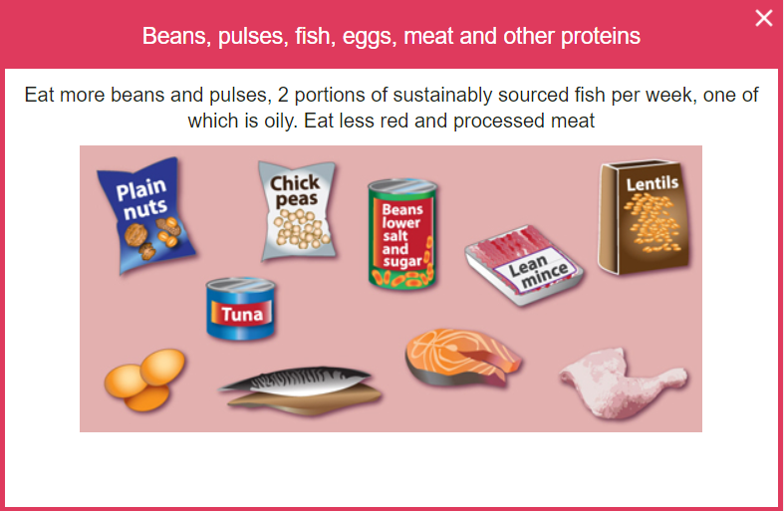
Shellfish
Shrimp and prawns are a wide group of small shellfish. The words ‘shrimp’ and ‘prawn’ are used to describe many different species.

Mussels and oysters are ‘bivalve molluscs’. Bivalve means that they have two shells that close around the soft body inside. Cockles, whelks, and winkles are small shellfish that are common around the UK.

Farming fish
Advantages
- Prevents wild fish from being overfished.
- Can provide fish to communities where wild fish is scarce.
- Can allow for fish to be farmed that are hard to catch.
Disadvantages
- Disease can be more common if many fish are kept close together.
- Farmed fish may harm wild fish if they escape.
- If waste from the fish farm is not disposed of correctly it can cause pollution.
Wild fishing
Disadvantages
- Can be less sustainable due to overfishing and may become more expensive.
- Nets can damage the seabed.
Cooking with fish
Fish can be cooked in a variety of ways, such as being grilled, baked, sautéed, fried, or barbequed.

Grilling and baking are usually healthier cooking methods, and they can also help to bring out the flavour of many fish.
Filleting
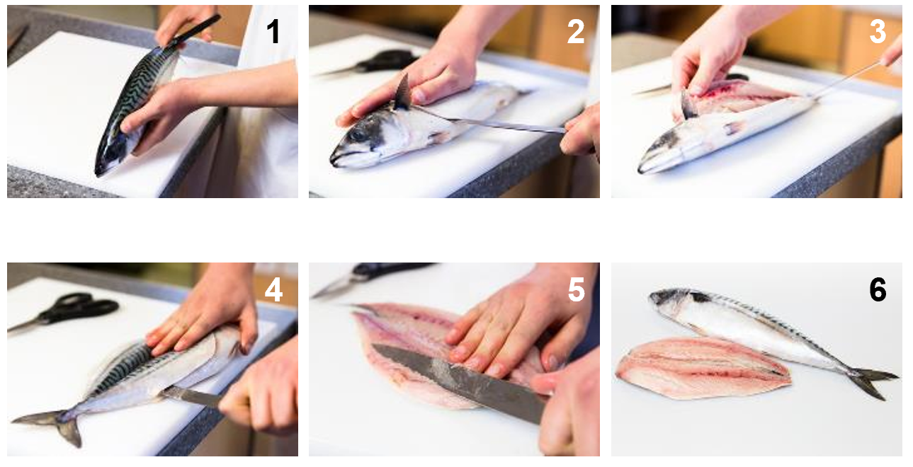
Sustainability
Because of the popularity of some fish, the numbers of some species have decreased. The MSC logo means that this fish has been caught in a way that is more sustainable.
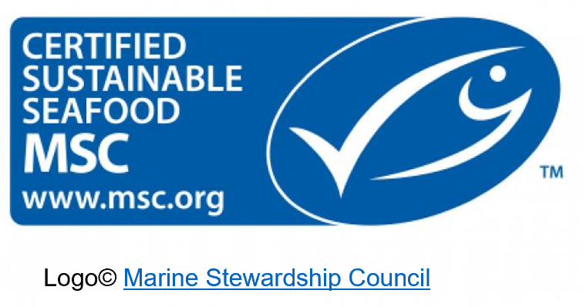
Key terms
Oily fish: A fish that contain a type of healthy fat called Omega-3.
Omega-3: A type of polyunsaturated fatty acid found in fish.
Shellfish: An aquatic shelled mollusc or crustacean that is edible.
MSC: Marine Stewardship Council logo, a logo that means fish has been caught sustainably.
Advantages
- Wild fish have a more varied diet than farmed fish and therefore may taste different.

Fishing at sea
Most fishers go out to sea in boats and use nets to catch a large number of fish at one time.
When the boat is in the right position, the fishers drop their nets. Once dropped, the boat then tows the net around, scooping up fish. This is known as trawling.

Some fish are caught on lines, rather than nets.
Some other fish, like mackerel, can also be caught on lines by a method called ‘trolling’.
Trolling is similar to trawling, but instead of dragging a net, the boat drags many lines with hooks to catch the fish.

White fish
Cod and haddock are the most popular fish in the UK. They are flaky, white fish when cooked.
Most of the cod and haddock eaten in the UK is breaded or battered.

Plaice, sole, halibut and turbot are all types of flatfish that are classed as white fish.
Oily fish
The UK Eatwell Guide states that one of the recommended two portions of fish a week should be oily.

Salmon and trout are classified as ‘oily fish’, which means they contain a type of healthy fat called Omega-3. Mackerel, herring, and sardines are types of small oily fish that are mostly sold in cans.

