Coagulation

Learning
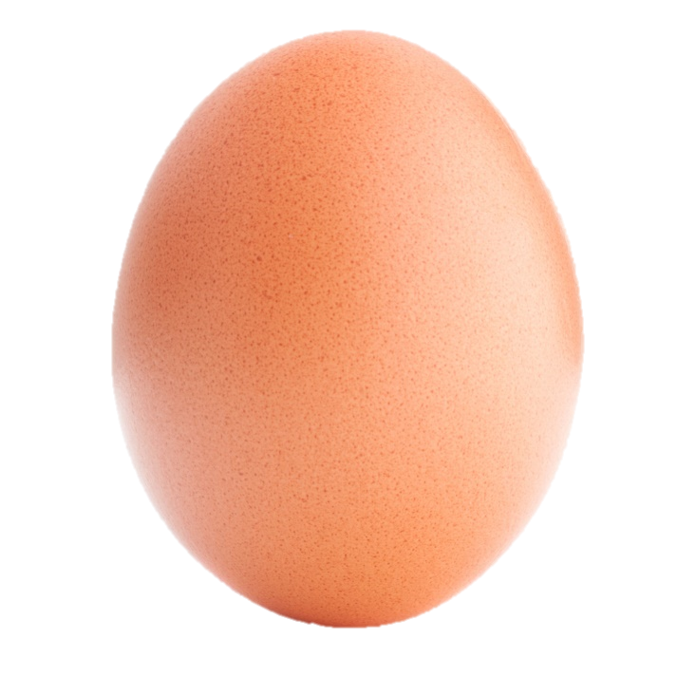
The aim of this session is to:
- demonstrate coagulation;
- identify other agents that can induce or help to cause coagulation.

You will need:
- 3 eggs;
- saucepan;
- 3 small bowls or saucers (optional);
- slotted spoon;
- white vinegar.

Instructions:
- (Optional) You may wish to crack the eggs into the bowls or saucers first, as this can make it easier to slip the eggs into the water.
- Fill the saucepan at least 5cm deep with water and bring to the boil.
- Turn the water down to a simmer and gently slip one egg into the water.
- Poach the egg for 2-3 minutes.
- Remove the egg with the slotted spoon and observe it. How well has the egg white coagulated? Is the egg well shaped?
- Add 2 x 5ml spoons of white vinegar to the water and ensure it is evenly mixed.
- Poach a second egg in this water for 2-3 minutes. How does this egg compare to the first egg?
- Tip away the hot water and add cold water to the pan. Tip the third egg into the water. What happens this time?

Questions
Think about these questions after you have completed the experiment:
- Describe the appearance of the three eggs.
- Why do the egg proteins coagulate in the boiling water, but not the cold water?
- Why is vinegar sometimes added to the water?
- Name different ways in which protein coagulation can occur.
- Name some other foods that rely on protein coagulation to be ready to eat.

