Food commodities: Fruit and vegetables
Fruit
One of the main purposes of fruit is to spread the seeds of the plant.

Fruit can be classified as:
- berries;
- citrus fruit;
- fleshy fruit;
- pomes;
- stone fruit.

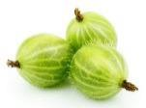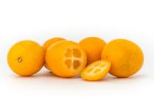
Berries Citrus fruit
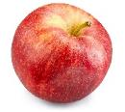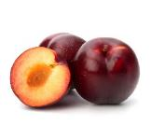
Pomes Stone fruit
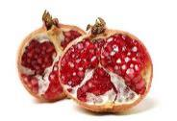
Fleshy fruit
Fleshy fruits – e.g. guava, melon
These fruits are usually fairly large and do not have a central stone.
Often, the seeds in the fruit are eaten along with the flesh as they are small and soft, but this is not the case with melons. Melons are, botanically speaking, berries and are a particular group of berries known as pepoes.
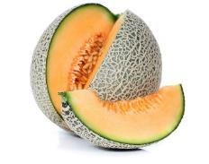
Eat 5 A DAY!
Fruit and vegetables are an important part of a healthy, balanced diet.
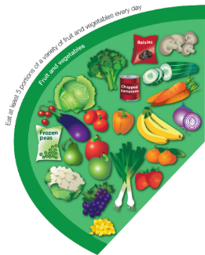
Some types are good sources of fibre, as well as providing lots of essential vitamins and minerals, such as:
- vitamin a;
- vitamin c;
- folate;
- potassium.

Eating lots of fruit and vegetables can help you maintain a healthy weight (as they are naturally low in calories) and having your 5 A DAY could reduce your risk of some diseases.
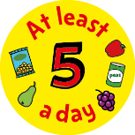
Vegetables are the edible part of a plant.
They are often grouped according to the part of the plant that is eaten:
- bulbs;
- flowers;
- fruit;
- leaves;
- roots;
- seeds;
- stem (stalk).

Citrus fruits – e.g. kumquat, lime
Citrus fruits are also berries and are a type of berry known as hesperidiums (a berry with sections of pulp inside a peelable rind).

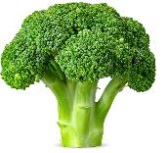
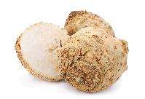
Legumes – e.g. sugar snap peas,
black beans
Legumes are grown for their edible seeds, known as beans and peas. They are the fruit (seed) of a plant. Legume seeds that are dried and used as food are called pulses (e.g. lentils).
Flowers – e.g. broccoli, cauliflower, capers
Flowers are part of the plant that allow it to reproduce. Some flowers are edible, but many others are not.
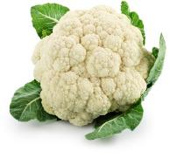
Fruit – e.g. cucumber, pepper, tomatoes
The fruit of a plant is created after its flowers have been pollinated. Many fruits are sweet, but some fruits are not and are usually used like a vegetable in food.
Bulbs – e.g. garlic, fennel, onions, shallots Some plants have bulbs which stay underground to store food for the plant when it is not growing. When the time is right, the bulb produces shoots which grow up through the soil.

Berries – e.g. blackberries, blueberries
A berry is a small, sweet fruit. They are often coloured red, blue or black.
True berries are defined as a fleshy fruit where the entire ovary wall (in a single flower) ripens into a fruit.

Celeriac is a stem
Roots – e.g. turnips, yams, potatoes
The roots of the plant suck up water and useful nutrients from the soil to help the plant stay healthy.
Tubers (e.g. potatoes) store nutrients for the plant and also propagate new plants by forming new stems and leaves.
What counts?
All fruit and vegetables count, including fresh, frozen, canned, dried and juiced varieties.
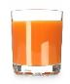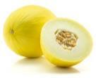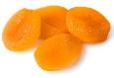
150ml 80g 30g

Key terms
Fruit: The mature ripened ovaries of flowers.
Vegetables - the edible part of a plant.
Flowers: The part of the plant that allow it to reproduce.
Stem (stalk) – e.g. celeriac, kohlrabi
The stalk of the plant helps to keep it standing up and also helps to move water and nutrients to other parts of the plant.
Increasing the vegetable content in dishes:
- Add vegetables into rice, pasta or couscous.
- Experiment with colourful and interesting salads, salsas, vegetable-based dips.
- Vegetables like carrot, parsnip and beetroot can also be added to sweet foods, such as cakes.
- Incorporate vegetables into sauces or with other foods.
Stone fruit (drupes) – e.g. nectarine
A drupe is defined as a fleshy fruit containing a single seed (also known as a pit or stone), which is not eaten.
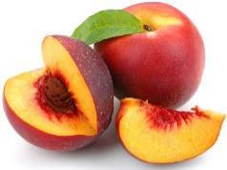
Pomes – e.g. apples, pears, quince
Pomes are berry-like fruits, with a large portion of outer flesh and a tough ‘core’ which contains the seeds (usually five.)

Multiple fruits – e.g. pineapple
Multiple fruits are fruits that are formed from separate flowers, but that fuse together into a single mass.

For more information, go to: https://bit.ly/3ErAcYD
Leaves – e.g. cabbage, cavolo nero, lettuce
Plant leaves capture sunlight and use the energy from it to make food. This process is known as photosynthesis.
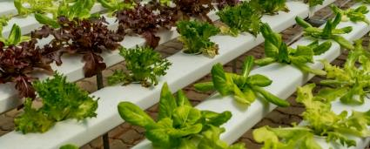
*Some plants are grown hydroponically. This means that they get their water from a nutrient solution, rather than the soil.
Tasks
- Create an infographic on fruit and vegetables. Include: why they are important, what they are and ways to include them in a healthy, varied and balanced diet.
- Keep a fruit and vegetables diary for one week. See if you can achieve 5 A DAY and choose a variety.

Mushrooms – e.g. shiitake, oyster
Mushrooms are different kinds of fungi, rather than plants.

Many types of mushrooms are dangerous to eat. Mushrooms available for consumers to buy are carefully selected to be safe.

