What happens when meat is cooked?

Explain the changes that occur during cooking.
Protein:

The proteins in meat coagulate on heating. At around 60°C the protein begins to denature and the muscle fibres become firmer.
After 60°C the fibres shrink and the meat juices are squeezed out.
Fat:

The fat on the outside and in the muscle fibres melts during cooking. This means more of the collagen is exposed to the heat helping the meat to become more tender.

Marbling therefore helps meat to stay tender and provides flavour.
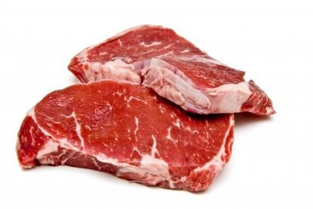
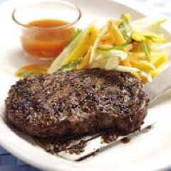
Collagen:

When meat is cooked, the collagen becomes soft and soluble, and forms gelatine.
Collagen becomes water soluble more easily when there is some liquid with the meat.
Some meat cuts that have a lot of collagen are therefore best cooked by a moist heat method.
Colour:

The colour of meat changes during cooking because myoglobin becomes a brown/grey colour.

Other colour changes are due to non-enzymic browning known as the Maillard reaction. This occurs in dry heat on the outside surface of meat when the proteins and carbohydrates react with each other.

