Caramelisation of onions

Learning
The aim of this session is to:
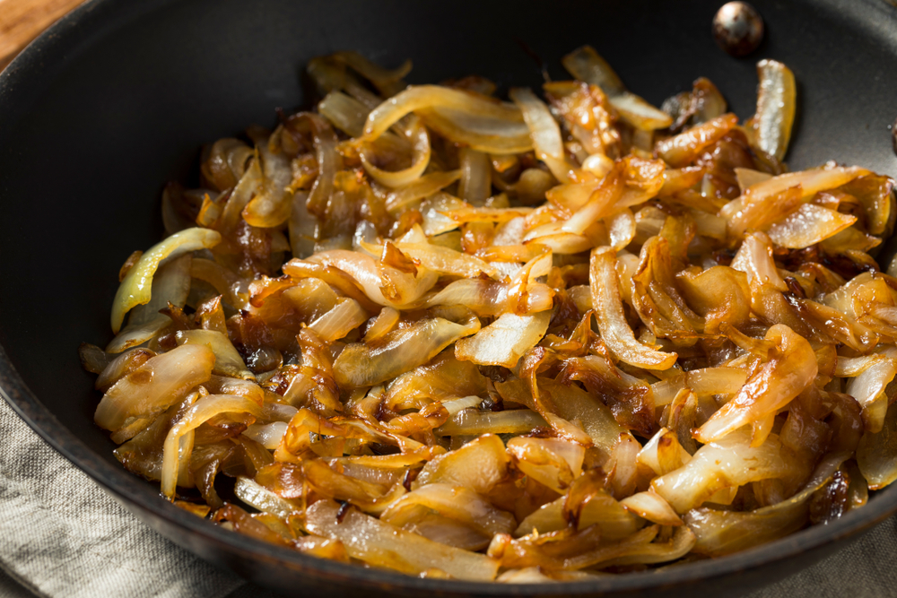
- demonstrate how onions caramelise.

You will need:
- 1 white onion
- cooking oil or ghee
- caster sugar
- balsamic vinegar
- water;
- large saucepan;
- spatula.

Instructions:
- Weigh the onion then remove skin and reweigh.
- Peel and slice the onion into measured slices.
- Weigh the sliced onions.
- Melt the ghee or oil and fry gently – time caramelisation.
- Use a food probe to check temperatures as onions caramelise.
- Compare to sugar boiling scales.
- Test pH of the mixture.

Variables
Use these variables to repeat the experiment and note the differences:
- Onions and ghee/oil
- Onions, ghee/oil and 10g caster sugar
- Onions, ghee/oil and 10ml balsamic vinegar

Extension
You could also try the following additional variables:
- Add ½ tsp teaspoon bicarbonate soda
- Soak the sliced onions in water, drain, dry and fry
- Use different frying fats: rapeseed oil, olive oil, dripping
- Add 10g of plain flour, or cornflour to the onions
- Add 10g apple juice or 1 tsp caster sugar
- Vary the onions – red onion, shallots, leeks.

Data to collect
- Weight of raw onion
- Weight of onion pre-cooking
- Weight of onion caramelised
- Comparison of colour of onions against a benchmark range (photograph)
- Accurate small measurements of 10g sugar etc
- Sensory analysis – raw / caramelised onions
- Recipes that incorporate caramelisation of onion.

Questions
Think about these questions after you have completed the experiment:
- Describe the differences between the slices removed at each time point. Are they harder or softer? What colour are they? Do they look different? Do they smell different?
- Why does it take time for the sugars in the onion slices to become caramelised?
- What needs to be removed by heating the onions to make this happen?

Refer to the Caramelisation of onions presentation for more information.

