Eastern Asian cuisines –

a brief overview

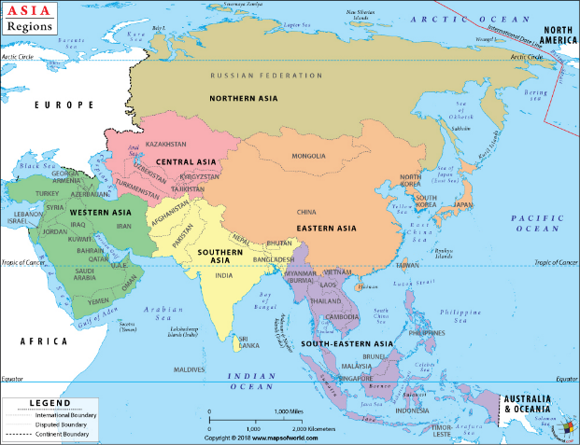
- Asia can be divided into five regions. These are Central Asia, East Asia, South Asia, Southeast Asia, and Western Asia.
- East Asia includes China, Hong Kong, Japan, Macau, Mongolia, North Korea, South Korea, and Taiwan.
- The geography of East Asia is varied depending on the zone. The inner continental area has a temperate climate, while Mongolia is covered by the arid Gobi Desert. China, the largest country in the region, has both mountains and plateaus, while Japan has many thousands of islands and coastlines. These difference all have an influence on the cuisine of the area. Being one of the most populated regions of the world East Asia has many regional cuisines.
- The countries of eastern and southeastern Asia have a culinary tradition that stretches back over thousands of years. Rice was first cultivated in China in Neolithic times and still forms the basis of most East Asian cuisines. Rice and wheat noodles are also popular. Pork, chicken and seafood are popular proteins, together with a wide variety of soy products.

Chinese cuisine
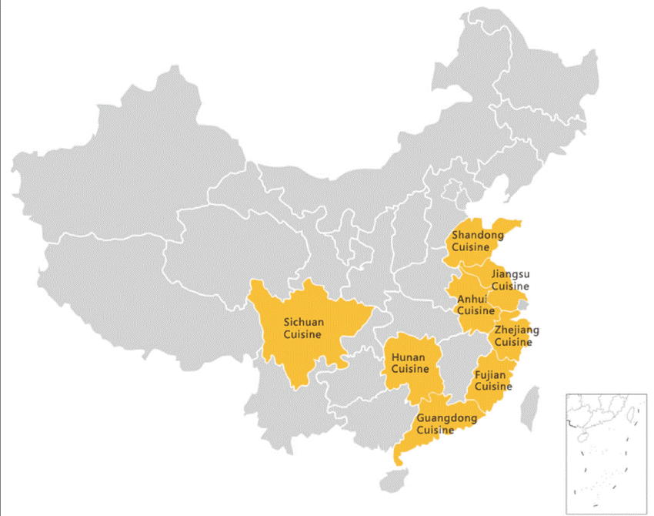
Chinese cuisine is rich and diverse and varies in style and taste from region to region. Its history dates back thousands of years, evolving according to changes in both the environment (such as climate) and local preferences over time. Chinese cuisine also varies depending on class and ethnic background, and it is often influenced by the cuisines of other cultures. Of the various regional styles of Chinese cuisine, it is the Cantonese cuisine from Guangdong that is the most widely recognised globally.

There are a number of distinctive styles from different regions that contribute to the whole of Chinese cuisine, and of these there are eight specific culinary traditions that are recognised throughout Chinese society and around the globe. They are - Anhui, Cantonese, Fujian, Hunan, Jiangsu, Shandong, Szechuan and Zhejiang.

Anhui (Hui) - derived from the native cooking styles of the people located in the Huangshan Mountains region in China. Although it is similar to Jiangsu cuisine, there is less emphasis on seafood and more on a wide variety of locally grown herbs and vegetables from both the land and the sea.

Cantonese (Yu) - due to Guangdong’s proximity to the South China Sea, the people of the region have access to a plentiful supply of imported food and fresh seafood. Cantonese cuisine incorporates almost all edible meats, including chicken feet, duck’s tongue, snakes and snails. However, due to availability, lamb and goat are rarely eaten. Many cooking techniques are used, including wok hei (stir frying) and steaming. Spices are used moderately, and fresh herbs are seldom added to the food.

Fujian (Min) - is influenced by its coastal position and mountainous terrain, and ingredients such as woodland mushrooms, bamboo shoots, fish, shellfish and turtles are used regularly. The cuisine in this area is known to have particular emphasis on umami taste.

Hunan (Xiang) - food is renowned for being hot and spicy, with garlic, chili peppers and shallots used liberally.

Jiangsu (Su) - cuisine consists of a several different styles of Chinese cooking. The food in Jiangsu cuisine is known as being soft, but not to the point of falling apart: the meat tastes tender but wouldn’t separate from the bone when picked up.

Shandong (Lu) - derived from the native cooking styles of Shandong, it consists of two predominant styles: Jiaodong, characterised by light seafood dishes; and Jinan, a style that uses soup in its dishes. Although it is less available in the West, Shandong cuisine is often considered one of the most influential styles of cooking in the Chinese culinary history.

Szechuan (Chuan) - is renowned for its use of bold flavours; chili, garlic and Szechuan pepper are used liberally in dishes. Szechuan pepper has a unique taste: it is intensely fragrant, citrusy and causes a numbing sensation in the mouth. Szechuan cuisine often contains food that has been preserved through pickling, salting and drying.

Zhejiang (Zhe) - food is fresh and light. It consists of at least four styles of cooking: Hangzhou, characterised by the use of bamboo shoots; Shaoxing, specialising in poultry and fish; Ningbo, specialising in seafood; and Shanghai, with xiao long bao.

Japanese cuisine
Sushi and sashimi are two of the most popular food types in Japanese cuisine. Each uses fresh fish and rice, ingredients that are abundant in Japan. Tempura, another favourite, features pieces of meat, fish, and/or vegetables covered in a tempura batter and deep fried until they are crunchy and golden. They can then be dipped in sauces such as tsuyu sauce or shoyu. Teriyaki is also a popular Japanese cooking style in which foods are grilled with a glaze of soy sauce, mirin and sugar and then served with sticky rice.

A typical Japanese dinner includes rice, soup, pickles, salad, and protein and vegetable dishes. Drinks, such as tea, beer, and sake, are served alongside, and the meal may be followed by dessert. The dishes include classic Japanese foods, and other Asian and Western cuisines influence many modern recipes.
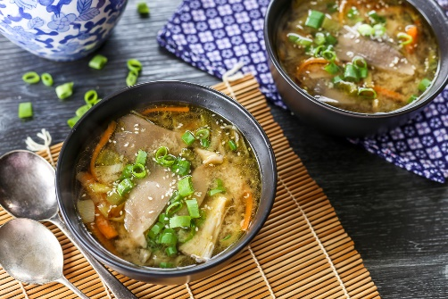
The meal structure in Japan differs slightly from the multiple courses traditionally found in Western and European cuisine, where each course is served separately. The average homemade Japanese meal (or gohan) involves a single course with several dishes presented at once, while dessert serves as the second course.

In addition to rice, every Japanese meal includes soup. A miso-based soup (miso shiru) is the most common. Dashi-based soup (sumashi jiru) is also popular and can include many vegetable, protein, and seafood combinations.

Korean cuisine
Korean foods are typified by their use of rice, vegetables and seafood, cooked in a wide variety of sauces and spices. Seasonings include red pepper, green onion, soy sauce, bean paste, garlic, ginger, sesame, mustard and vinegars. Some favourites include Kimchi, a fermented and spiced cabbage that is added to many Korean dishes, and Tteokbokki, which are hot and spicy rice cakes. Also popular is the Korean barbecue pulgoki, which is meat marinated in a sauce made with soy sauce, garlic, sugar, sesame oil, and other seasonings, which is then cooked over a fire in front of the dinner table.

Known as a sweeter version of the Western pancake, hoeddeok, or sometimes spelled as hotteok, is a popular Korean street food, especially during the winter season. It is a flat, circular dough that is filled with a mixture of cinnamon, honey, brown sugar, and small pieces of peanut and cooked on a griddle to make a crunchy exterior and soft middle.

One of the oldest and probably the most essential dishes in Korean cuisine, kimchi is a spicy and sour dish made up of fermented vegetables. It is made with a variety of ingredients, but the most common main ingredient is cabbage. Kimchi is popular around the world for its unique flavour and nutritional benefits. For Koreans it has significant cultural value - without kimchi, dinner is considered incomplete.

Mongolian cuisine
Mongolian cuisine is mainly derived from the traditions of ethnic Mongols. It is a blend of their nomadic diet and influences from northern China and Russia. Influenced by cuisine from northern China, Inner Mongolian cuisine generally tends to be salty and sour. Spices are often used in cooking.

Mongolians have different eating habits depending on their geographical location due to the local products available. In pastoral areas, ethnic Mongolians eat beef, mutton, and dairy products as their staple food.

In rural areas, the eating habits of ethnic Mongolians are similar to the Han (Chinese majority) people. They eat corn flour and millet as the staple food, and sometimes they eat rice, wheat, coarse rice, buckwheat flour, and sorghum.

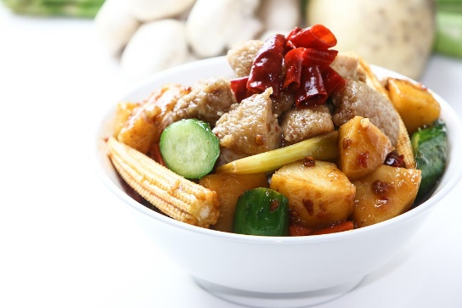
Typical Mongolian dishes include roast meat, jerky, instant-boiled mutton, roast leg of lamb, hand-stripped mutton, milk tea, cheese, and yogurt. Hand-stripped mutton is the most famous dish.

Ethnic Mongolians are hospitable: they always welcome guests by preparing their best ‘roasted whole sheep' to be “stripped” using their hands.

Taiwanese cuisine
Taiwanese cuisine reflects its history of migration and colonisation. It’s been greatly influenced by Japanese cuisine and the various regional Chinese cuisines, mainly from the mid to southern provinces of China. Fujian and Hakka-style dishes are prominent, as are dishes from other regions like Guangdong, Shanghai, Hunan, and Sichuan.

Taiwanese food has also been shaped by its geographic location, being an island, seafood is prominent in Taiwanese cuisine. Chicken and pork are also common while rice is a staple dish. A range of seasonings are used to flavour Taiwanese dishes, some of the most common being soy sauce, sesame oil, rice wine, fermented black beans, and pickled radish.

One of the most important aspects of Taiwanese food culture are xiaozhi. These refer to a group of snacks similar to Spanish tapas or Turkish meze.

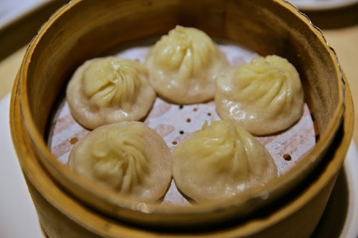
Did you know?
Huaiyang cuisine (East China), known for elegant dishes that rely on intricate knife skills and many types of dumplings, is almost always a little sweet, never spicy, and focuses on preserving the original colours of ingredients. The dishes are often seen as quite luxurious and opulent as Yangzhou was a major trading centre and one of the wealthiest cities through much of China’s history.
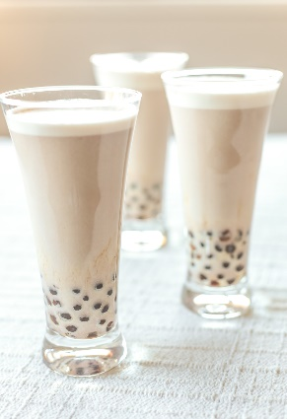

Bubble tea represents the "QQ" food texture that Taiwanese love. The phrase refers to something that is especially chewy, like the tapioca balls that form the "bubbles" in bubble tea.

Chun Shui Tang and Hanlin Tea Room both claim to have invented bubble tea by combining sweetened tapioca pudding (a popular Taiwanese dessert) with tea.

