Hot cross buns

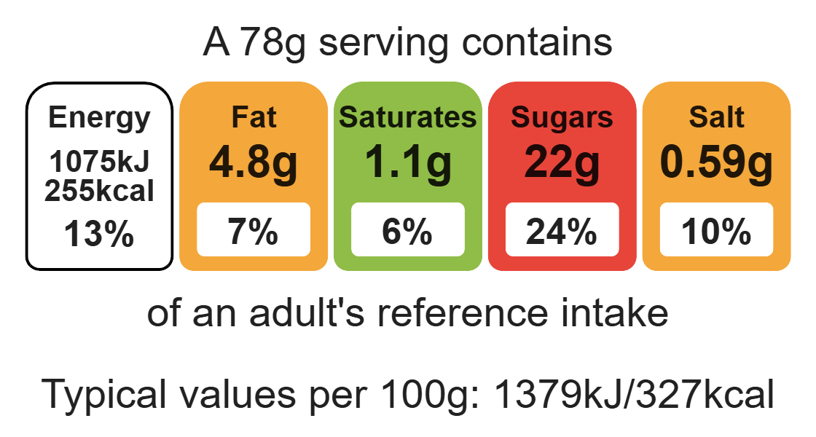
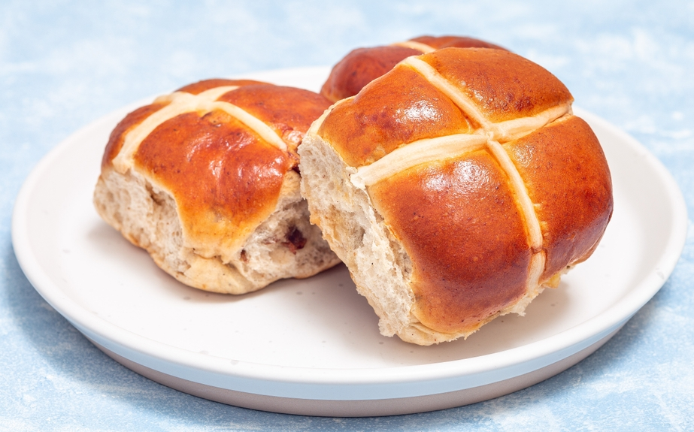

Ingredients (makes 12)

50g reduced-fat spread

150ml semi-skimmed milk

2 x 5ml spoon fast action fast action yeast (or 1 sachet)

400g strong wholemeal flour
Complexity: medium

1 x 5ml spoon salt

1 x 5ml spoon mixed spice

Equipment

Baking tray

Weighing scales

Measuring jug

Measuring spoons

Saucepan

Mixing spoon

Sieve

Large mixing bowl

Pastry brush

Cooling rack

½ x 5ml spoon cinnamon

½ x 5ml spoon nutmeg

75g golden caster sugar

150g currants and 100g mixed peel

2 eggs

1 x 15ml spoon granulated sugar

2 x 15ml spoons water

Method
- Mix the spread and milk in a saucepan and warm until the spread has melted.
- Sift the flour, salt and spices into a mixing bowl.
- Add the yeast to the mixing bowl.
- Add the currants and peel to the bowl next and stir to ensure they are well coated; then add the sugar.
- Crack and beat the eggs in a separate bowl before adding to the mixing bowl.
- Stir in the liquid and beaten eggs to the dry ingredients to form a soft dough.
- Turn onto a floured surface and knead for 6-8 minutes until smooth and no longer sticky.
- Divide the dough into 12 and shape into buns.
- Place the buns well apart on greased baking tray.
- To make crosses, slash the buns with a sharp knife or use thin strips of pastry or pipe on crosses using a paste made from 2 x 15ml spoons each of plain flour and water.
- Cover the buns and leave to rise in a warm place until double in size - about 1 hour.
- Bake in a hot oven, 200C/gas 6 for 15-20 minutes until golden brown.
- Whilst the buns are baking, gently melt the sugar and water in a saucepan until the sugar has dissolved and the mixture has become syrupy.
- Turn out onto a cooling rack and brush the buns with a sugar/water syrup.

Top tips
- Reduce food waste: Use up any leftover fruit such as, apricots, berries, peaches, plums or pears. The fruit can be canned, dried or frozen.
- Turn up the flavour: Try adding ½ x 5ml spoon cinnamon to enhance the flavour.

Food skills
Weigh, measure, melt, simmer and boil, sift, mix, stir and combine, beat, knead, portion/ divide, form and shape, prove, bake, glaze and coat.

