Heat transfer (exchange)
1) Identify three reasons why heat may be applied to food.

- _____________________________________________________________

- _____________________________________________________________

- _____________________________________________________________

2) Identify two reasons why heat may be removed from food.

- _____________________________________________________________

- _____________________________________________________________

3) Match the descriptions to the method of heat transfer they are describing.
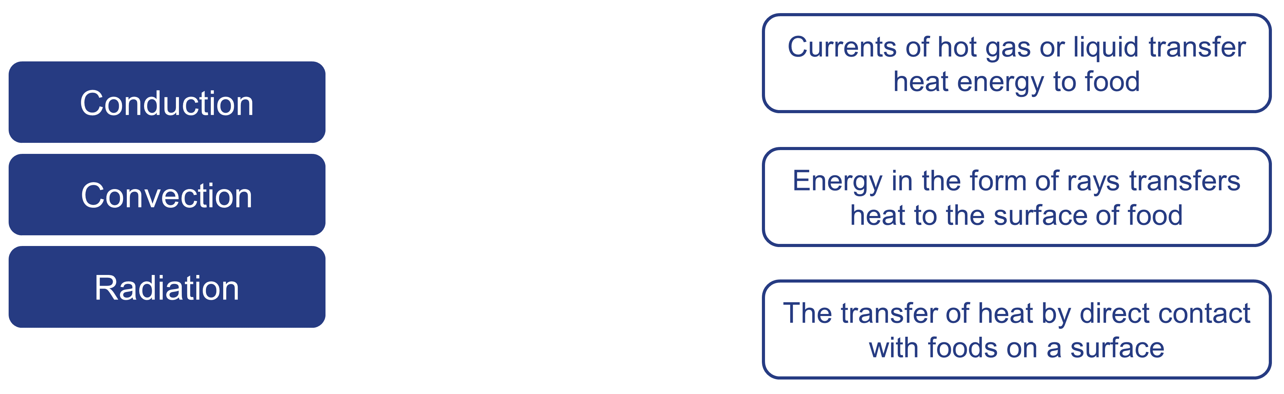

- Explain why, in an oven that does not use fan assistance, the hottest part is at the top.
______________________________________________________________________

______________________________________________________________________

______________________________________________________________________

- Complete the following passage, using the terms provided:

When ___________ or ___________ are heated, the molecules become more ______________. This makes them move around more quickly.
Because of this, the molecules move further apart, making them less ____________. This causes them to rise.
Cooler liquid or gas falls to take its place. This in turn becomes heated and rises up, creating moving ‘____________ currents’.
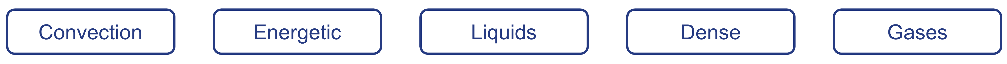

- Which two methods of heat transfer are used to make a beef casserole?
- ____________________

- ____________________

- Which two methods of heat transfer are used to cook a kebab on a grill?
- ____________________

- ____________________

