Naan bread

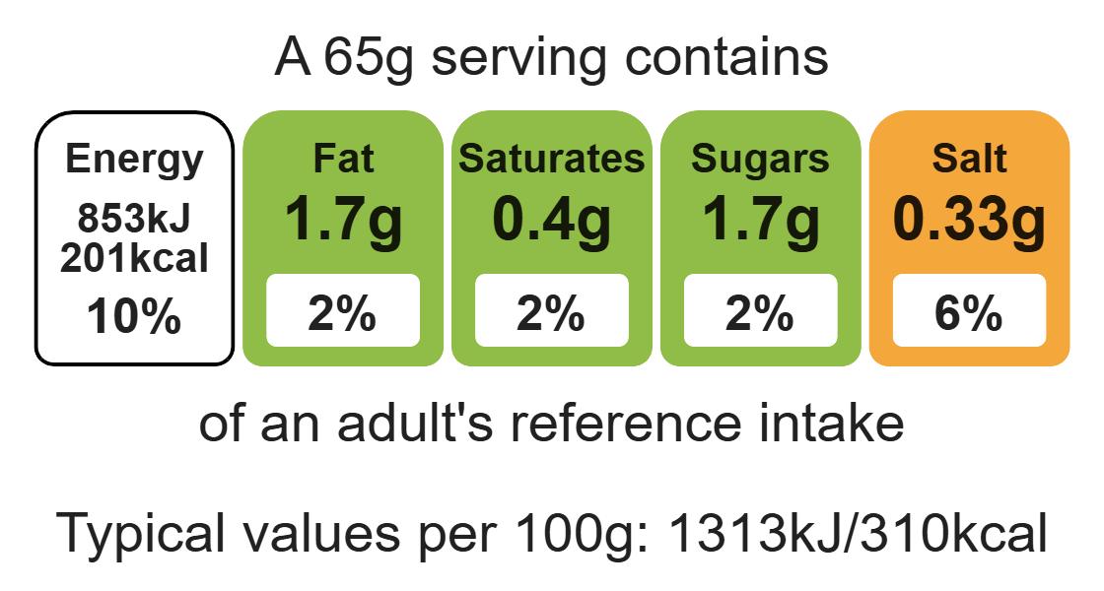


Ingredients (serves 4)
Complexity: low - medium
60ml semi-skimmed milk
200g strong flour

Equipment

Baking tray

Weighing scales

Measuring jug

Saucepan

Sieve

Mixing bowl

Mixing spoon

Rolling pin

Cooling rack

1x5ml spoon baking powder
½ sachet instant yeast
1x5ml oil
1x15ml spoon reduced-fat plain yogurt

Method
- Warm the milk (either in a saucepan or microwave).
- Sift the flour and baking powder into a bowl. Stir in the yeast.
- Add the yogurt, oil and warm milk.
- Mix into a soft dough.
- Knead for 10 minutes.
- Leave the dough to prove (rise) for around 30-60 minutes.
- Preheat the oven to 250°C or gas mark 8.
- Place the baking tray in the oven to warm.
- Knead the dough and divide into 4.
- Roll out each piece of dough into a ‘tear’ shape (oval).
- Cook the naans on the heated tray for 3-4 minutes, until puffed up and brown.

Top tips
- Turn up the flavour: Brush the naans with a low-fat spread and sprinkle with poppy or sesame seeds before baking (be ingredient aware!). Why not add dried fruit, coconut or spices to the naan mix before baking.
- Serving suggestion: Make a meal out of your naan. Once baked, stuff with your favourite curry.

Food skills
Weigh, measure, microwave, sift, mix, stir and combine, knead, portion/divide, form and shape, bake.

