Vegetarian lasagne

Complexity: medium
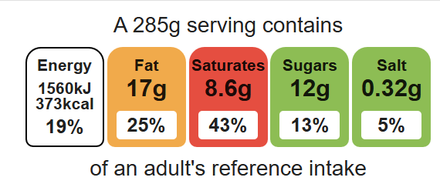

Equipment

Weighing scales

Chopping board

Sharp knife

Vegetable peeler

Garlic press

Saucepan

Frying pan

Heat resistant spoon

Measuring spoons

Measuring jug

Small bowl

Metal spoon

Ovenproof dish or foil trays

Ingredients (serves 3)
1 onion
1 garlic clove
1 carrot
2 celery sticks
100g dried lentils
1 x 10ml spoon oil or spray oil
400g canned chopped tomatoes
1 x 5ml spoon mixed herbs
1 x 15ml spoon tomato purée
200ml reduced-fat crème fraîche
25g reduced-fat cheddar
50ml semi-skimmed milk
Black pepper
6 wholemeal lasagne sheets

Method
Top tips
- Turn up the flavour: Experiment with different herbs, for example fresh basil or oregano.
- Reduce food waste: Use different vegetables such as courgettes, peppers or aubergine. Anything that might need using up!

- Preheat the oven to 190°C or gas mark 5.
- Prepare the ingredients:
- peel and chop the onion;
- peel and crush the garlic;
- top and tail, peel and dice the carrot;
- slice the celery;
- grate the cheese.
- Fry the onion, garlic, carrot and celery in the oil until soft, for about 4 minutes.
- Add the lentils, tomatoes, herbs and tomato purée.
- Pour in just enough water to cover the mixture, bring to the boil and then allow to simmer for 15 minutes with the lid on.
- Blend the crème fraîche, half the grated cheese, milk and pepper together in the small bowl.
- In an ovenproof dish or foil tray, spread some lentil mixture in the bottom, cover with lasagne sheets and a little crème fraîche sauce. Repeat this, finishing with the sauce on top.
- Sprinkle the remaining grated cheese on top and bake for 20 minutes.

Food skills
Weigh, measure, peel, cut, chop, slice, dice and trim, fry and sauté, mix, stir and combine, melt, boil and simmer, layer and bake.

