Enzymic browning

Learning
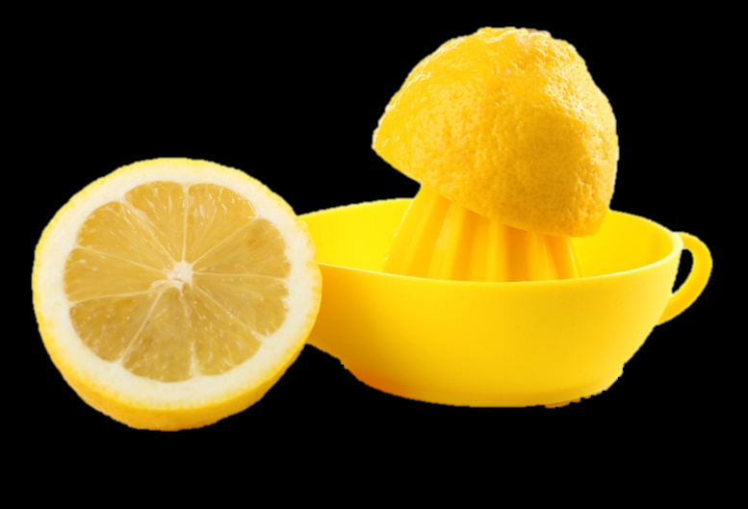
The aim of this session is to:
- demonstrate enzymic browning;
- find out how enzymic browning can be prevented or reduced.

You will need
- 1 apple (or a potato/iceberg lettuce);
- 3 dishes or saucers;
- 150ml water;
- 5g sugar;
- 1 lemon;
- knife;
- chopping board;
- juicer.

Instructions
- Prepare 3 clearly-labelled dishes, containing each of the following:
  - 50ml water;
  - 50ml water and 5g sugar;
  - 50ml water and juice of half a lemon.
- Slice the apple, potato or iceberg lettuce into approximately ½ cm thick slices.
- Place one or two slices onto each dish.
- Leave the slices in the dishes for about half an hour.
- Check on the three slices. Which has browned the most and which the least? Write down your observations.

Questions
Think about these questions after you have completed the experiment:
- What causes the sliced fruit or vegetable to go brown?
- What is in the dish with the slice that browns the least?
- How does this substance prevent browning?
- Describe other methods that could prevent these slices from going brown.

