Technical Manager
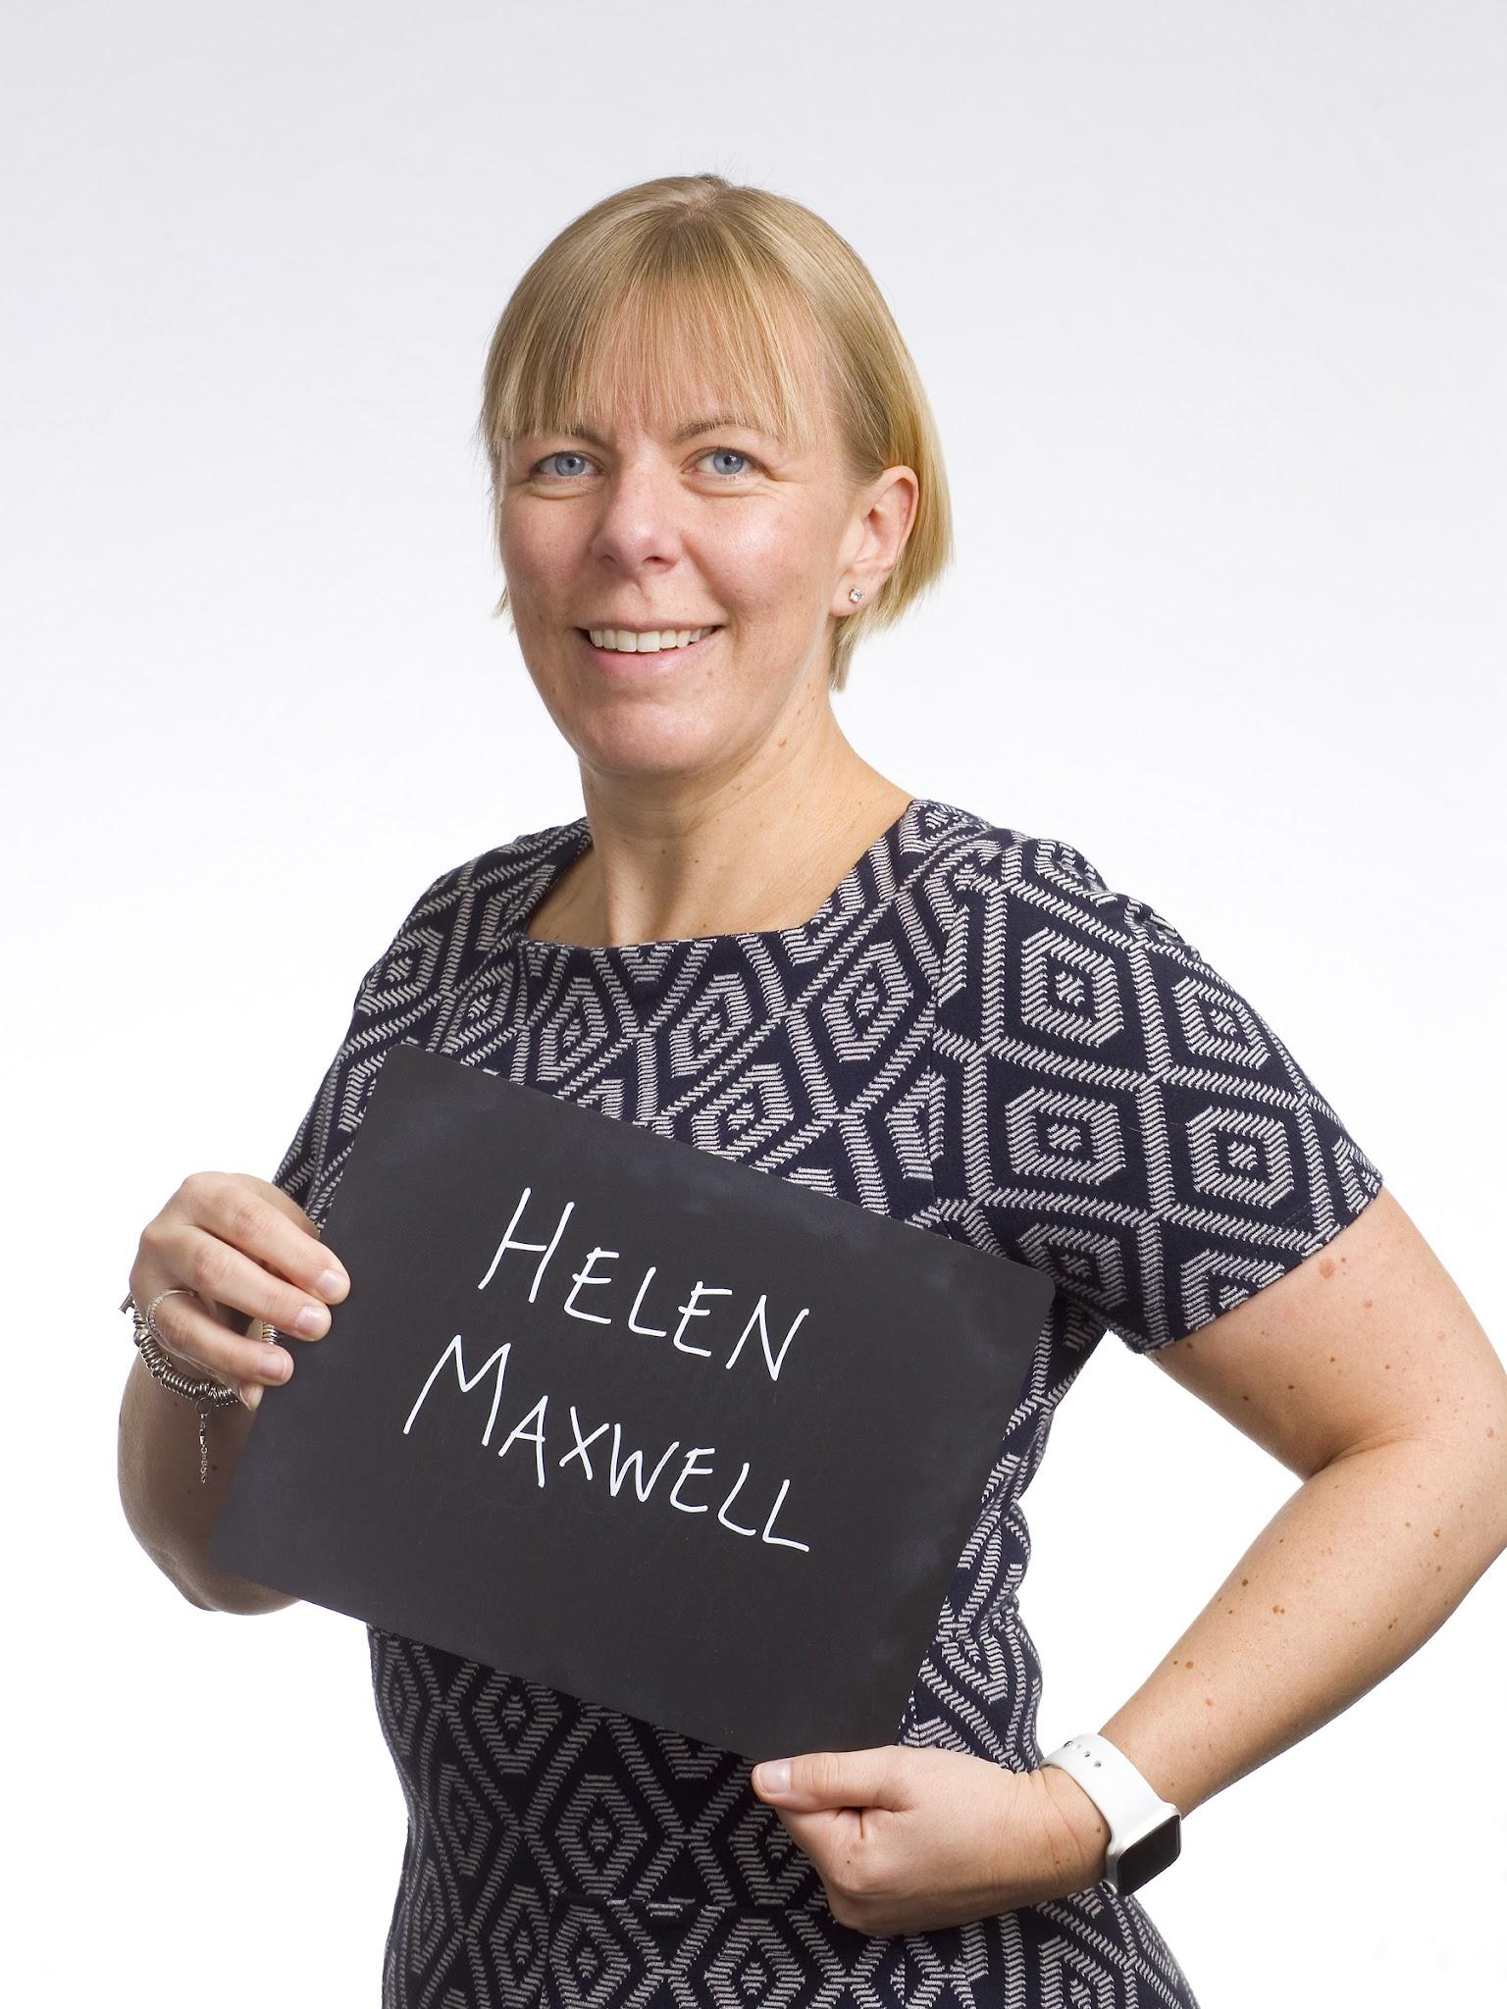
Name Helen Maxwell

What qualifications do you have?
GCSEs
A Level Maths, Chemistry & Biology
Degree - BSc (Hons) Food Quality

What does your job involve?
Ensuring the quality, safety and legality of Waitrose beef products.
I work with the Waitrose team to see new products through from
concept to launch, investigate customer complaints and work with our suppliers to
ensure high levels of food hygiene and animal welfare standards are maintained.

What, or who, inspired you to take your chosen career pathway?
I had great science teachers at school who included food-based experiments into their lessons; it was those teachers plus a great careers advisor suggesting a career in food science that set me on my career pathway.

What route did you take from leaving school to your current job?
On leaving school I went onto a tertiary college to study for my A levels, I then went to Bournemouth University to study for my degree. During my degree I had a year out and worked for Marks & Spencer in their food team. After leaving university I worked in a food microbiology laboratory, I then moved into food manufacture (bakery and then sandwich manufacture) before joining Waitrose & Partners 8 years ago.

What is the key knowledge, skills and experience needed for your job
For my role as a Technical Manager, you need a good understanding of food safety (HACCP) and legality. Problem solving and the ability to manage multiple work streams are key skills. Experience in working in a food manufacturing environment really helps me in my current role.

What is the best thing about your job?
No two days are the same, working with fantastic people and spending time in food factories.

What questions are you often asked about your job?
Whether I love my job (which I do), my favourite Waitrose product and are certain foods safe to eat past their expiry date.

What advice would you offer to someone interested in doing what you do?
Approach local food manufacturing businesses to undertake some work experience for free so you can see first hand the careers available within the food industry.

