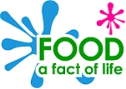
Bread planning
What are you making? _________________________________.

Who is it for? _________________________________________.

When is it for? ________________________________________.

Write a checklist to help you make sure your dish is suitable for the event and the people who will eat it.

My dish will:

- __________________________________________________
- __________________________________________________

- __________________________________________________

What will it look like? | What ingredients will you need?

How will you make it? | What equipment will you need?

Fill in this part of your sheet after you have made your dish.

Does it look as you planned? | Does it taste as you planned?
What would you do differently next time?

