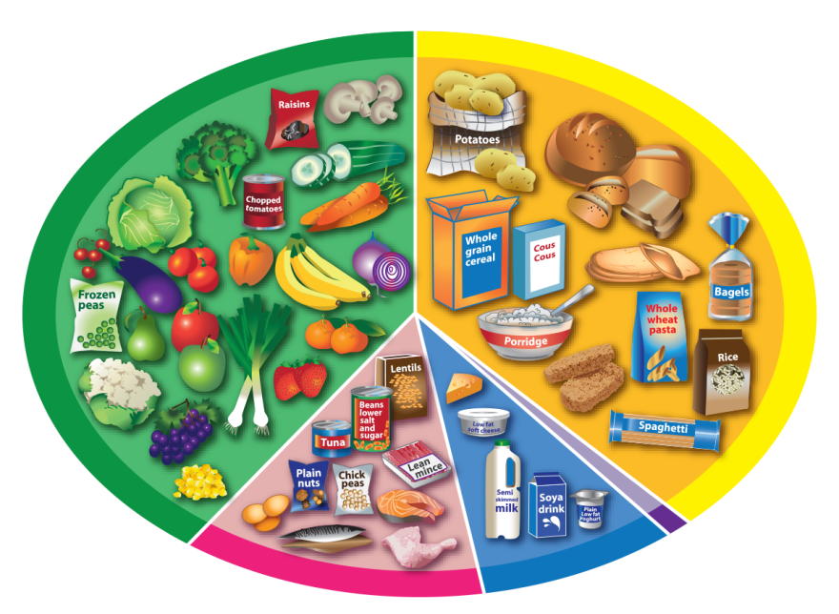
The Eatwell Guide

Fruit and vegetables
Potatoes, bread,
rice, pasta
and other starchy
carbohydrates


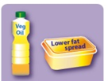
Oil and spreads
Dairy and
alternatives
Beans, pulses,
fish, eggs, meat
and other proteins
6-8
a day

