Recipe modification

Many front-of-pack labels use the traffic light system. It was devised to help consumers make healthier choices. Below are some examples of front of pack and back of pack nutrition labelling for a selection of ready meals. The ingredients list used to prepare the ready meal is also included. Using the questions as a guide, modify the recipe ingredients to create a healthier ready meal.

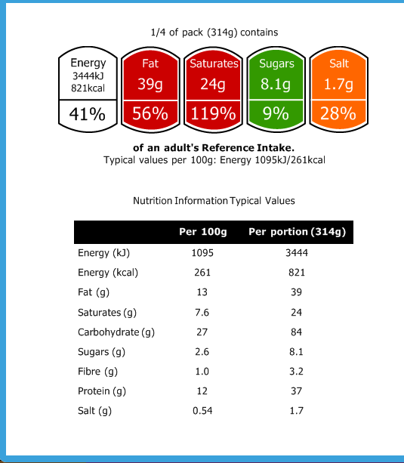
A. Macaroni cheese
Ingredients (serves 4)
30g butter
350g macaroni
1 garlic clove (5g)
1 tsp English mustard powder (3g)
3 tbsp plain flour (60g)
500ml whole milk
250g mature cheddar
50g parmesan

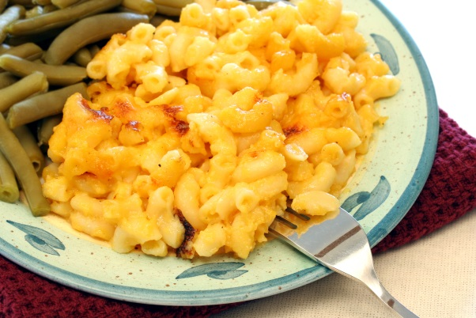

The developer of this ready meal has asked you to modify the ingredients list so that the front of pack nutrition label has no red colour coding (no nutrient values classified as ‘high’ per 100g or per portion). The developer would also like the energy content of the ready meal to be 2510kJ/600kcal or under.

Questions

- What changes could be made to the ingredients list to make the values amber or green? This might include changing the amount or type of ingredient.
______________________________________________________________________

______________________________________________________________________

______________________________________________________________________

2. Explain the changes you have made. How do you think each change will impact on the nutritional value of the macaroni cheese?
______________________________________________________________________

______________________________________________________________________

______________________________________________________________________

3. Enter the revised ingredients list into Explore food. Create a label. Compare the label of the original recipe to the label of your modified recipe. How do the traffic lights compare?
______________________________________________________________________

______________________________________________________________________

______________________________________________________________________

4. Have you met the developer’s request? If not, what further modifications could be made?
______________________________________________________________________

______________________________________________________________________

______________________________________________________________________

5. On the packaging of the macaroni cheese, the developer would like a serving suggestion. What would you recommend to ensure a healthy, balanced meal?
______________________________________________________________________

______________________________________________________________________

______________________________________________________________________
B. Cheese and bacon quiche
Ingredients (serves 4)
Pastry:
150g plain flour
75g butter
Filling:
250g cheddar
200g streaky bacon
5 eggs
100ml whole milk
200ml double cream
1g salt

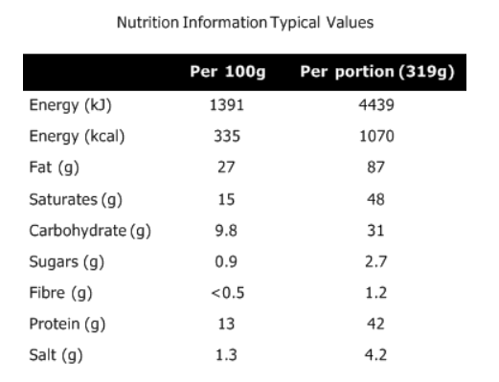
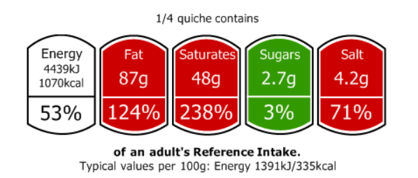

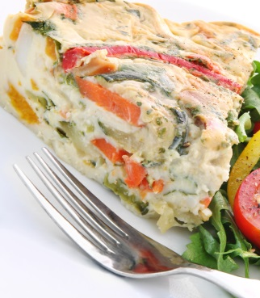

The developer of this ready meal has asked you to modify the ingredients list to make this a ‘healthier quiche’. Consider portion sizes and healthy eating guidelines (e.g. the Eatwell Guide, eight tips for healthy eating) as well as altering the nutrient content.

Questions

1. What changes could be made to the ingredients list to make this a healthier quiche? This might include changing the amount or type of ingredient.
______________________________________________________________________

______________________________________________________________________

______________________________________________________________________

2. Explain the changes you have made. How do you think each change will impact on the nutritional value of the quiche? What would the potential health benefits to the consumer be?
______________________________________________________________________

______________________________________________________________________

______________________________________________________________________

3. Would you change the portion size of this quiche? If so, why?
______________________________________________________________________

______________________________________________________________________

______________________________________________________________________

4. Enter the revised ingredients list (and new portion sizes, if applicable) into Explore food. Create a label. Compare the label of the original recipe to the label of the modified recipe. How do the traffic lights compare?
______________________________________________________________________

______________________________________________________________________

______________________________________________________________________

5. On the packaging of the quiche, the developer would like a serving suggestion. What would you recommend to ensure a healthy, balanced meal?
______________________________________________________________________

______________________________________________________________________

______________________________________________________________________


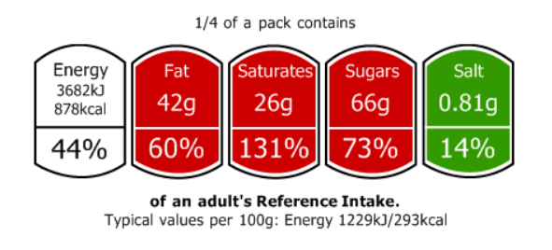
C. Apple crumble
Ingredients (serves 4)
Crumble topping:
300g plain flour
175g brown sugar
200g butter
Filling:
450g apples
50g brown sugar
20g plain flour
3g ground cinnamon

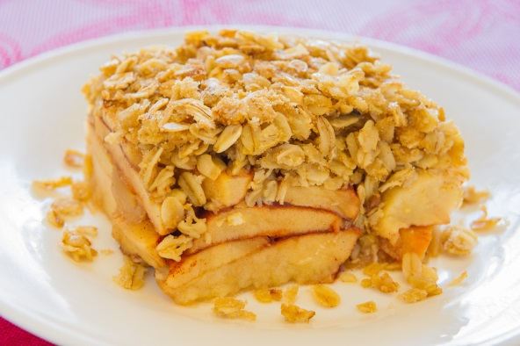

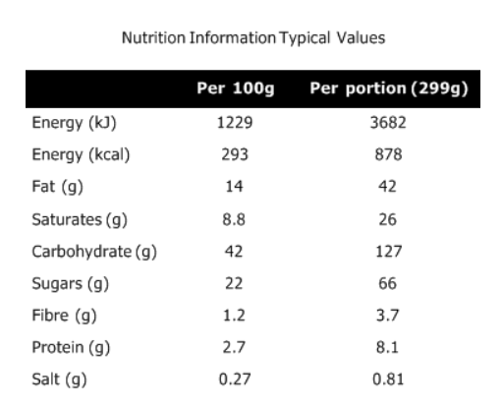

Modify the ingredients list of the apple crumble to reduce the amount of fat, saturated fat and sugars provided. As well as altering the ingredients, consider changing the suggested serving size.

Questions

1. What modifications would you make to the ingredients?
______________________________________________________________________

______________________________________________________________________

______________________________________________________________________

2. Explain the changes you have made and what nutrients do you think these changes will impact on? Explain the health benefits of your proposed changes.
______________________________________________________________________

______________________________________________________________________

______________________________________________________________________

3. Would you make any alterations to the portion size? If so, why?
______________________________________________________________________

______________________________________________________________________

______________________________________________________________________

4. Enter the revised ingredients list (and portions, if applicable) into Explore food. Create a label. How has your modifications impacted on the nutritional value of the dish?

______________________________________________________________________

______________________________________________________________________

______________________________________________________________________

D. Pizza
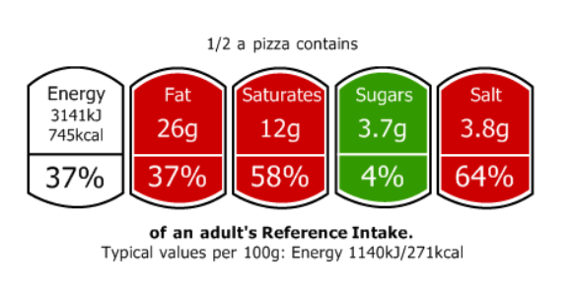
Ingredients (serves 2)
250g strong white flour
2g salt
3g fast action dried yeast
150ml warm water
6g olive oil
75g homemade tomato sauce
40g salami
100g mozzarella
75g ham

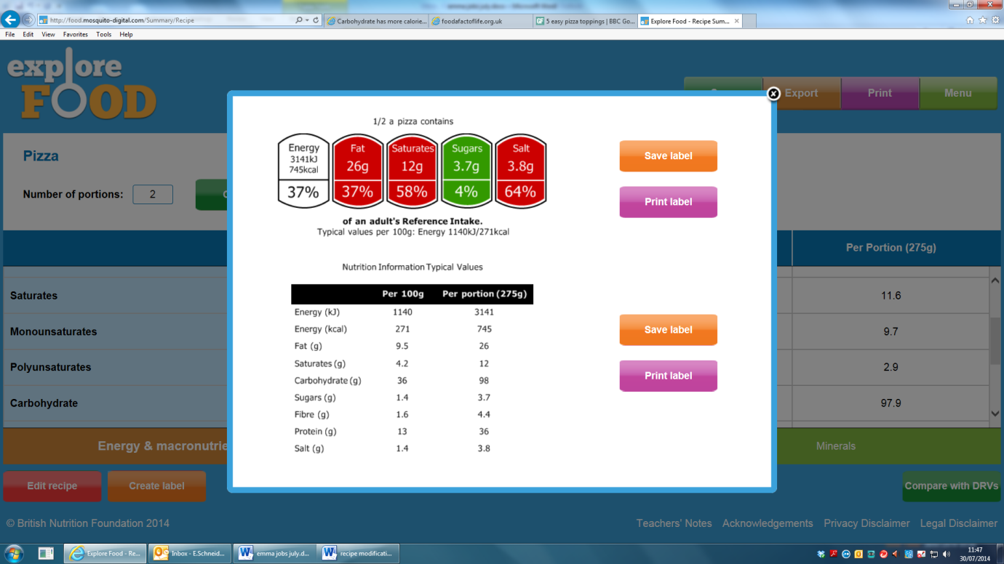
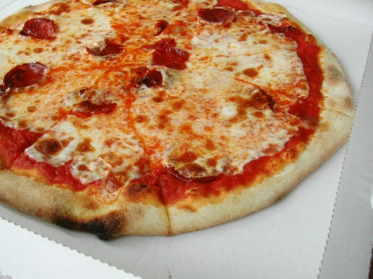

Modify the toppings used on the pizza to reduce the amount of fat, saturated fat and salt provided. Ensure that the values for fat and saturated fat tare either amber or green.

Questions

- What changes would you make to the toppings?
______________________________________________________________________

______________________________________________________________________

______________________________________________________________________

- Why have you made your choice of toppings and what nutrients do you think your change of toppings will affect?
______________________________________________________________________

______________________________________________________________________

______________________________________________________________________

- Enter the revised ingredients list into Explore food. Create a label. How have your modifications impacted on the nutritional values of the product? Explain the health benefits to the consumer of your proposed changes.
are the main contributors to the high salt content

______________________________________________________________________

______________________________________________________________________

______________________________________________________________________

- Apart from the salt used to make the dough, what other ingredients?

______________________________________________________________________

______________________________________________________________________

______________________________________________________________________

2g of salt is used to make the pizza dough base. Salt is needed when making bread dough as it helps to strengthen the gluten and helps the yeast during fermentation and is therefore important for good volume and texture. However, eating too much salt can lead to high blood pressure. Could the recipe for the dough base be modified so less salt is used? Look online or try experimenting with different salt quantities.

