Eastern European cuisines –

a brief overview

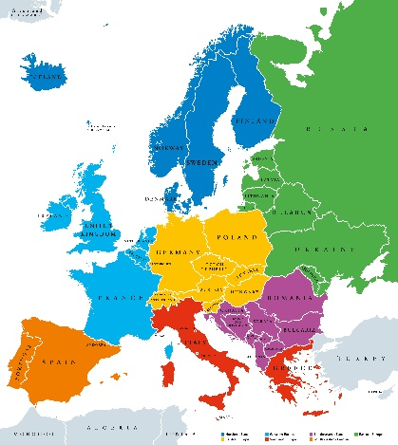
According to the United Nations definition, countries within Eastern Europe are Belarus, Bulgaria, the Czech Republic, Hungary, Moldova, Poland, Romania, Slovakia, Ukraine and the western part of the Russian Federation.

The cuisine of the region is strongly influenced by its climate and natural resources. Eastern Europe is in a region of world that has historically been defined by ever-changing political boundaries, poverty, and harsh weather.

The basics of Eastern European cuisine, however, has stayed pretty much the same. All the counties of Eastern Europe developed their own unique cuisine based on the access to ingredients and growing seasons.

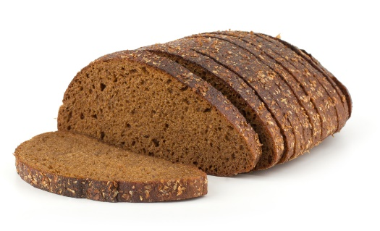
History
The basics of Eastern European food stayed pretty much the same for hundreds of years because they were based on a limited choice of ingredients such as grains like barley, rye, wheat and buckwheat. Rye is still in common use today to make a dark, heavy bread.

Marriages between the nobility centuries ago brought the cuisine and flavours of Italian, French, Turkish, Russian, Jewish and German foods to mix with those of Eastern

Europe. Traditional Eastern European cuisine was therefore significantly influenced by those of almost all other areas of Europe, leading to dishes often involving pancakes, breads, and berries that you might expect to find elsewhere.

Cold and hot soups are also vital dishes, such as Goulash from Hungary, Polish pierogi, and Ukraine’s borscht.

Modern cuisine
Chefs throughout the major cities of Eastern Europe are transforming traditionally heavy dishes including meat and potatoes into lighter dishes, adding a contemporary spin and emphasising local ingredients.

Food and farming
A focus on dairy farming has led to many dishes that include butter, yogurt, sour cream, and cheese. Fertile farmlands produce grains like rye, barley, wheat, buckwheat to make the breads, dumplings, and pastries.

Because the region is surrounded by a vast number of lakes and other bodies of water, fish is frequently used in Eastern European dishes. Because they are inexpensive to raise, chickens are the other main source of protein, especially the meat, eggs (in dumplings and pastries), and bones (for soups).

The climate is good for growing vegetables, such as onions, garlic, turnips, beets, and radishes. These were kept in cold storage or pickled for the long winter. Fruits like cherries, plums, pears, and raspberries are used for desserts. Nuts such as walnuts, almonds, and chestnuts are important ingredients as well. Mushrooms grow in the many forests that are also home to wild game; they are used dishes like hunter's stew and venison goulash.

A characteristic of Eastern European cuisine is the preservation of food. Many ways of preserving food such as drying (mushrooms), pickling (vegetables such as cabbage, beets, cucumbers, lemons), smoking (fish), salting (meat), and alcohol preservation (fruits such as pears and apples) are used.

Ingredients
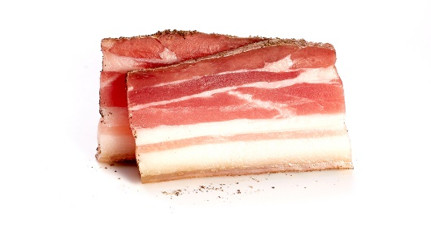
Buckwheat - buckwheat is the most popular cereal in Ukraine, Russia, Belarus, Estonia, Latvia, and Poland. It is used as the main grain ingredient in a soup, a side dish, or the basis for pancakes.

Salo - Salo is historically attributed to Ukraine and looks like a fatty bacon, it is an essential part of the national cuisine. However, it is also popular in Russia and Belarus (salo), Poland (słonina), Romania (slănină), Bulgaria (slaina), and Hungary (asszalonna). It is often served skinless, salted, on a slice of brown bread.

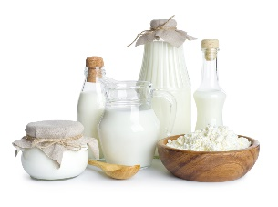
Kefir – Kefir is a cultured, fermented milk drink, originally from the Caucasus Mountain region that divides Asia and Europe. It is similar to yogurt but thinner in consistency. It has a tart, sour taste and a slight ‘fizz’, due to carbon dioxide – the end product of the fermentation process. The length of the fermentation time determines the flavour.

It can be used in the same way as milk/yogurt, as the base for dips/marinades and in baking. Due to its acidity, it can be used instead of buttermilk to make soda bread.

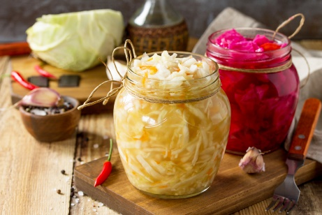
Sauerkraut - A diet staple of Germany and much of central and eastern Europe, sauerkraut is finely sliced cabbage that’s been subjected to lactic-acid fermentation.
Salt is added to prepared cabbage, which draws the liquid from it and encourages the conversion of natural sugars in the cabbage into lactic acid. Together with the salt, this preserves the cabbage.

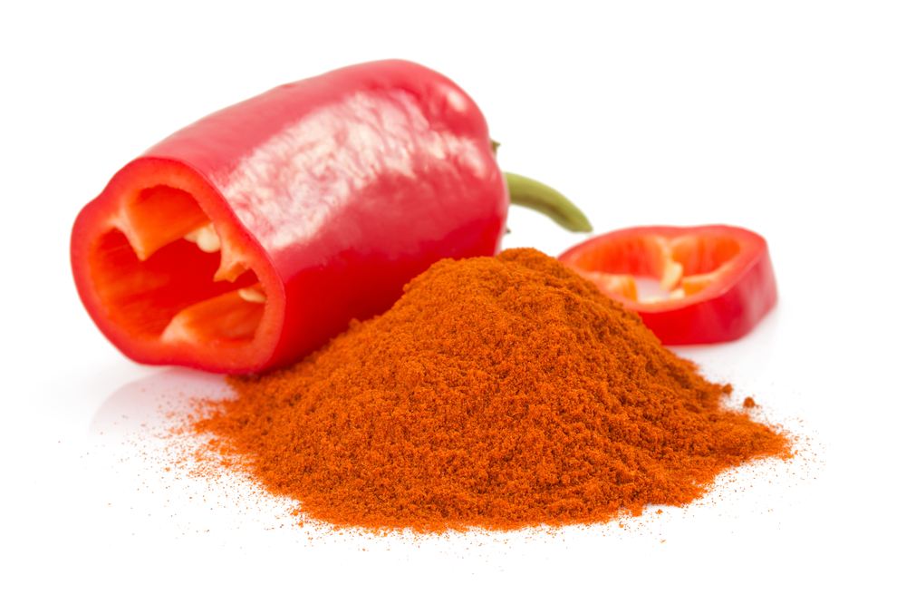
Paprika - Paprika is thought to have been introduced to Hungary by conquering Turks during the 16th century. As with other capsicums, the heat intensity of depends upon growing conditions such as soil and climate. The pepper is dried then ground into a fine, rich red powder. There are varieties including sweet, bittersweet, hot and smoked that range from mild to hot. Hungarian national dishes incorporating paprika include gulyas (goulash), and paprikash (paprika gravy: a recipe combining meat or chicken, broth, paprika, and sour cream).

National dishes
Belarus - the most popular dishes are pork stew (machanka) and vereshchaka, homemade sausages, draniki (thick potato pancakes), kolduny, kletski (dumplings), babka (baked grated potato pie), and cold sorrel soup.  Draniki is regarded as the national dish. It is a type of pancake that is made from potatoes. This breakfast dish has been prepared in Belarus since the 19th century when potatoes were the main agricultural crop. In the past, draniki was prepared using only three ingredients; potatoes, onion and salt but as time passed, more modern recipes have been developed. | 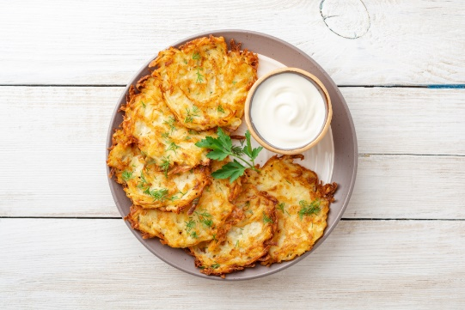
Bulgaria – the national dish is considered to be Shopska Salata or summer salad.  The salad is made of roughly chopped fresh summer tomatoes and cucumbers, plus sweet green peppers and red or green onions with finely grated sirene cheese (a local Bulgarian feta) and some parsley on top.  The salad is the same colours as the Bulgarian flag and is said to have been invented in the 1960s by the socialist party as a tourist promotion to highlight local ingredients. | 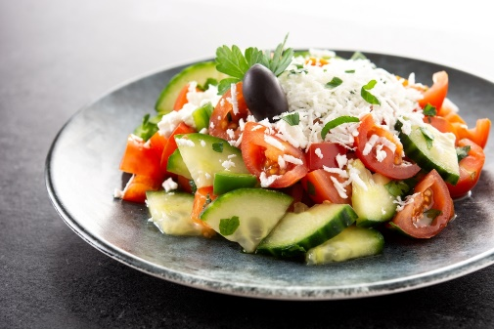
Czech Republic - Vepřo knedlo zelo (pork-dumpling-cabbage) is one of the Czech Republic’s national dishes. Vepřo knedlo zelo is a dish of roast pork and cabbage with hearty dumplings. The meat is roasted and served with an onion and caraway gravy.  Sauerkraut is typically used in the preparation of this meal, but red cabbage can also be used. There are sour and sweet varieties of this dish, and the recipe can include other meats, including beef and chicken. | 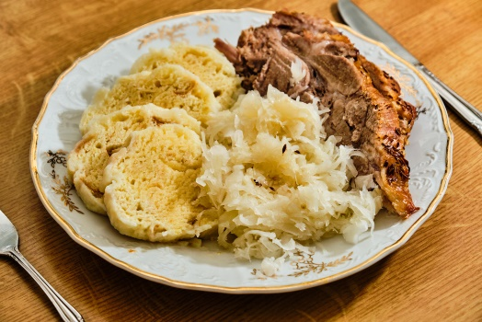
Hungary – the national dish is Goulash. Almost each region has its own variety, but Goulash is a simple soup or stew made from meat (usually beef or pork) and vegetables. The dish is generously seasoned with paprika. Goulash can be dated back to medieval Hungary when shepherds cooked thick stews from dried meats and fresh vegetables. | 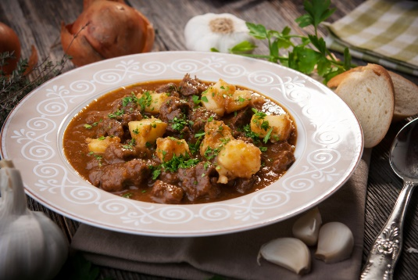
Moldova - the national dish of Moldova is Mamaliga - a porridge made with yellow maize flour. It is made by boiling water, salt and cornmeal in a shallow cast iron pot with a curved bottom. It can be made thicker, where it can be cut into slices like bread, or softer, similar to the consistency of thick oatmeal.  Typically, this dish is served with shaved brinza (salty, homemade cheese) and meat or fish, but sometimes there’s sour cream or garlic on the side, or it’s crushed into a bowl of hot milk. | 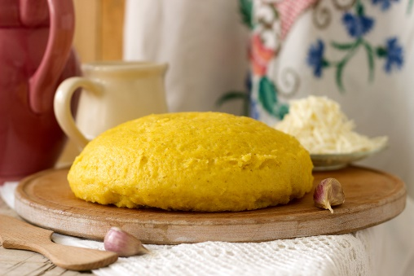
Poland – one of the Polish national dishes is Bigos stew (often called Hunters stew). It can be made with any kind of meat from pork to rabbit or venison, but always includes spicy Polish sausage. There are many recipes but all use sauerkraut and fresh shredded cabbage. The stew is usually seasoned with salt, black peppercorns, allspice, juniper berries and bay leaves. Bigos is often slightly sweetened with sugar, honey, raisins, prunes or plum butter known in Polish as powidła. | 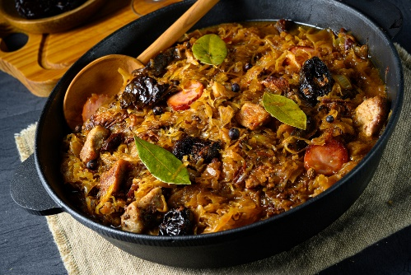
Romania - Sarmale is considered the Romanian national dish. It is made of minced meat (usually pork) mixed with spices, rice, and onions, then rolled up in sour (fermented) cabbage leaves, and boiled in a sauce made of sauerkraut juice, tomato juice, and other flavourings. In some Romanian regions they use vine leaves instead of cabbage. For fasting or for a vegan choice, the minced meat can replaced with a mixture of ground nuts, grated carrots, and chopped mushrooms. | 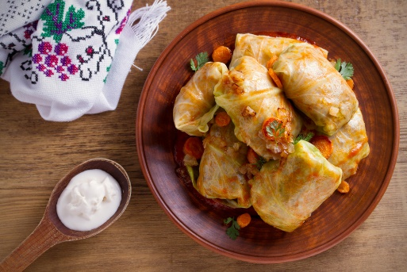
Slovakia - Bryndzové halušky (Dumplings with sheep’s cheese) is Slovakia’s national dish. Bryndzové refers to the creamy, soft, locally produced sheep’s cheese that is unique to Slovakia. The cheese is served on top of halušky, or potato dumplings, which are very similar to Italian gnocchi. Finally, pieces of smoked bacon, sausage and spring onion are often sprinkled on top. | 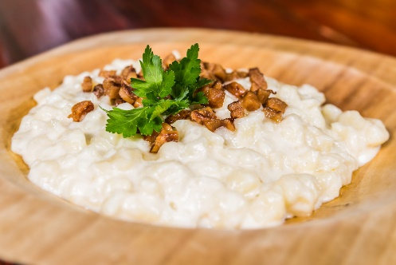
Ukraine - The national dish of Ukraine is Borscht (also spelled Borsch, Borsht or Borshch). This soup is common across eastern Europe but originates from Ukraine. It is a soup made with beetroot, meat or bone stock, and sautéed vegetables. There are many variations - the broth can be made with beef, pork, chicken, or as a vegetarian version.  The essential ingredient in every borscht is beetroot. It gives the dish its distinctive red colour and a characteristic earthy flavour. | 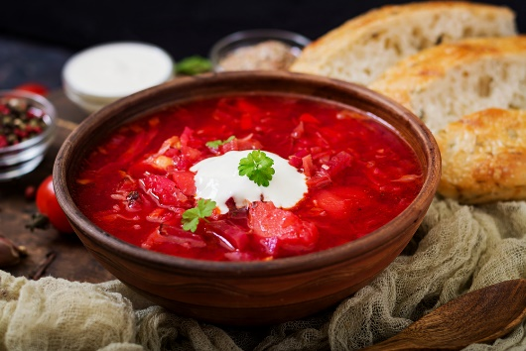

Did you know?
It is traditional in Eastern Europe to take a gift of bread, salt and wine to a new home or to greet guests at one's own door in this manner. It is also traditional for the parents of newly married couples to greet them at their new home with this gift.
Ukrainian bublik

The bread in this symbolic gift signifies the wish that the family should never know hunger. The salt symbolises both the wish that their lives should always have flavour and a reminder that life might be difficult at times, and they must learn to cope with life's struggles. The wine symbolised the parents' hope that the couple would never know thirst and enjoy a life of good health and cheer in the company of many good friends.

