Koftas
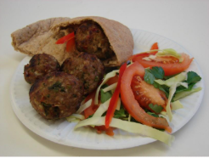

Complexity: medium

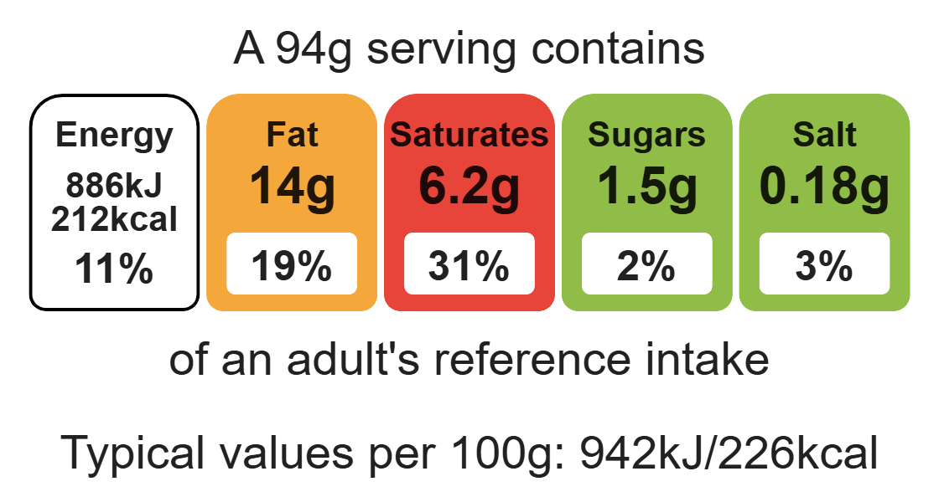

Ingredients (serves 2)
1 onion
1 clove of garlic
½ chilli

Equipment

Weighing scales

Chopping board

Sharp knife

Food processor

Flour dredger (optional)

Skewers

200g lamb mince
1 x 5ml spoon cumin
1 sprig of fresh parsley, mint and coriander

Method
- Prepare the vegetables:
- peel onion and cut in half;
- peel the garlic;
- cut off the top of the chilli and remove the seeds.
- Put the onion, chilli and garlic into the food processor and blitz.
- Add the mince, cumin and herbs to the food processor and blitz.
- Sprinkle a little flour onto a chopping board, then divide and shape the mixture into 8 balls.
- Thread the meat balls onto the skewers. Thoroughly wash and dry your hands after touching the raw meat.
- Carefully place the skewers onto a grill pan.
- Grill for 10-15 minutes, turning occasionally to ensure even cooking. The meatballs should be thoroughly cooked with no pink remaining.
- Serve in a pitta with salad.

Top tips
- Focus on fibre: Serve the koftas with a wholemeal pitta to increase the fibre content.
- Serving suggestion: Serve the koftas with a wholemeal pitta, salad and low fat hummus.
- Vary your protein: Try making these koftas with beef or turkey mince.
- If you don’t have a food processor, prepare the onion, chilli and garlic by hand. Mix everything together in a mixing bowl.

Food skills
Weigh, measure, cut, chop, slice, dice, mix, stir and combine, grill.

