Victoria sponge cake

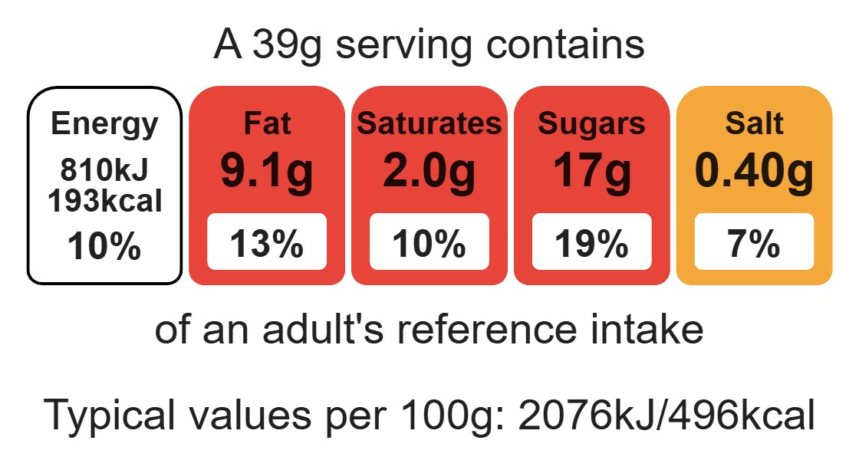
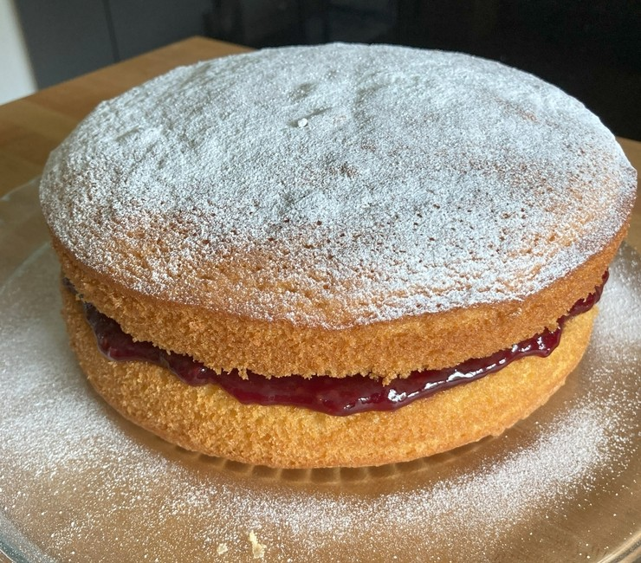

Ingredients (serves 12)
150g caster sugar
150g reduced-fat spread
150g self-raising flour
3 eggs
1 x 5ml spoon baking powder
3 x 15ml spoon jam
vegetable oil for greasing tins

Equipment

2 sandwich cake tins

Weighing scales

Pastry brush

Large mixing bowl

Electric hand whisk

Sieve

Metal spoon

Spatula

Palette knife

Cooling rack

Measuring spoons

Complexity: low - medium

Method
- Preheat the oven to 180ºC, gas mark 4.
- Grease and line 2 sandwich cake tins.
- Cream the sugar and spread together using an electric hand whisk until light and fluffy.
- Crack the eggs into a small bowl and beat with a fork.
- Gradually add the beaten egg to the spread and sugar.
- Sift the flour and baking powder into bowl or onto a plate or piece of greaseproof paper.
- Fold the flour and baking powder into the mixture, a spoon full at a time.
- Divide the mixture equally between the cake tins.
- Place in the oven and bake for 15 – 20 minutes, until golden brown and springy to the touch.
- Remove from the tins immediately and allow and place on a cooling rack.
- Once completely cooled, spread the jam over the base of one cake.
- Place the other sponge on top and dust with icing sugar to serve.

Top tips
- When lining a sandwich cake tin it is only necessary to line the bottom of the tin. The sides can be greased with oil and a pastry brush.
- Turn up the flavour: Try using lemon curd, or fresh raspberries as an alternative filling for the cake.
- Focus on fibre: Replace half the flour with wholemeal flour to boost the fibre content of this dish.

Food skills
Weigh, measure, cream, beat, fold, portion or divide, bake, spread.

