Testing food for vitamin C

Introduction
This is a simple test which shows whether food contains vitamin C. If vitamin C is present in the food the DCPIP changes colour.

This test does not tell you how much vitamin C is present.

You will need
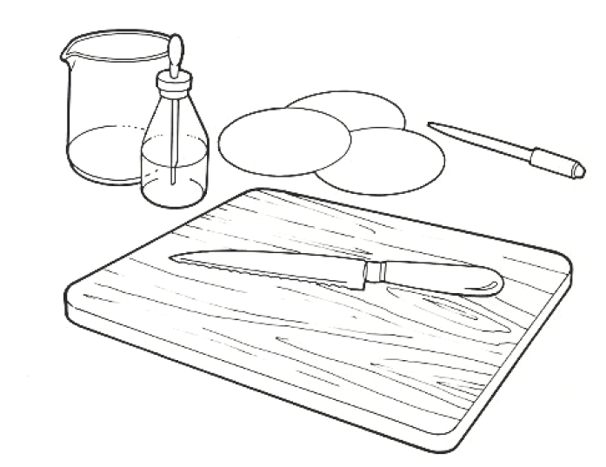
Equipment
Dropping pipette
Sharp knife
Chopping board
Beaker

Materials
Samples of fruit and vegetables
DCPIP Papers
1% vitamin C solution




Some people are allergic or intolerant to a particular food or ingredient. Refer to the 14 allergens and check against student records before completing this experiment.

Care should be taken when using sharp knives.
Do not consume food in a laboratory, or any food used for experiments, because it may contaminated.

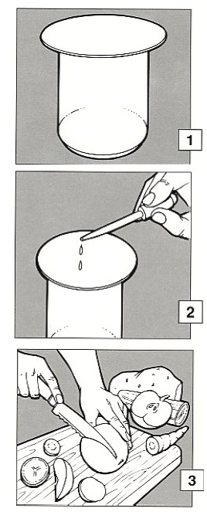
Method

- Put a DCPIP paper into a small beaker.

- Put a few drops of vitamin C solution on to the DCPIP paper and observe the colour change.

This colour change will show you that vitamin C is present.

- Cut a slice from each of the fruits and vegetables provided.

- Press each slice of fruit or vegetable into a separate DCPIP paper, or a clean part of paper, for a few seconds.

- Remove the fruit or vegetable and observe and record any changes in colour in the papers.

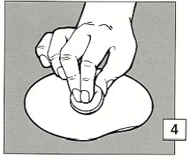

Extension work
Repeat this test using samples of other foods such as a range of fruit juices and drinks; fresh, frozen and canned peas.

Another way of carrying out this test is to use commercially produced test strips. These will give you an indication of how much vitamin C is present.

