Vegetable tagine with couscous

Ingredients
Complexity: medium-high

1 onion

1 carrot

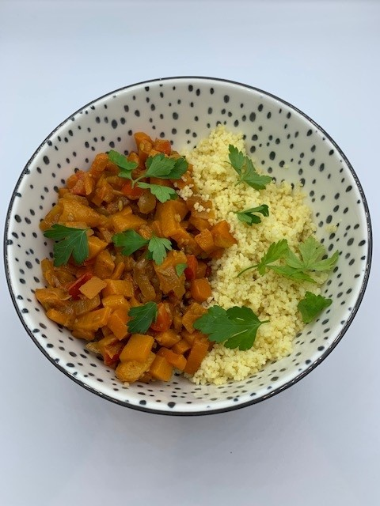
2 garlic cloves

½ red pepper

1 sweet potato

1 reduced salt vegetable stock cube

50g ready to eat dried apricots

1 tomato

1 x 15ml spoon oil

1 x 5ml spoon paprika
1 x 5ml spoon fennel seeds
1 x 5ml spoon coriander seeds
Fresh black pepper – seasoning
100g couscous
100ml boiling water

Optional
25g fresh coriander - garnish

Equipment

Chopping board, vegetable knife, measuring jug, measuring spoons, large frying/sauté pan, mixing spoon, heatproof bowl, fork.

Method
- Prepare the ingredients:
- peel and chop the onion;
- peel and dice the carrot;
- peel and finely chop the garlic;
- deseed and dice the pepper;
- peel and evenly chop the sweet potato;
- cut the dried apricots into quarters;
- cut the tomato into quarters;
- roughly chop the coriander (if using).
- Heat the oil in a large frying pan over a medium heat. Add the onion, carrot and garlic and fry for 5 minutes until softened.
- Add the paprika, fennel and coriander seeds, red pepper and sweet potato.
- Stir, and cook for 2 minutes over a high heat.
- Make 500ml of vegetable stock.
- Stir in 300ml of the stock, add the apricots and tomato and mix. Add black pepper to season. Simmer for 15 mins, or until the sweet potato is tender and cooked, adding more stock if necessary.
- Place the couscous in a heatproof bowl and pour over 100ml boiling water.
- Cover and leave to absorb the water for around 10 minutes. Fluff with a fork to separate the grains.
- Serve the tagine with the couscous, garnishing with fresh coriander (if using).

Top tips
- Serve the tagine with quinoa as an alternative to couscous. Garnish with chopped coriander and mint and add some pomegranate seeds for colour and texture.
- Try and use seasonal vegetables such as courgettes, parsnips or pumpkin cut into chunks as alternatives. How many of your 5 A Day can you include?

Food skills
- Weigh and measure
- Peel
- Chop
- Dice
- Mix and stir
- Fry/sauté
- Simmer

Did you know?
The tagine is often linked to Harun al Rashid, a ruler of the Islamic empire in the late 8th century. In the 9th century, historians found a collection of stories in which the tagine was described. Some food historians believe that the tagine goes even further back to the Roman Empire who used portable ovens like the shape of the tagine.

The tagine was used by nomads in North Africa who made food over a fire. Because of the tenderisation in the tagine, they could use lower quality and tougher meat to produce a succulent stew. Although the dish has Berber origins, there are influences of in the ingredients and spices from the cuisines of Arab and Ottoman invaders, Moorish refugees from Spain, and French colonialists.

This recipe was kindly donated by Co-op Group Limited.

