Meat free West African Jollof rice

Ingredients
Complexity: medium
1 small onion
Spray oil
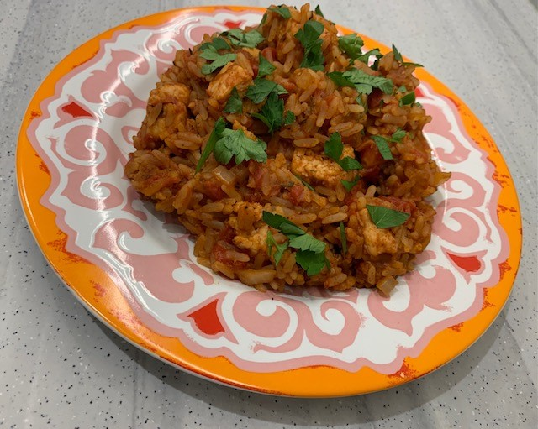
½ x 5ml spoon ground ginger
½ x 5ml spoon cinnamon
½ x 5ml dried thyme
¼ x 5ml cayenne pepper
Black pepper
150g easy cook white rice
1 x 400g can chopped tomatoes
1 x reduced salt vegetable stock cube
200ml boiling water
140g meat free ‘chicken style’ pieces
1 bay leaf (optional)

Optional
1 x 15ml spoon parsley – garnish

Equipment

Chopping board, vegetable knife, large (lidded) saucepan, mixing spoon, measuring spoons, can opener, measuring jug.

Method
- Prepare the ingredients:
- peel and chop the onion;
- chop the parsley (if using).
- Add the spray oil to a large saucepan and gently fry the onions for 3-4 minutes until the onions are soft.
- Add the ground ginger, cinnamon, thyme and cayenne pepper to the pan. Season with black pepper. Stir well and cook for 1 minute.
- Add the rice and stir.
- Add the canned tomatoes.
- Crumble in the stock cube and add 200ml boiling water. Stir well.
- Add the meat free ‘chicken style’ pieces.
- Add the bay leaf, if using.
- Bring to the boil and then reduce to a simmer.
- Cook for 15 minutes until the rice is tender. Add more boiling water if need be.
- Remove the bay leaf.
- Garnish with chopped parsley, if using, and serve.

Top tips
- Use ground chilli as an alternative to cayenne pepper.
- Use brown rice for added fibre – cook for 20-25 minutes.
- Add vegetables to the rice mixture such as diced peppers or sliced okra.
- Try using chopped fresh tomatoes when they are in season.

Food skills
- Weigh
- Measure
- Peel
- Chop
- Fry/sauté
- Mix/stir
- Boil
- Simmer

Did you know?
Jollof rice is a tomato and rice-based dish that is widely eaten across West and Central Africa. There are varying methods of making Jollof rice across the countries where it is eaten. Jollof rice can be made with beef, chicken or fish, or vegetables and pulses.

The origins of Jollof rice can be traced to the 1300s in the ancient Wolof Empire (also called the Jolof Empire), which cover parts of today's Senegal, The Gambia and Mauritania. Rice farming was common in this region, and Jollof started as a dish called thieboudienne, made with rice, fish, shellfish and vegetables. The Wolof people dispersed across the region and settled in different parts of West/Central Africa, taking their rice dish with them.

