Scone-based pizza

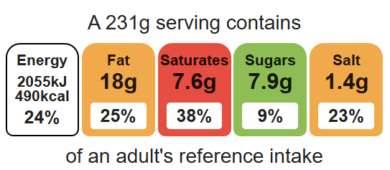
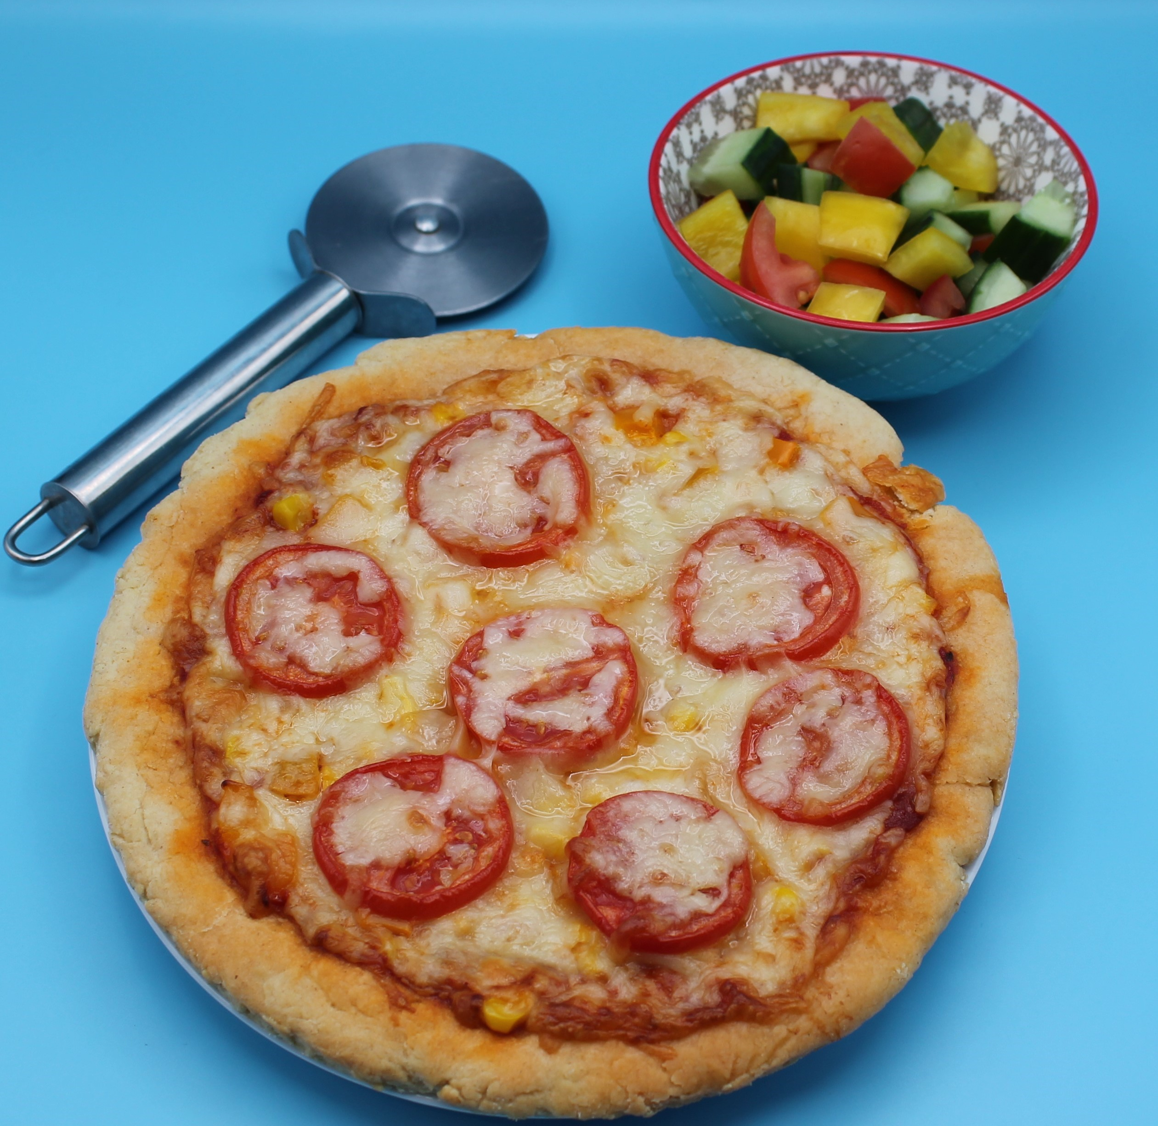
Complexity: medium

Ingredients (serves 2)

50g reduced-fat cheese, e.g. mozzarella or cheddar

Equipment

Baking tray

Weighing scales

Chopping board

Grater

Sharp knife

Sieve

Mixing bowl

Measuring jug

Palette knife

Flour dredger

Metal spoon

Measuring spoons

Rolling pin (optional)

2 mushrooms

1 tomato

½ pepper

75g self-raising white flour

75g self-raising wholemeal flour

25g baking fat/block

100ml semi-skimmed milk

2 x 15ml spoons of passata or tomato purée

25g sweetcorn

½ x 5ml spoon mixed herbs

Method
1. Preheat oven to 200°C or gas mark 6.
2. Line a baking tray.
3. Prepare the pizza toppings;
- grate the cheese;
- slice the mushrooms;
- slice the tomato;
- deseed and dice the pepper.
4. Sieve the flour into the bowl.
5. Using your fingertips, rub-in the fat into the flour until it resembles breadcrumbs.
6. Make a well in the centre of the mixture. Gradually add the milk to the flour and mix to form a soft dough.
7. Transfer the dough onto a floured surface. Knead lightly and roll into a circular shape, approximately1.5cm deep.
8. Place the dough onto the baking tray.
9. Spread the passata sauce or tomato purée over the dough using the back of a spoon.
10. Arrange the mushrooms, tomato, pepper and sweetcorn over the base.
11. Sprinkle the cheese and herbs over the top of the pizza.
12. Place the pizza in the oven and bake for 10 – 15 minutes, until golden brown.

Top tips
- Reduce food waste: Add leftover vegetables to your pizza.
- Focus on fibre: Replace the white flour with 75g wholemeal flour for an extra fibre boost.
- Turn up the flavour: Experiment with different toppings such as tuna, onion, pineapple or different types of cheese.

Food skills
Weigh, measure, grate, cut, chop, slice, dice and trim, sift, rub-in, mix, stir, combine, knead, form and shape, bake.

