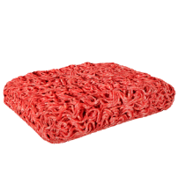
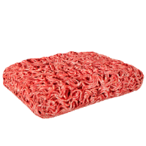
Lean beef mince
Beef mince
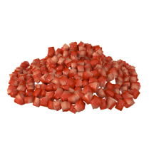

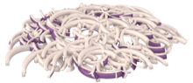
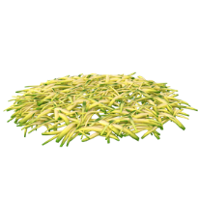
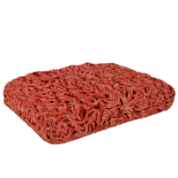
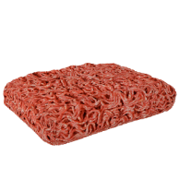
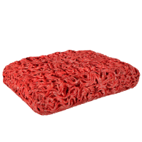
89kJ/21kcal
Per 100g
150kJ/35kcal
Per 100g
74kJ/18kcal
Per 100g
526kJ/125kcal
Per 100g
934kJ/223kcal
Per 100g
Chopped red pepper
Chopped courgette
Chopped onion
Lean lamb mince
688kJ/165kcal
Per 100g
688kJ/165kcal
Per 100g
Lamb mince
Extra lean beef mince
711kJ/170kcal
Per 100g
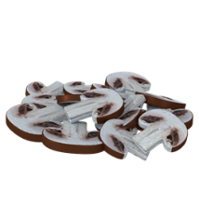
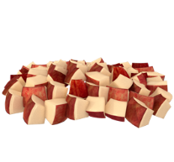
Diced fresh apple
Chopped mushroom

Chopped celery
674kJ/158kcal
Per 100g
Canned pineapple chunks
1092kJ/261kcal
Per 100g
Mixed dried herbs
266kJ/68kcal
Per 100g
Frozen peas
Chopped dried apricot

29kJ/7kcal
Per 100g
215kJ/51kcal
Per 100g

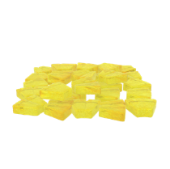

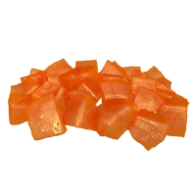

200kJ/47kcal
Per 100g

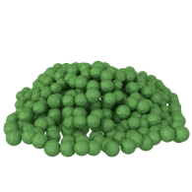
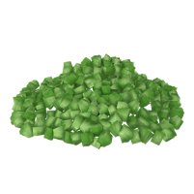

30kJ/7kcal
Per 100g

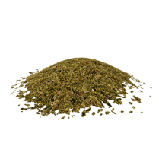
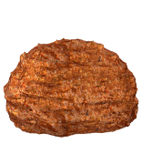
Medium curry paste

1154kJ/279kcal
Per 100g
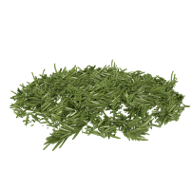
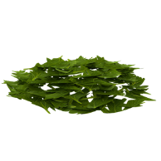
Chopped fresh rosemary
Chopped fresh parsley

738kJ/177kcal
Per 100g
141kJ/34kcal
Per 100g

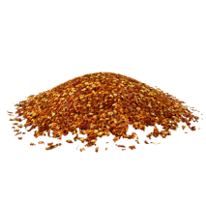
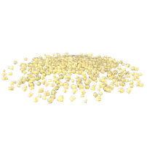
Chopped fresh garlic
Crushed chilli flakes

No nutrition composition data available
411kJ/98kcal
Per 100g

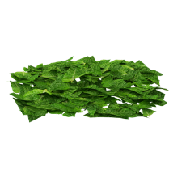
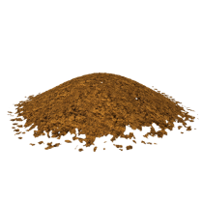
Chinese 5 spice
Chopped fresh mint

No nutrition composition data available
181kJ/43kcal
Per 100g

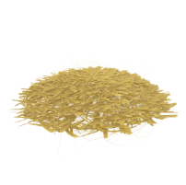
Grated root ginger
188kJ/44kcal
Per 100g
Grated hard cheese e.g. Cheddar

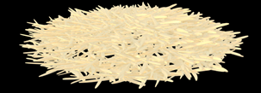

1725kJ/416kcal
Per 100g
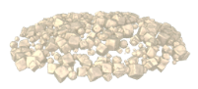
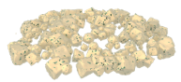
Crumbled white cheese e.g. Feta
Crumbled blue cheese e.g. Stilton

1037kJ/250kcal
Per 100g
1698kJ/410kcal
Per 100g

Diced semi-soft cheese e.g. Mozzarella
Sliced goat’s cheese

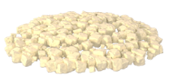

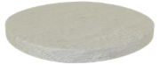

1329kJ/320kcal
Per 100g
1067kJ/257kcal
Per 100g

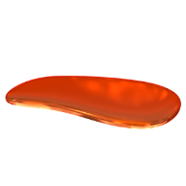
Tomato purée
Hot sauce


314kJ/75kcal
Per 100g
287kJ/67kcal
Per 100g

Pesto
Marmalade



1114kJ/261kcal
Per 100g
1703kJ/420kcal
Per 100g
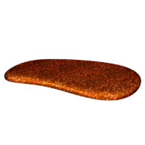

Hot pepper sauce
Fish sauce
Worcestershire sauce
480kJ/113kcal
Per 100g
BBQ sauce
598kJ/140kcal
Per 100g
Bun base
Wholemeal bun
White bun
Chutney
476kJ/111kcal
Per 100g

67kJ/16kcal
Per 100g

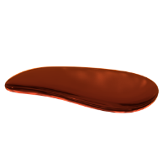


242kJ/57kcal
Per 100g



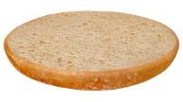

1078kJ/254kcal
Per 100g

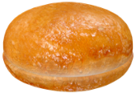
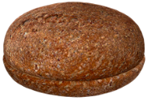

1078kJ/254kcal
Per 100g
1037kJ/244kcal
Per 100g
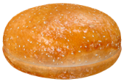
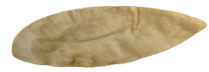
Seeded sesame bun
Gluten free roll
1206kJ/285kcal
Per 100g
Wrap
Bagel
Mini naan
Baguette
Brioche bun
1084kJ/255kcal
Per 100g
Pitta bread

1086kJ/257kcal
Per 100g

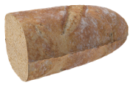
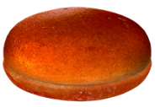

1121kJ/263kcal
Per 100g
1352kJ/322kcal
Per 100g


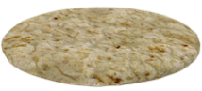

1206kJ/285kcal
Per 100g
1161kJ/273kcal
Per 100g

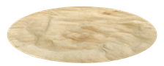
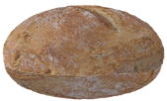

1223kJ/292kcal
Per 100g
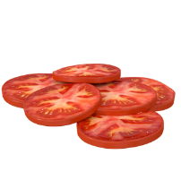
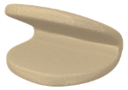
Sliced tomato
Mixed lettuce
Sliced celery
Sliced Gherkin
Sliced peppers
Sliced cucumbers
Sliced beetroot
Steamed bao bun

61kJ/14kcal
Per 100g
1657kJ/396kcal
Per 100g

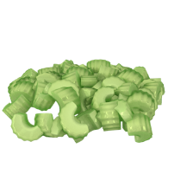

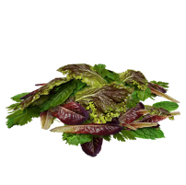

30kJ/7kcal
Per 100g
48kJ/11kcal
Per 100g

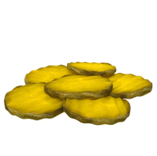
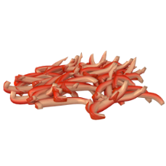

61kJ/14kcal
Per 100g
89kJ/21kcal
Per 100g

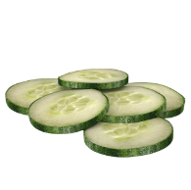
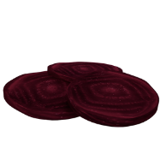

117kJ/28kcal Per 100g
60kJ/14kcal
Per 100g
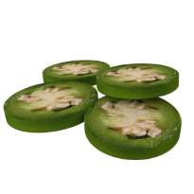
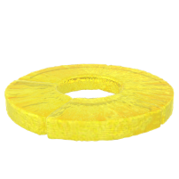
Sliced jalapeno peppers
83kJ/20kcal
Per 100g
Grilled bacon (lean)
1194kJ/287kcal
Per 100g
Sliced avocado
784kJ/190kcal Per 100g
Sliced reduced fat cheese e.g. Cheddar
1305kJ/314kcal
Per 100g
Sliced hard cheese e.g. Cheddar
1725kJ/416kcal
Per 100g
1067kJ/257kcal
Per 100g
Crumbled hard blue cheese e.g. Stilton
1698kJ/410kcal
Per 100g
Pineapple ring
200kJ/47kcal Per 100g

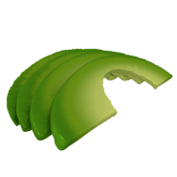

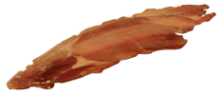

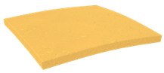
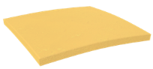

Sliced semi-soft cheese e.g. Mozzarella

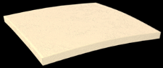
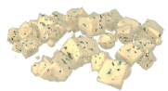
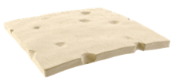

Sliced white cheese e.g. Feta
1037kJ/250kcal
Per 100g
Mayonnaise
Tomato ketchup
Horseradish
Mustard
Sweetcorn relish
Sliced onion
Cheese slice (processed)

1234kJ/297kcal
Per 100g

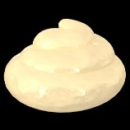


489kJ/115kcal
Per 100g
489kJ/115kcal
Per 100g

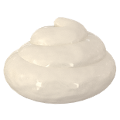


640kJ/153kcal
Per 100g
579kJ/139kcal
Per 100g

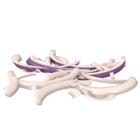
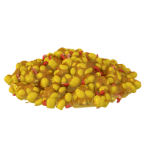

150kJ/35kcal
Per 100g
614kJ/144kcal
Per 100g
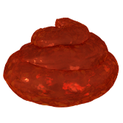
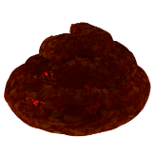
Chutney
Sweet chilli sauce
BBQ sauce
Mild salsa

485kJ/114kcal
Per 100g
476kJ/111kcal
Per 100g

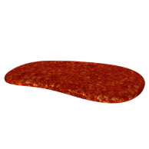


975kJ/230kcal
Per 100g
598kJ/140kcal
Per 100g

