Session 11: Back to basics

Welcome
This session welcomes students back to the cooking area after their second module, i.e. sessions 6 - 10. By now, students should be becoming more confident and competent cooks. They should know the cooking area well, use equipment safely and wisely, and be able to prepare a range of ingredients and dishes independently. This session is about learning how to make a classic tomato ragu (sauce), which can then be used in many different ways in the future. It revises how to chop an onion. It also provides you with the opportunity to assess students' practical capability. You could use the practical observation sheet to help.

During this session, students will make either a classic tomato ragu or ratatouille. These have been chosen as they demonstrate how a simple tomato based sauce can form the basis of many dishes and meals, as well as being another opportunity to practice essential knife skills.

There is lots of room for students to be creative, selecting different ingredients that could be combined into the dishes. You could get your students to use the classic tomato ragu or ratatouille recipe writing frames before cooking to develop their own ideas. The students' own recipe creations could then be used in this session.

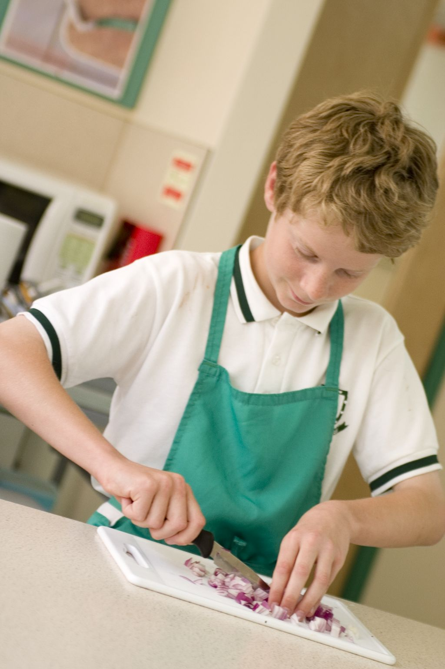
If you have an established lesson plan and/or recipe, which supports the aims and objectives of this session, feel free to use it instead. Look at the support materials provided within this session as they support this activity and may well be useful in your own lessons, e.g. worksheets, PowerPoint presentations.

This session can act as a stand-alone lesson, focusing on ragu sauce preparation and the safe use of the hob. Alternatively, it could be integrated into a series of lessons, e.g. exploring different ways in which a ragu sauce can be used in a variety of dishes.

Aims and objectives

Aim
For students to:
- make a basic tomato ragu sauce and discover how it can form the basis of many of dishes and meals.

Objectives
Students should be able to:
- prepare an onion;
- simmer a sauce;
- use the hob safely;
- make a tomato based dish, e.g. a classic tomato ragu or ratatouille.

Cooking session
Two cooking session plans, based on the Licence to Cook recipes are supplied within this session.

If you have your own tried and tested classic tomato ragu or ratatouille recipe, feel free to use it instead. In addition, you may wish to make other types of sauces, such as Arrabbiata, Puttanesca or a tuna and pepper sauce. You may wish to use the basic ragu sauce in a quick recipe, such as spinach and ricotta cannelloni.
Each plan refers to aspects of healthy eating, wise food shopping and food safety and hygiene which are themes which run through each session. Suggestions can be found on page 9.

Before the cooking session
There are a number of factors that you need to consider before the cooking session. More detailed guidance is available in the Cooking session guide.

You will need to consider:
- Ingredients: who will be providing the ingredients and where will they be stored? The recipes call for a little oil for frying. It may be easier for the school to provide the oil for students to share.
- Recipe: are pupils going to use a printed-out copy or follow instructions on an interactive whiteboard?
- Equipment: is all the equipment needed for the session available, clean and in good working order? Check that all the hobs are in good working order and clean. Students will require the use of a saucepan - check that there are enough. For the ragu, students may also require an additional saucepan for cooking pasta and a colander for draining.
- Aprons: do you have enough and are they clean?
- Hair: do you have ties/bands for long hair?
- Containers: will students be able to take away the ragu/ratatouille they make? If so, in what?
- Waste: do you have adequate disposal facilities, including recycling or composting?
- Cooking area: is it clean and ready to use?
Differentiation and inclusion
Before this practical session, you will need to consider the age, ability and any special requirements of your students. This will determine recipe selection, any advanced ingredient preparation and equipment used.

Do any of your students need:
- help preparing the onion? This could be chopped in a food processor.
- ready prepared ingredients, so that time can be spent on making the ragu, e.g. cooked pasta?
- to follow different recipes? The classic tomato ragu recipe is easier than the ratatouille.
- challenging, perhaps allowing them to cook and drain pasta too?
- extension activities, such as developing the ragu into a main meal dish, e.g. spaghetti Bolognese?

Demonstration
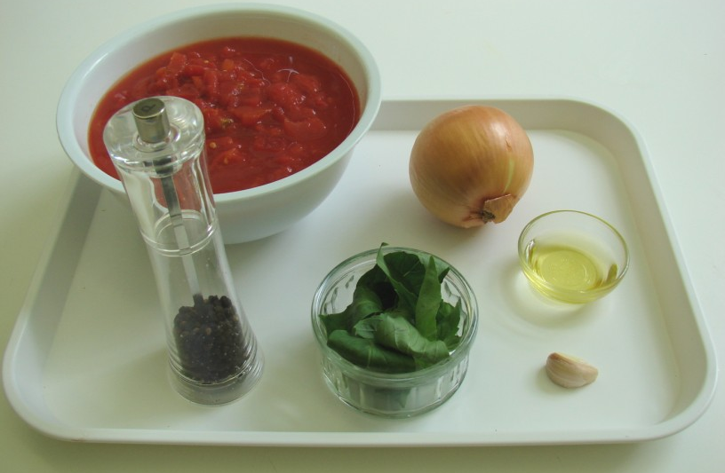
During the session you will be running through the basic recipe - you may wish to demonstrate the onion preparation and garlic crushing to reinforce previous learning.

Ensure that you have all the ingredients and equipment you need before the session, perhaps on trays for ease, for your demonstration.

Think about:
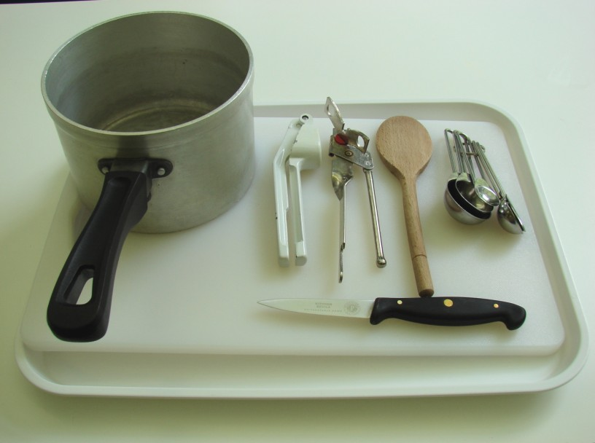
- describing the ingredients and equipment used;
- highlighting how a basic tomato ragu sauce can be used in lots of different recipes;
- showing how to simmer;
- ensuring that students have followed and understood the method.

More detailed guidance is available in the Demonstrating guide.

Risk assessment

The two cooking session plans and recipes highlight a number of different hygiene and safety issues which need to be considered before, during and after the cooking session.

Before the cooking session, you will need to assess these risks in relation to the number of students being taught, as well as their experience, and consider measures that can be put into place to manage the risk. Below are examples of potential risks, along with preventative measures.

Classic tomato ragu
Potential risk | Measure | Likelihood
Cuts from using a knife unsafely | Demonstrate safe use of knives and monitor students’ use | Low
Cuts due to running in room with knife | Remind students of rules in kitchen and instil safe conduct | Low/Med

Ratatouille
Potential risk | Measure | Likelihood
Dirt or food poisoning bacteria present on raw food, causing cross contamination | Wash vegetables | Low

Time
The session plans are based on a 60 minute session.

If you have less time available, you will need to modify the session plan to better suit your circumstances. For example, within this session you might:
- demonstrate the safe use of the hob at another time;
- demonstrate key aspects from the recipe, rather than every stage;
- have ingredients pre-measured and/or prepared;
- use pre-prepared garlic, e.g. in a tube, jar or frozen;
- allow students to work with a partner.

During the lesson
Time (mins) | Activity: Classic tomato ragu | Equipment/ Resources
0 | Registration  Explain to the students that they will be making a classic tomato ragu.  Go through the aims and objectives for the lesson. | PowerPoint  Classic tomato ragu recipe
5 | Gather the students around a demonstration area, with your tray of ingredients and equipment. Ensure that all students have their apron on, hair tied back, and hands washed.  Briefly talk through the recipe - note your expectations, for example:  * dicing the onion finely;  * frying the onion and garlic gently;  * simmering the ragu and adjusting seasoning to develop its flavour;  * using the hob safely;  * being hygienic and safe when preparing food. | Aprons  Demonstration ingredient and equipment tray
 | Demonstration  * Place out the chopping board and vegetable knife. Have a small bowl or plate handy for peelings and other waste.  * Explain that you will be showing how to prepare an onion safely. Use the Claw grip to cut away one end of the onion (not the root). Then use the Bridge hold to cut the onion in half. Peel away the outer skin. Next, cut length ways into the onion – but do not cut through the root. The root will keep the onion together. Next, use the Claw grip to slice across the onion.  * Remind students how to switch on the hob. If you have electric and gas hobs, you may need to show them both types.  * Go through the ingredients to check that all students remember how to prepare each item. You may need to recap crushing garlic.  * Explain to the students that the onion and garlic are fried in the oil – this helps to develop flavour, as well as making the onions soft. If time, you can show students this stage.  * Lastly, tomatoes and basil are added. The tomato sauce is then brought to the boil (rapid bubbling) and then to a simmer (gently bubbling). Talk about how this sauce is the basis of many other dishes, such as a Bolognese sauce, vegetable sauce or ratatouille.  * Remind students about using the hob safely and turning the saucepan handles away from the front edge. | Aprons  Demonstration ingredient and equipment tray

15 | Ensure that all students wash their hands. Allow them to start making their classic tomato ragu. During this time, circulate the room to ensure that students are preparing ingredients and using the hob safely.  In this time, students should:  * prepare the onion and garlic;  * fry the onion and garlic gently;  * tear the basil into the sauce;  * simmer the sauce gently;  * use the hob safely. | Basic equipment  Ingredients  Saucepans
30 | All ragu sauces should be on the hob simmering - they take at least 20 minutes.  During the remaining time students should be washing up, cleaning work surfaces and putting away equipment.
40 | Most students should finish their ragu.
50 | Give a 5 minute time warning.  Remind students that all washing-up should be completed, work surfaces should be clean and their tomato ragu sauce should be placed in a container. Circulate the room, ensuring that sinks are clean, and equipment is put away properly.
55 | Plenary  Pose the following questions to the students:  * What were the main skills demonstrated today?  * Name 5 other ingredients that could be added to this sauce.  * How could this sauce be used in other dishes?
60 | Finish

After the session
Check that the room is clean and tidy. Students should leave the room as they find it.

The classic tomato ragu may need to be refrigerated until the end of the school day, if so, ensure that each container is covered and clearly labelled with the student’s name and group. The refrigerator should be between 0-5ºC.

Students may wish to reheat the sauce at home. To microwave, place the sauce in a suitable container and cover loosely. Cook for full power for 3 minutes. Alternatively, place the sauce in a saucepan and reheat until bubbling.

If the same students are with you for another cooking session in the next few days or week, remind them of the ingredients and/or containers they need to bring, if appropriate. You may wish to provide students with recipes or writing frames.

During the lesson
Time (mins) | Activity: ratatouille | Equipment/ Resources
0 | Registration.  Explain to the students that they will be making ratatouille. Go through the aims and objectives for the lesson. | PowerPoint Ratatouille Recipe
5 | Gather the students around a demonstration area, with your tray of ingredients and equipment. Ensure that all students have their apron on, hair tied back and hands washed.  Briefly talk through the recipe - note your expectations, for example:  * preparing the onion carefully;  * frying the onion and garlic gently;  * using the Bridge-hold and Claw-grip knife techniques to prepare the vegetables;  * using the hob safely;  * being hygienic and safe when preparing food. | Aprons  Demonstration ingredient and equipment tray
Demonstration
* Place out the chopping board, vegetable knife and vegetable peeler. Have a small bowl or plate handy for peelings and other waste.
* Demonstrate how to dice the aubergine. Use the Claw grip to cut the aubergine into thick slices (1-1.5cm) – remove the ends. Take one slice and cut into thick strips – keeping the strips together. Rotate the aubergine slice by 45º and cut across the strips making cubes (dice).
* If needed, remind students how to prepare an onion. Use the Claw grip to cut away one end of the onion (not the root). Then use the Bridge hold to cut the onion in half. Peel away the outer skin. Next, cut length ways into the onion – but do not cut through the root. The root will keep the onion together. Next, use the Claw grip to slice across the onion.
* Go through the ingredients to check that all students remember how to prepare each item. You may need to recap crushing garlic or preparing the green pepper and courgette.
* Remind students how to switch on the hob. If you have electric and gas hobs, you may need to show them both types.
* Explain to the students that the onion and garlic are fried in the oil – this helps to develop flavour, as well as making the onions soft. If time, you can show students this stage.

* Next, the pepper, courgette and tomatoes are added. The ratatouille is then brought to the boil (rapid bubbling) and then to a simmer (gently bubbling). Talk about how this sauce can be adapted for many other dishes, such as a sauce over fish or different vegetables, herbs and spices could be added.
* Remind students about using the hob safely and turning the saucepan handles away from the front edge.
15 | Ensure that students all wash their hands. Allow them to start making their ratatouille. During this time, circulate the room to ensure that students are preparing ingredients and using the oven safely.  In this time, students should:  * prepare the onion and garlic;  * prepare the aubergine, green pepper and courgette;  * fry the onion and garlic gently;  * tear the basil into the dish;  * simmer the dish gently;  * use the hob safely. | Basic equipment  Ingredients  Saucepans
35 | All ratatouilles should be on the hob cooking - they take at least 20 minutes.  During the remaining time students should be washing up, cleaning work surfaces and putting away equipment.
50 | Give a 5 minute time warning.  Remind students that all washing-up should be completed, work surfaces should be clean, and their ratatouille should be placed in a container. Circulate the room, ensuring that sinks are clean, and equipment is put away properly.
55 | Plenary  Pose the following questions to the students:  * What were the main skills demonstrated today?  * Name 5 other ingredients that could be added to this dish.  * What could you serve this dish with?
60 | Finish

After the session
Check that the room is clean and tidy. Students should leave the room as they find it.

The ratatouilles may need to be refrigerated until the end of the school day, if so, ensure that each container is loosely covered and clearly labelled with the student’s name and group. The refrigerator should be between 0-5ºC.

Students may wish to reheat the ratatouille at home. To microwave, place the sauce in a suitable container and cover loosely. Cook for full power for 3-4 minutes. Alternatively, place the ratatouille in a saucepan and reheat until bubbling/piping hot.

If the same students are with you for another cooking session in the next few days or week, remind them of the ingredients and/or containers they need to bring, if appropriate. You may wish to provide students with recipes or writing frames.

Areas of learning

Healthy eating
- Sauces are good ways of adding extra vegetables to the diet.

Wise food shopping
- Use the ragu or ratatouille as a sauce for other meals.
- Go for economy brands of canned tomatoes for sauces.
- Make double the amount and the sauce or ratatouille for another time.

Food safety and hygiene
- When getting ready to cook, always wear an apron, tie back long hair, roll up long sleeves, remove any jewellery and wash your hands.
- Ensure that all vegetables are washed before use.
- Do not buy or use dented cans.

Extending this activity
This session provides a great opportunity to be integrated into existing lessons or be developed into a mini-scheme of work.

For example, students could:
- explore different ways in which a ragu sauce can be used in a variety of dishes;
- plan and create different types of tomato based sauces, perhaps based on providing cheap main meals for a family of four;
- evaluate different types of ingredients that could be added to sauces via a taste test.

Appropriate aspects of ICT could also be integrated, including:
- recording the cost of the ingredients and comparing it to the cost of shop bought sauces/dishes;
- creating a recipe plan or flow-chart;
- modelling nutrition profiles of different sauces;
- exploring the internet for different uses of a basic tomato sauce.

Shopping list

Classic tomato ragu
Ingredient | X1 | X10 | x20
Onion | 1 | 10 | 20
Garlic clove (each | 1 | 10 | 20
Oil | 1x15 ml spoon | 150ml | 300ml
Tomatoes ,canned | 2 | 20 | 40
Basil ,fresh | 1 handful | 1-2 plants | 3-4 plants
Black pepper | a few twists | a few twists | a few twists
Pasta shapes | 100 g | 1kg | 2kg

Ratatouille
Ingredient | x1 | x10 | x20
Oil | 1x10ml spoon | 100ml | 200ml
Onion | 1 | 10 | 20
Garlic clove (each) | 1 | 10 | 20
Aubergine (each) | 1 | 10 | 20
Green pepper (each) | 1 | 10 | 20
Courgette (each) | 1 | 10 | 20
Tomatoes ,canned | 1 | 10 | 20
Basil, fresh | 1 handful | 1-2 plants | 3-4 plants

Equipment list

Classic tomato ragu

Vegetable knife, chopping board, garlic press, measuring spoons, saucepan, wooden spoon, large saucepan.

Ratatouille
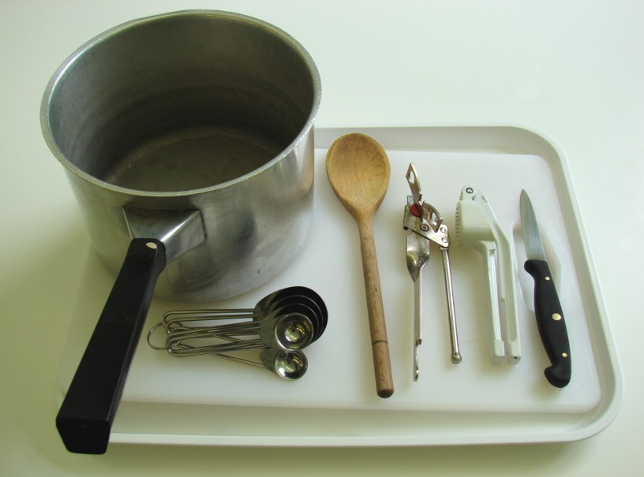
Chopping board, vegetable knife, garlic press, saucepan, measuring spoons, wooden spoon, can opener.

Containers

If students take their dishes, they will need to bring (or be provided with by the school) a suitable container, such as a foil container with a lid.

