Gzik (Polish cottage cheese dip)

Ingredients
Complexity: low-medium
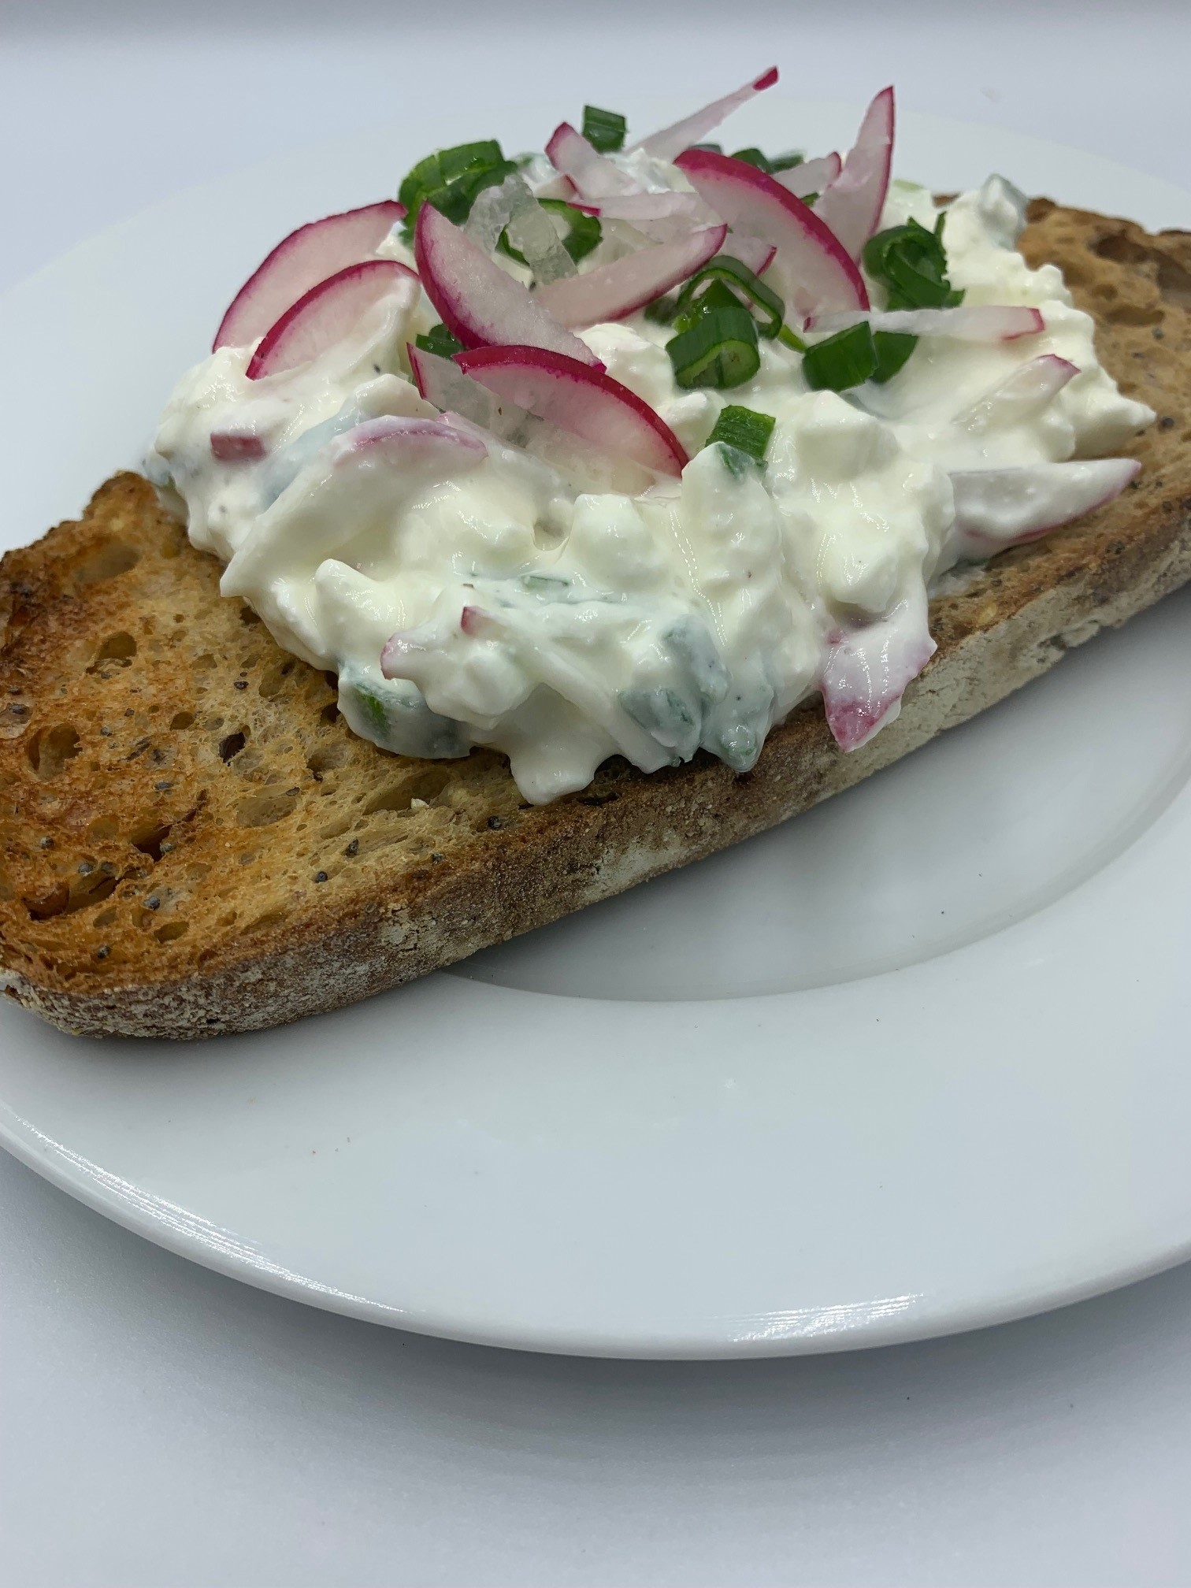
250g reduced fat natural cottage cheese
2-3 radishes
1 small bunch of chives or 2-3 spring onions
1 x 15ml reduced fat sour cream, crème fraiche or Greek yogurt
Black pepper

Equipment
Chopping board, vegetable knife, mixing bowl, fork, measuring spoon.

Method
- Prepare the ingredients:
  - finely chop the radishes;
  - finely chop the chives or the spring onions (green tops only).
- Place the cottage cheese in a mixing bowl.
- Add the chopped radishes and chives or spring onion green and mix well with a fork.
- Add the sour cream, crème fraiche or Greek yogurt and mix well.
- Add black pepper for seasoning.
- Serve with bread, toast or boiled/baked potatoes (known as Pyry-z-gzikiem).

Top tips
- To reduce food waste, chop the whites of the spring onions and add them to the cottage cheese mix.
- Why not make your own cottage cheese to use in this recipe? Find a recipe here.

Food skills
- Measure
- Cut
- Chop
- Mix

Did you know?
This cottage cheese dip is popular all over Poland. Depending on the region, it is eaten in different ways – it can be served as an open sandwich or as part of a meal with baked or boiled potatoes. Gzik on buttered rye bread is a popular breakfast dish.

It is made from a farmer’s cheese called twarog, which is essentially a dry version of cottage cheese. The cheese, which comes moulded into a thick disc, is mashed with a fork, then loosened with plain yogurt or cream. The traditional recipe uses radishes and spring onions, but other ingredients can also be used such as, boiled egg, garlic, smoked mackerel, chopped vegetables, e.g. peppers, carrots. Herbs such as dill can also be added.
This recipe was adapted from a recipe for Gzik, kindly donated by Olga Lang-Kabaca

