Cooker safety certificate

Well done!


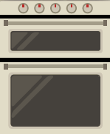
can use a cooker skillfully and safely.
Hob
Grill
Oven

