Graduate Engineer

Aaya Mohammed, ADM Milling Ltd
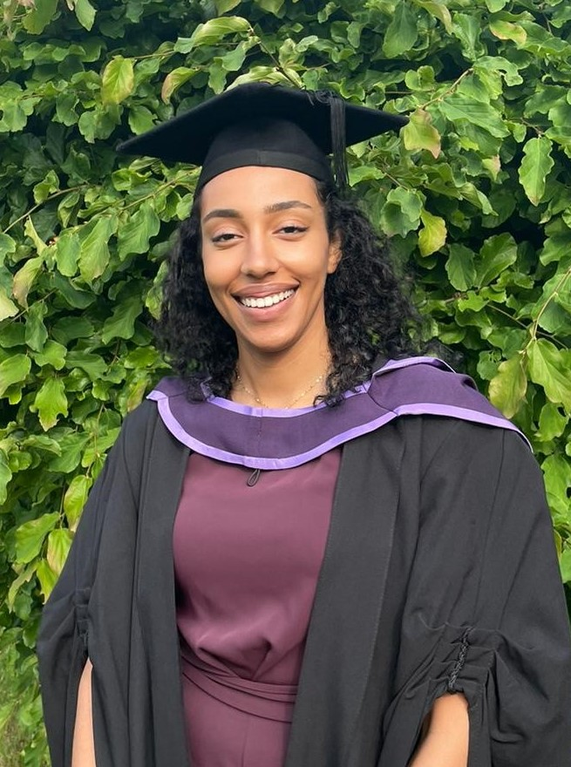

What qualifications do you have?

Integrated Master’s degree in Chemical Engineering

What does your job involve?
My job involves taking on projects and carrying them from start to finish. This means working with various people as a team to bring an idea to life. There is a lot to understand and as each project is different, there isn’t a definitive description of a standard approach. However, it usually involves designing a change or new process and then ensuring it is feasible by either calculating the savings/costs/yield. Then we will work with suppliers and get the project approved, where the installation team will carry out the works. Throughout this process, I am ensuring that all works are done safely and managing the progress and any issues that may arise. My main aim in my job is to improve the efficiency, safety and reliability of the process.

What, or who, inspired you to take your chosen career pathway?
Before applying for the role, I had very limited knowledge or experience about flour milling. It seems to be an industry which does not come in the radar and so I really took it upon myself to see where I can go and make a difference using my skills and knowledge. I knew I wanted to use my math skills to help improve process, especially in the energy and sustainability aspects.

What route did you take from leaving school to your current job?
After leaving school, I attended university where I studied Chemical Engineering. Once I graduated, I was keen on finding a role where I can contribute and implement projects to improve the process efficiency, reduce costs and energy usage. I came across a graduate engineer job advertisement for ADM and applied as the role matched a lot of the responsibilities and tasks that I was looking to grow and flourish in.

What is the key knowledge, skills and experience needed for your job?
One of the key skills needed is being proactive and project management. It is very important that you are willing to learn on the job and have excellent communication skills.

What is the best thing about your job?
Constantly being challenged with new and different tasks. No two days are the same, and it gives a sense of accomplishment when projects are completed and successful. Working on a range of projects means I get to help improve the process in many ways.

What questions are you often asked about your job?
Most of the time I get plainly asked what is it that I do, as my job title is quite vague. My response to this, is that this is the beauty of the role. There is no specific department or field that I am limited to. I have the opportunity to make changes across all areas of the business. Flour milling has really evolved over the years and the technology involved today shows how advanced this industry has become and will continue to develop.

What advice would you offer to someone interested in doing what you do?
Don’t be afraid to go for it, I would recommend this industry to everyone. There is a lot you can do and if you work hard and are keen on taking new opportunities and challenges it will be worth it.

