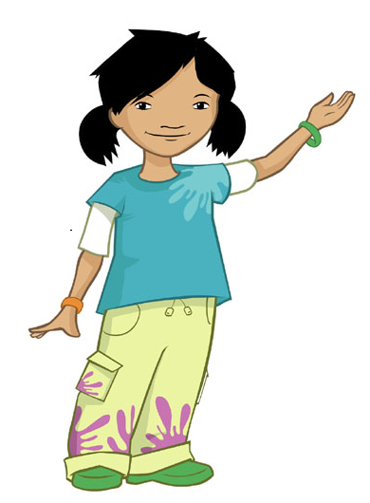
Tie back long hair
What do we need to do before we cook?
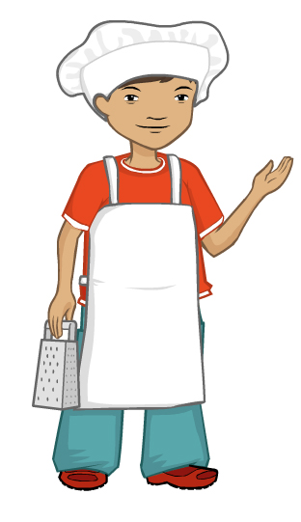

Roll up long sleeves

Take jewellery off

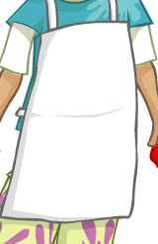

Put on an apron

Wash and dry hands

