Cuban arroz con pollo

Ingredients
Complexity: medium-high
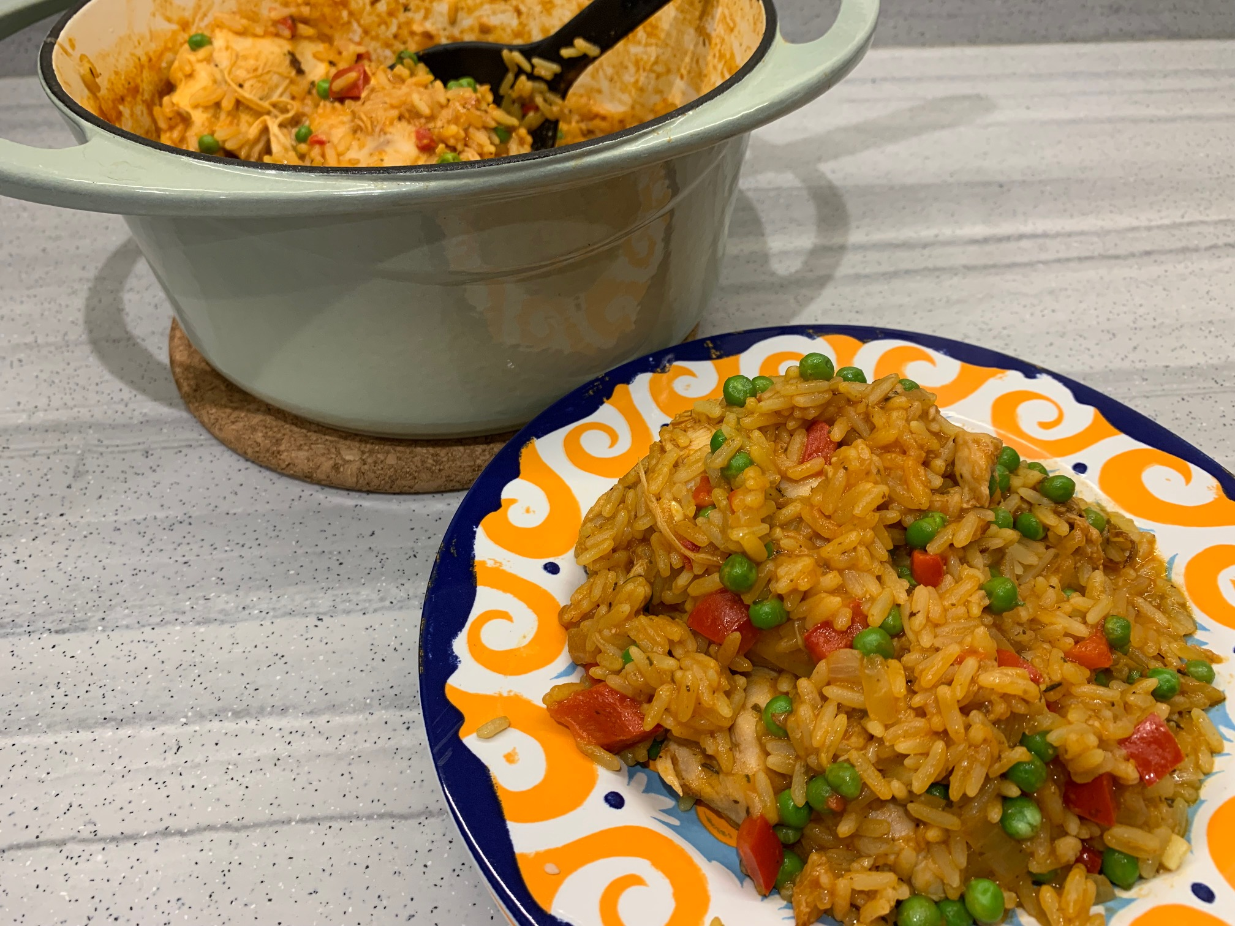
1 small onion
½ red pepper
2 garlic cloves
2 chicken thigh fillets
Spray oil
150g easy cook long grain rice
125ml passata
¼ tsp turmeric
1 x 5ml spoon dried oregano
1 x 5ml spoon dried cumin
1 reduced salt chicken stock cube
300ml boiling water
1 bay leaf (optional)
Black pepper
75g frozen peas

Equipment
Chopping board, vegetable knife, red board, large saucepan with lid, plate, tongs or spoon, mixing spoon, weighing scales, measuring spoons, measuring jug.

Method
- Prepare the ingredients:
  - peel and chop the onion;
  - deseed and chop the pepper;
  - peel and finely chop the garlic;
  - remove any fat from the chicken thighs, thoroughly washing and drying hands after touching the raw meat.
- Spray the saucepan with oil and brown the chicken thighs on both sides. Remove the chicken and place on a plate.
- Spray the saucepan again with oil and add the onion, garlic and red pepper. Fry gently for 3-4 minutes until the onion is soft.
- Add the rice, passata, turmeric, oregano, cumin. Stir well.
- Crumble over the stock cube. Add 300ml boiling water and stir.
- Add the bay leaf, if using.
- Add the browned chicken thighs and season with black pepper.
- Reduce the heat, cover with a lid and simmer for 20 minutes until the rice is tender and the chicken cooked. Stir occasionally to prevent the rice from sticking to the bottom of the pan. Add more boiling water if need be.
- Five minutes before the end of the cooking time, add the frozen peas.

Top tips
- This recipe uses chicken thigh fillets for ease and to reduce the cooking time. However, traditionally bone-in thighs would be used for flavour and value.
- A vegetarian alternative can be made by substituting the chicken with canned black beans added at step 4 and reducing the cooking time to 5 minutes to make Cuban rice and beans. A vegetable stock cube should also be used.

Food skills
- Weigh
- Measure
- Peel
- Cut
- Chop
- Fry
- Stir
- Simmer

Did you know?
Arroz con pollo can be traced back to the Spanish colonisation of Latin America, which brought rice to the region. As a result, many Latin countries have their own version of arroz con pollo.

The Cuban way of making arroz con pollo contains a range of spices but isn’t spicy in flavour. Also, turmeric is used to give the distinctive yellow colour to the rice, rather than saffron which is used in other countries.

In Spain, Calasparra rice is used in arroz con pollo. It absorbs stock and other flavours and holds its shape well during the cooking process and is widely used for making paella. Arborio rice (short grain/risotto) can be used as an alternative.

