Blueberry tasting
Use your senses to describe what blueberries are like.

 | Appearance | Odour (Smell) | Texture | Taste
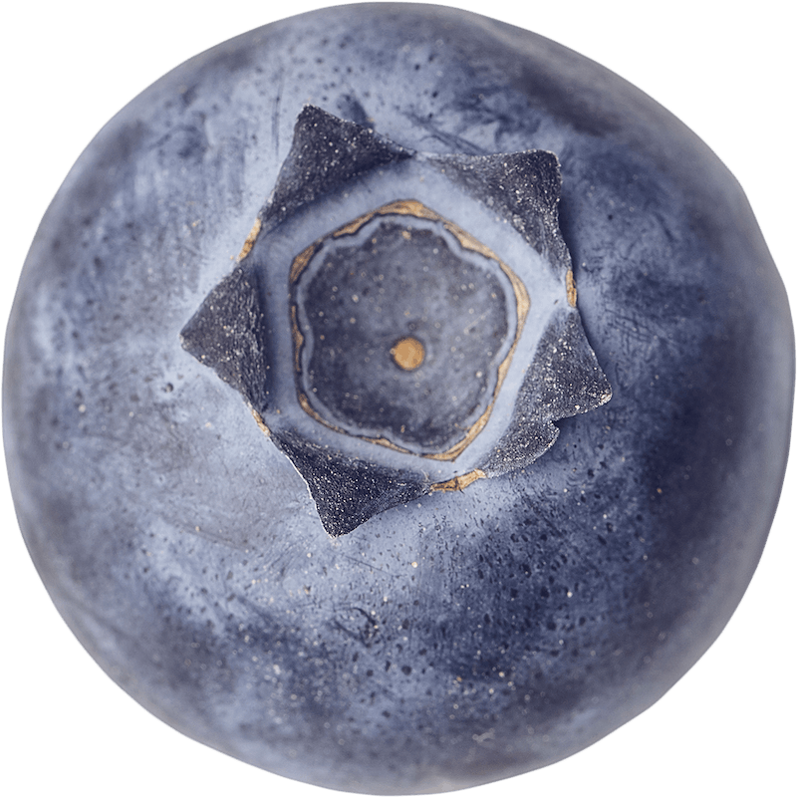

Word bank
Wrinkly  Fresh  Sour  Soft  Sharp | Colourful  Bland  Smooth  Hard  Mushy | Juicy  Grainy  Mouldy  Sweet  Dull

