Umami

Umami is a savoury taste, often known as the fifth taste. It is a subtle taste and blends well with other tastes. Most people do not recognise the taste unless attention is especially drawn towards it.

After eating Cheddar cheese or tomatoes, there may be a ‘savoury’ taste lingering - this is umami.

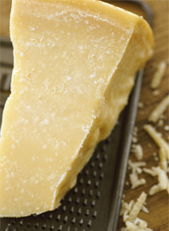
These are foods which all have an umami taste:

- tomatoes;
- cured pork, e.g. ham, sausage, bacon;
- Cheddar cheese;
- Parmesan cheese;
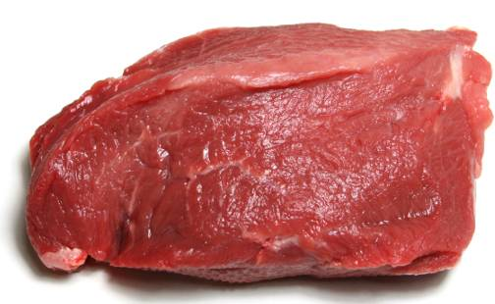
- meat, e.g. beef;
- anchovies;
- yeast extract.

Umami tasting – cherry tomatoes

Take the stem of a cherry tomato and chew the flesh around 30 times.

What sensations do you feel during and after eating it?

First you may taste sourness and sweetness which will pass quickly, there may also be an earthy taste as well.

After some minutes, there will be a different, lasting feeling in your mouth or a coating sensation on your tongue.
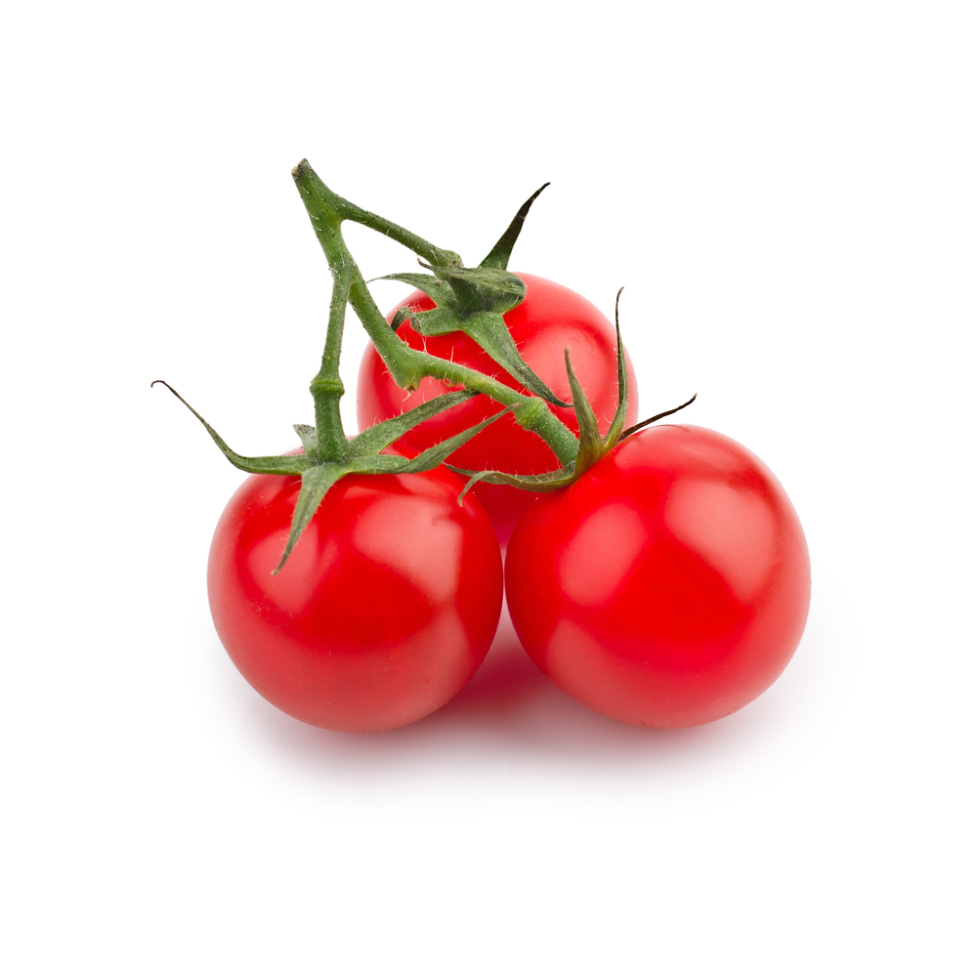
This subtle taste is umami.

Tasting notes

