Nutrition information per 100g
Energy 802kJ/188kcal
Protein 4.8g
Carbohydrate 43.4g
Fat 0.7g
Fibre 10g
Vitamin A 105µg
Vitamin C Trace
Calcium 92mg
Iron 4.1mg
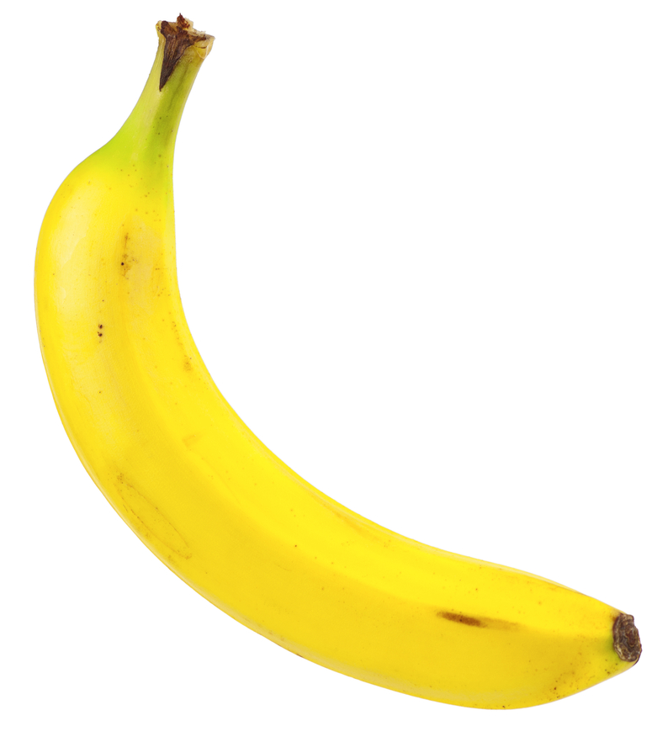
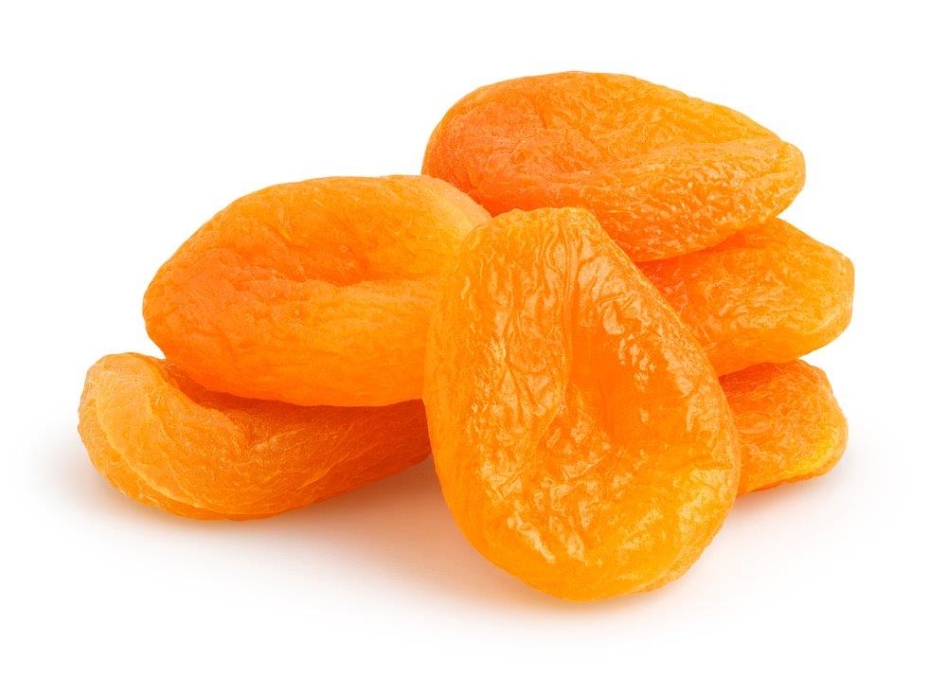
Serving size: 75-100 grams
Serving size: 15-30 grams
Nutrition information per 100g
Energy 348kJ/81kcal
Protein 1.2g
Carbohydrate 20.3g
Fat 0.1g
Fibre 1.4g
Vitamin A 4µg
Vitamin C 9mg
Calcium 6mg
Iron 0.27mg
Bananas

Type in name here
Type in name here

Dried Apricots

Type in name here
Type in name here

Banana
Nutrition information per 100g
Energy 152kJ/36kcal
Protein 0.8g
Carbohydrate 8.2g
Fat 0.2g
Fibre 1.2g
Vitamin A 9µg
Vitamin C 52mg
Calcium 24mg
Iron 0.11mg

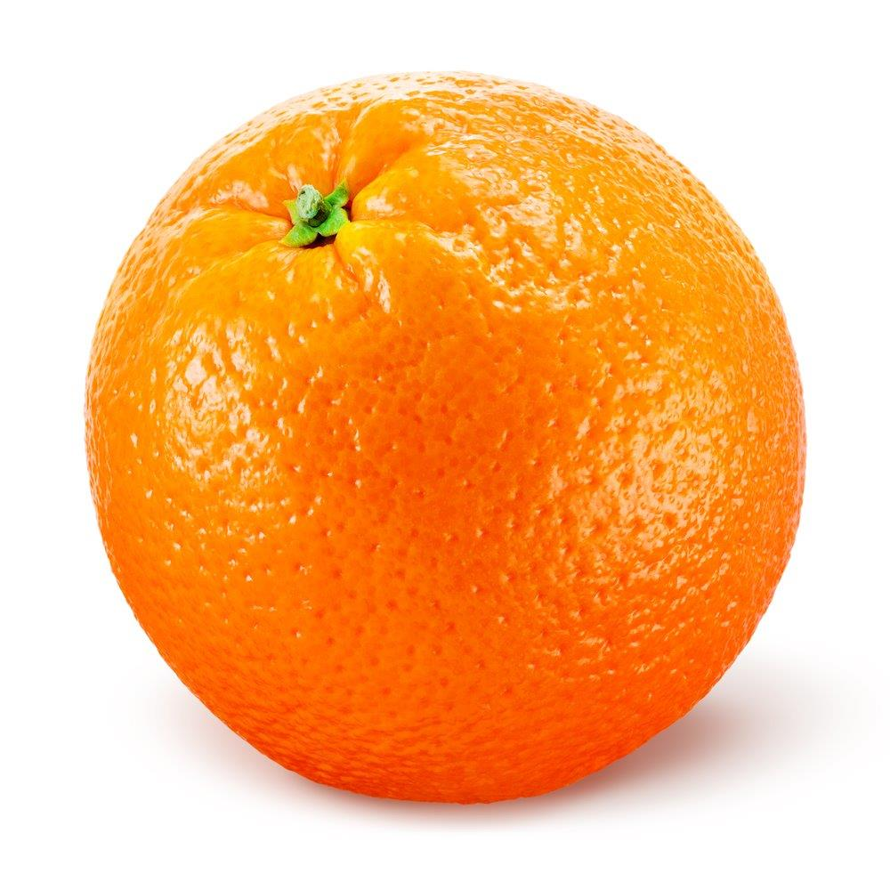

Serving size: 50-100 grams

Oranges

Type in name here
Type in name here

Nutrition information per 100g
Energy 329kJ/79kcal
Protein 6.7g
Carbohydrate 10.0g
Fat 1.6g
Fibre 5.6g
Vitamin A 42µg
Vitamin C 16mg
Calcium 19mg
Iron 1.5mg

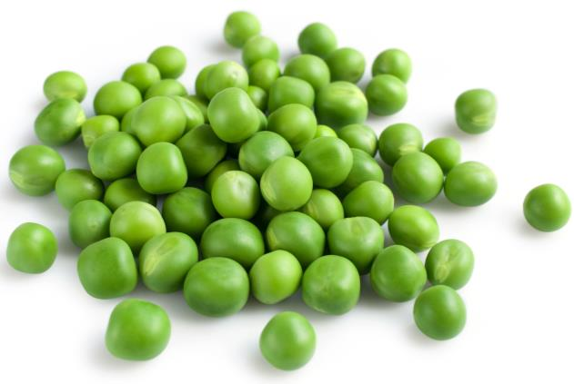

Serving size: 40-60 grams

Peas (boiled)
Nutrition information per 100g
Energy 61kJ/14kcal
Protein 0.5g
Carbohydrate 3.0g
Fat 0.1g
Fibre 1.0g
Vitamin A 58µg
Vitamin C 22mg
Calcium 8mg
Iron 0.24mg
Energy 329kJ/79kcals
Protein 6.7g
Carbohydrate 10.0g
Fat 1.6g
Fibre (AOAC) 5.6g
Vitamin A 42µg
Vitamin C 16mg
Calcium 19mg
Iron 1.5mg

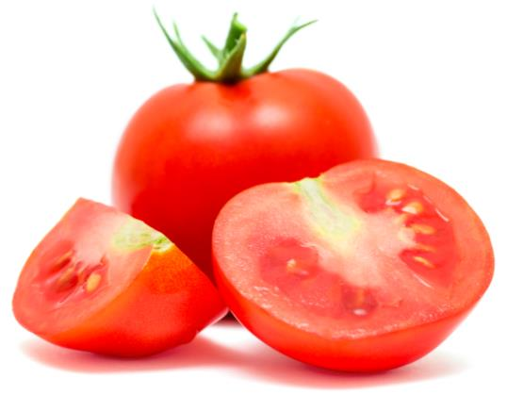

Serving size: 50-100 grams

Tomatoes

Type in name here
Type in name here

Nutrition information per 100g
Energy 718kJ/169kcal
Protein 5.5g
Carbohydrate 37.2g
Fat 0.8g
Fibre 2.5g
Vitamin A 0µg
Vitamin C 0mg
Calcium 12mg
Iron 0.78mg

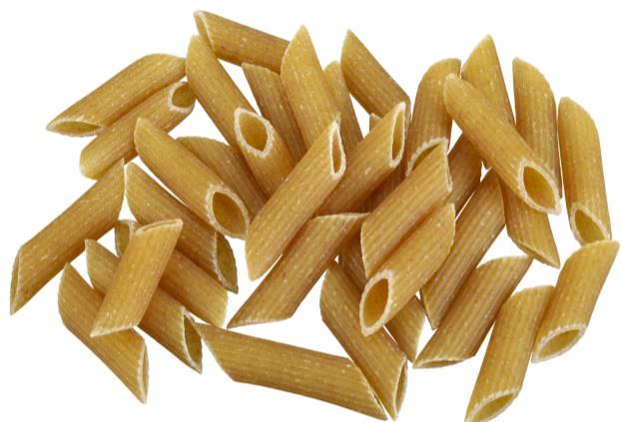

Serving size: 45-65 grams

White pasta (boiled)

Type in name here
Type in name here

Nutrition information per 100g
Energy 413kJ/97kcal
Protein 2.5g
Carbohydrate 22.6g
Fat 0.2g
Fibre 2.6g
Vitamin A 0µg
Vitamin C 6mg
Calcium 11mg
Iron 0.6mg
Energy 718kJ/169kcals
Protein 5.5g
Carbohydrate 37.2g
Fat 0.8g
Fibre (AOAC) 1.8g
Vitamin A 0µg
Vitamin C 0mg
Calcium 12mg
Iron 0.78mg

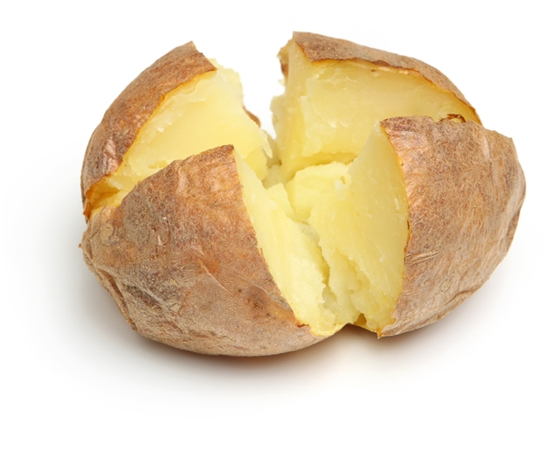

Serving size: 120-170 grams

Baked potato (with skin)

Nutrition information per 100g
Energy 1004kJ/236kcal
Protein 8.7g
Carbohydrate 48.7g
Fat 2.1g
Fibre 2.9g
Vitamin A 0µg
Vitamin C 0mg
Calcium 155mg
Iron 1.5mg

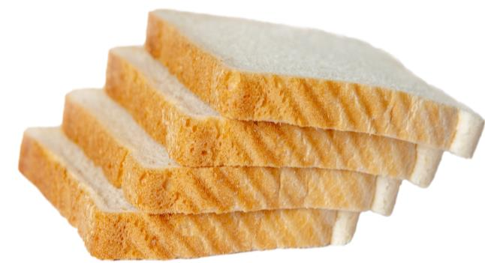

Serving size: 50-70 grams

White bread

Type in name here
Type in name here

Nutrition information per 100g
Energy 498kJ/117kcal
Protein 2.8g
Carbohydrate 26.5g
Fat 0.7g
Fibre 0.6g
Vitamin A 0µg
Vitamin C 0mg
Calcium 14mg
Iron 0.08mg

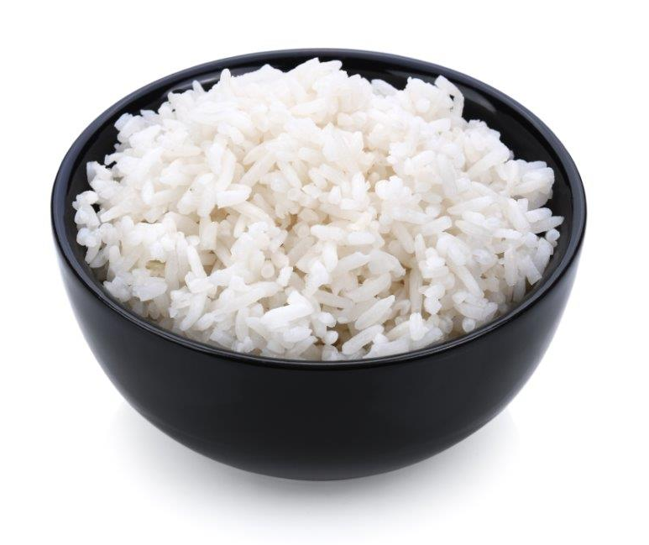

Serving size: 35-55 grams

Basmati rice (boiled)

Nutrition information per 100g
Energy 922kJ/217kcal
Protein 9.4g
Carbohydrate 42.0g
Fat 2.5g
Fibre 7g
Vitamin A 0µg
Vitamin C 0mg
Calcium 106mg
Iron 2.4mg

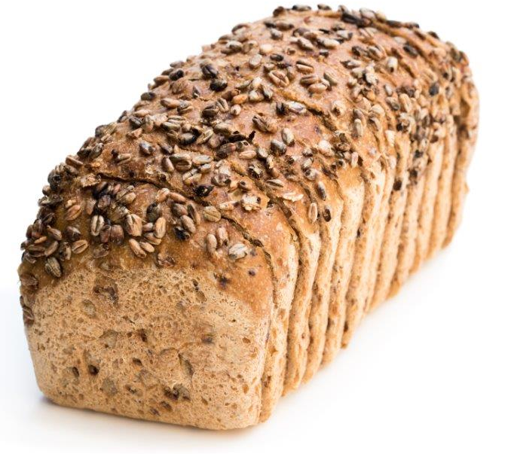

Serving size: 50-70 grams

Wholemeal bread

Type in name here
Type in name here

Nutrition information per 100g
Energy 195kJ/46kcal
Protein 3.5g
Carbohydrate 4.7g
Fat 1.7g
Fibre 0g
Vitamin A 20µg
Vitamin C 2mg
Calcium 120mg
Iron 0.02mg
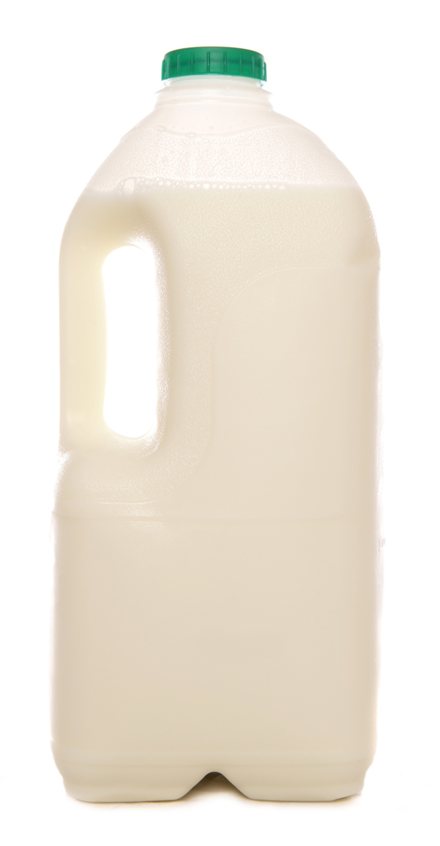

Serving size: 150-200 ml

Semi skimmed milk

Type in name here
Type in name here

Nutrition information per 100g
Energy 1725kJ/416kcal
Protein 25.4g
Carbohydrate 0.1g
Fat 34.9g
Fibre 0g
Vitamin A 388µg
Vitamin C Trace
Calcium 739mg
Iron 0.3mg

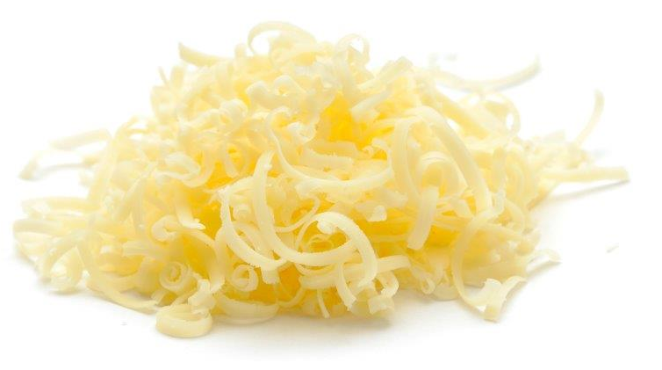

Serving size: 20-30 grams

Cheddar cheese

Type in name here
Type in name here

Nutrition information per 100g
Energy 331kJ/78kcal
Protein 4.2g
Carbohydrate 13.7g
Fat 1.1g
Fibre 0.3g
Vitamin A 10µg
Vitamin C 1mg
Calcium 140mg
Iron 0.11mg

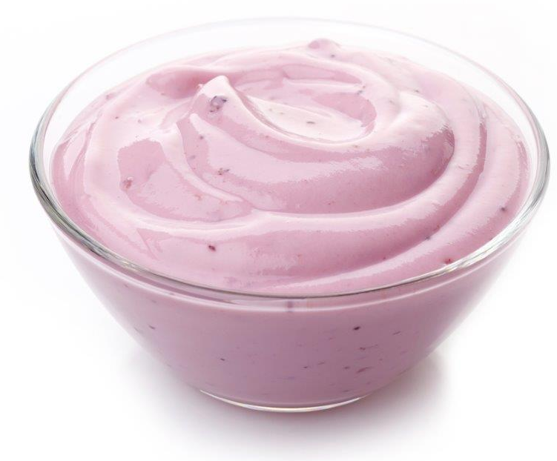

Serving size: 80-120 grams

Low fat fruit yogurt

Type in name here
Type in name here

Nutrition information per 100g
Energy 460kJ/109kcal
Protein 24.9g
Carbohydrate 0g
Fat 1g
Fibre 0g
Vitamin A 26µg
Vitamin C Trace
Calcium 10mg
Iron 1.51mg

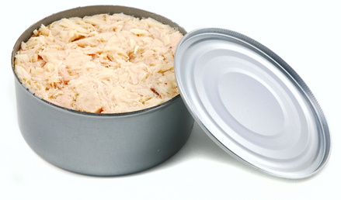

Serving size: 55-80 grams

Canned tuna (in brine)

Type in name here
Type in name here

Nutrition information per 100g
Energy 343kJ/81kcal
Protein 5.0g
Carbohydrate 15.0g
Fat 0.5g
Fibre 4.9g
Vitamin A 4µg
Vitamin C Trace
Calcium 42mg
Iron 1.42mg

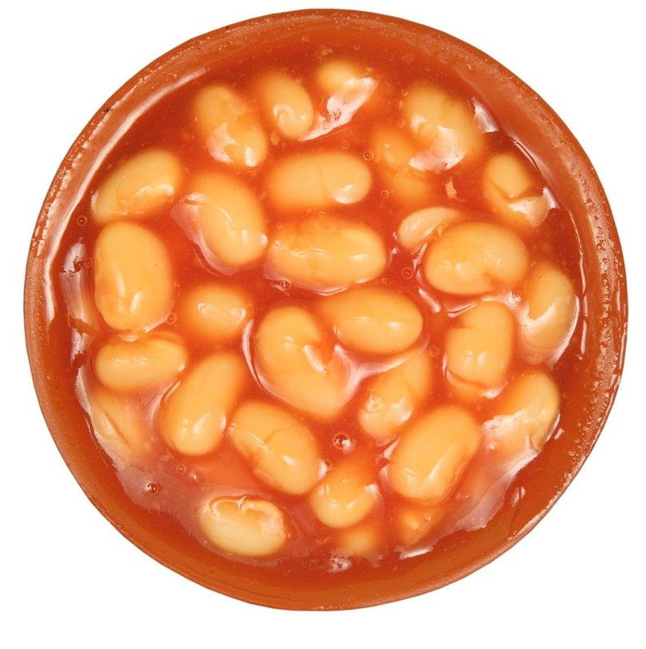

Serving size: 50-70 grams

Baked beans (in tomato sauce)

Type in name here
Type in name here

Nutrition information per 100g
Energy 448kJ/106kcal
Protein 24.6g
Carbohydrate 0g
Fat 0.8g
Fibre 0g
Vitamin A 3µg
Vitamin C Trace
Calcium 16mg
Iron 2.4mg

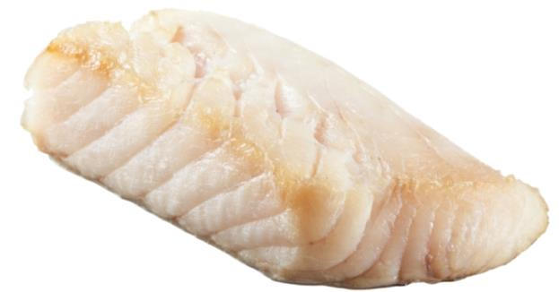

Serving size: 60-90 grams

Cod (grilled)

Type in name here
Type in name here

Nutrition information per 100g
Energy 221kJ/52kcal
Protein 13.0g
Carbohydrate Trace
Fat Trace
Fibre 0g
Vitamin A 0µg
Vitamin C 0mg
Calcium 8mg
Iron 0.05mg

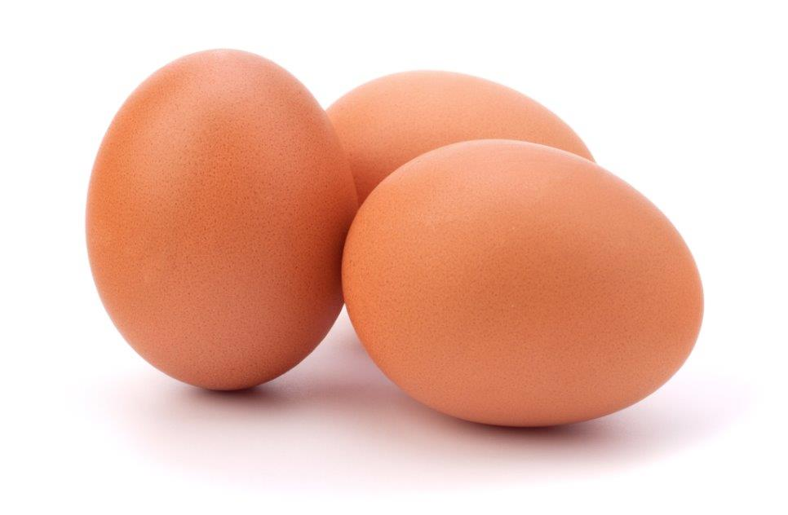

1 egg: 40 grams

Boiled egg

Type in name here
Type in name here

Nutrition information per 100g
Energy 1924kJ/458kcal
Protein 6.6g
Carbohydrate 63.5g
Fat 21.5g
Fibre 7.6g
Vitamin A 0µg
Vitamin C 14mg
Calcium 36mg
Iron 1.8mg

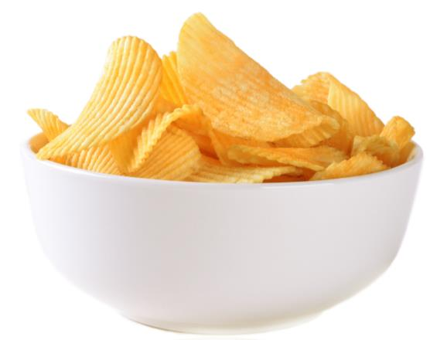

1 small bag: 25 grams

Reduced fat crisps

Type in name here
Type in name here

Nutrition information per 100g
Energy 3059kJ/744kcal
Protein 0.6g
Carbohydrate 0.6g
Fat 82.2g
Fibre 0g
Vitamin A 1060µg
Vitamin C Trace
Calcium 18mg
Iron Trace

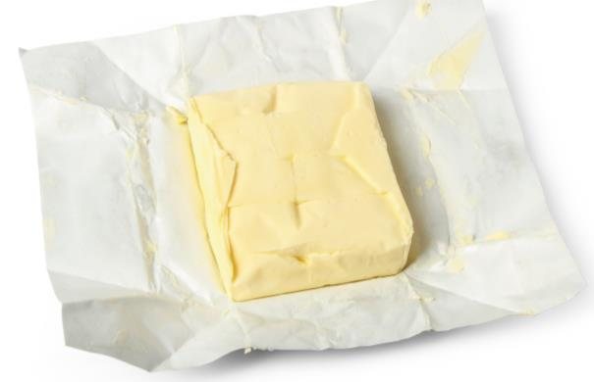

Serving size: 5 grams

Butter (unsalted)

Type in name here
Type in name here

Nutrition information per 100g
Energy 424kJ/100kcal
Protein 7.6g
Carbohydrate 17.5g
Fat 0.4g
Fibre 6.3g
Vitamin A 3µg
Vitamin C Trace
Calcium 16mg
Iron 2.4mg

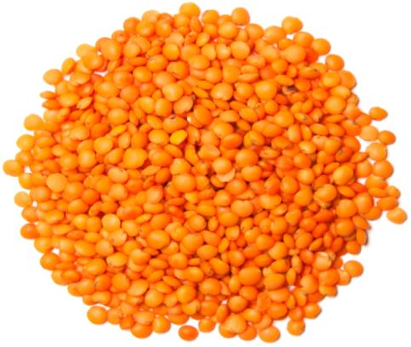

Serving size (cooked): 50-60 grams

Red lentils (boiled)

Type in name here
Type in name here

Nutrition information per 100g
Energy 2171kJ/519kcal
Protein 7.3g
Carbohydrate 56.0g
Fat 31.1g
Fibre 2.3g
Vitamin A 70µg
Vitamin C Trace
Calcium 226mg
Iron 2.05mg

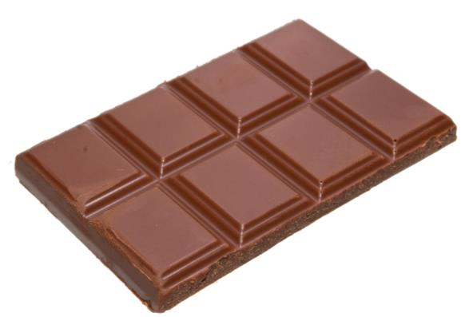

Serving size: 30 grams

Milk chocolate

Type in name here
Type in name here

Nutrition information per 100g
Energy 892kJ/213kcals
Protein 29.2g
Carbohydrate 0g
Fat 10.7g
Fibre 0g
Vitamin A Trace
Vitamin C 0mg
Calcium 22mg
Iron 2.1mg
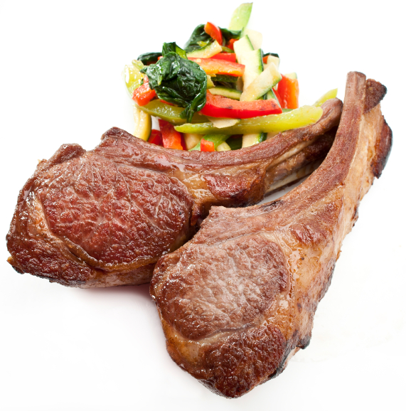
Serving size: 50-80 grams
Lamb chop (grilled)

Type in name here
Type in name here

