Climate change and food production pick and mix
Try these climate change and food production activities from this pick and mix selection!
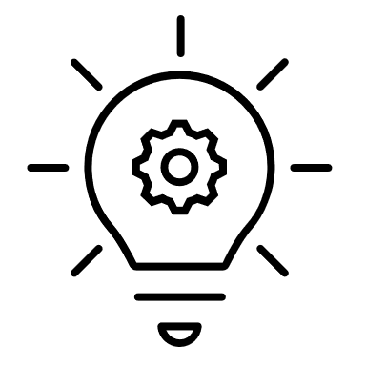  Design a sustainable food product that minimizes packaging and uses eco-friendly materials.  Consider how each component affects the environment | 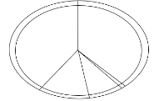  If everyone in the UK followed the Eatwell Guide, our diets would have a much lower environmental impact than they currently do.  Suggest five ways that you could follow the Eatwell Guide more closely and identify how this could change your personal environmental impact. Make a pledge and keep to these changes! | 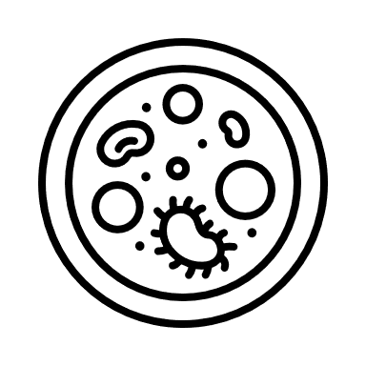  Research why good soil health is important when considering the impacts of climate change and sustainable food production.  Create a five-point plan for your local area for improving soil health. Remember to include why it is important along with plenty of tips! | 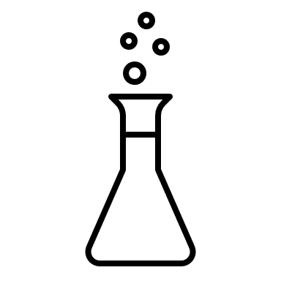  Some foods require more water to grow.  Explore the water footprint of ten different foods by comparing the water needed to produce a kg of each food.  Consider if there are any alternative foods that could be eaten that use less water.  Use this guide to help calculate the global average water footprint.
  Select commonly wasted foods (like bananas, bread, milk) and investigate the journey from farm to fork, including the resources (water, transport) each use.  Create a food map that highlights the carbon footprint of wasted foods, to gain an understanding of how local and seasonal eating reduces waste. |   Changing the way food is grown and reared can help maintain or increase food production.  Investigate crops that are resilient to changing climates and how they can help combat food insecurity. |   Research carbon storage and how farms can store some carbon in plants and the soil.  Create a short video or animation (1-3 minutes) showing what farmers can do to store more carbon. |   Create a recipe using only seasonal, local ingredients.  Research which foods are in season and why eating seasonally is more sustainable.  Make the recipe to share with your friends or family.
This resource meets the Guidelines for producers and users of school education resources about food.

