Brilliant bread

Complexity: low - medium

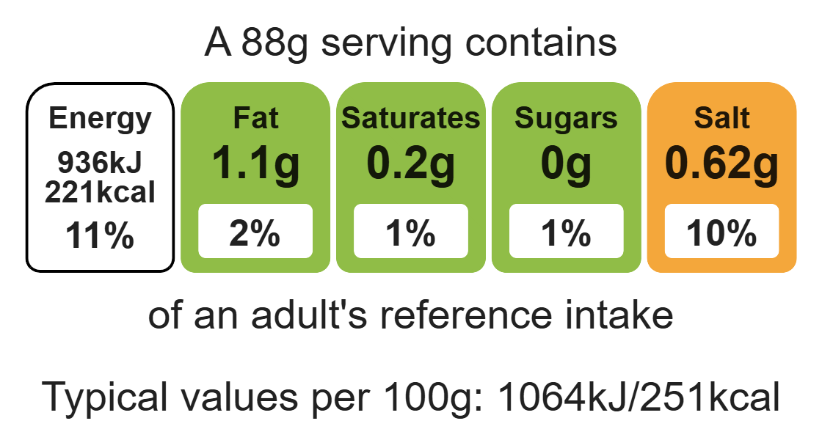

Ingredients (serves 4)
125g strong white flour

Equipment

Weighing scales

Measuring spoons

Measuring jug

Baking tray

Sieve

Mixing bowl

Mixing spoon

Flour dredger (optional)

Cooling rack

125g strong wholemeal flour
½ x5ml spoon salt
7g pack fast action dried yeast
150ml warm water

Method (cold prove alternative method)
1. Line the baking tray with greaseproof paper.
3. Sift together the flour and salt into the mixing bowl.
4. Stir in the yeast.
5. Make a well in the middle of the flour mixture and add the warm water gradually.
Note: the water must not be too hot.
6. Mix to form a ball of soft dough.
7. Sprinkle a little flour onto a clean work surface and place the dough on the surface.
8. Knead the dough for 10 minutes.
9. Divide the dough into 4 pieces and shape into rolls of your desired shape.
10. Place the rolls on the baking tray.
11. Place in a COLD oven and turn up the temperature immediately.
12. Remove from oven after approximately 15 – 20 minutes and cool on a cooling rack.
13. Test for readiness by tapping the bottom. It should sound hollow.
14. Allow to cool.

Top tips
- Focus on fibre: decorate your bread with seeds before baking. (Be ingredient aware!)
- Turn up the flavour: why not try adding 25g apple, grated cheese, dried fruit or diced garlic to the flour mixture?

Food skills
Weigh, measure, sift, mix, stir and combine, knead, portion/divide, decorate and garnish, form and shape, roll out.

