Sizzling stir fry
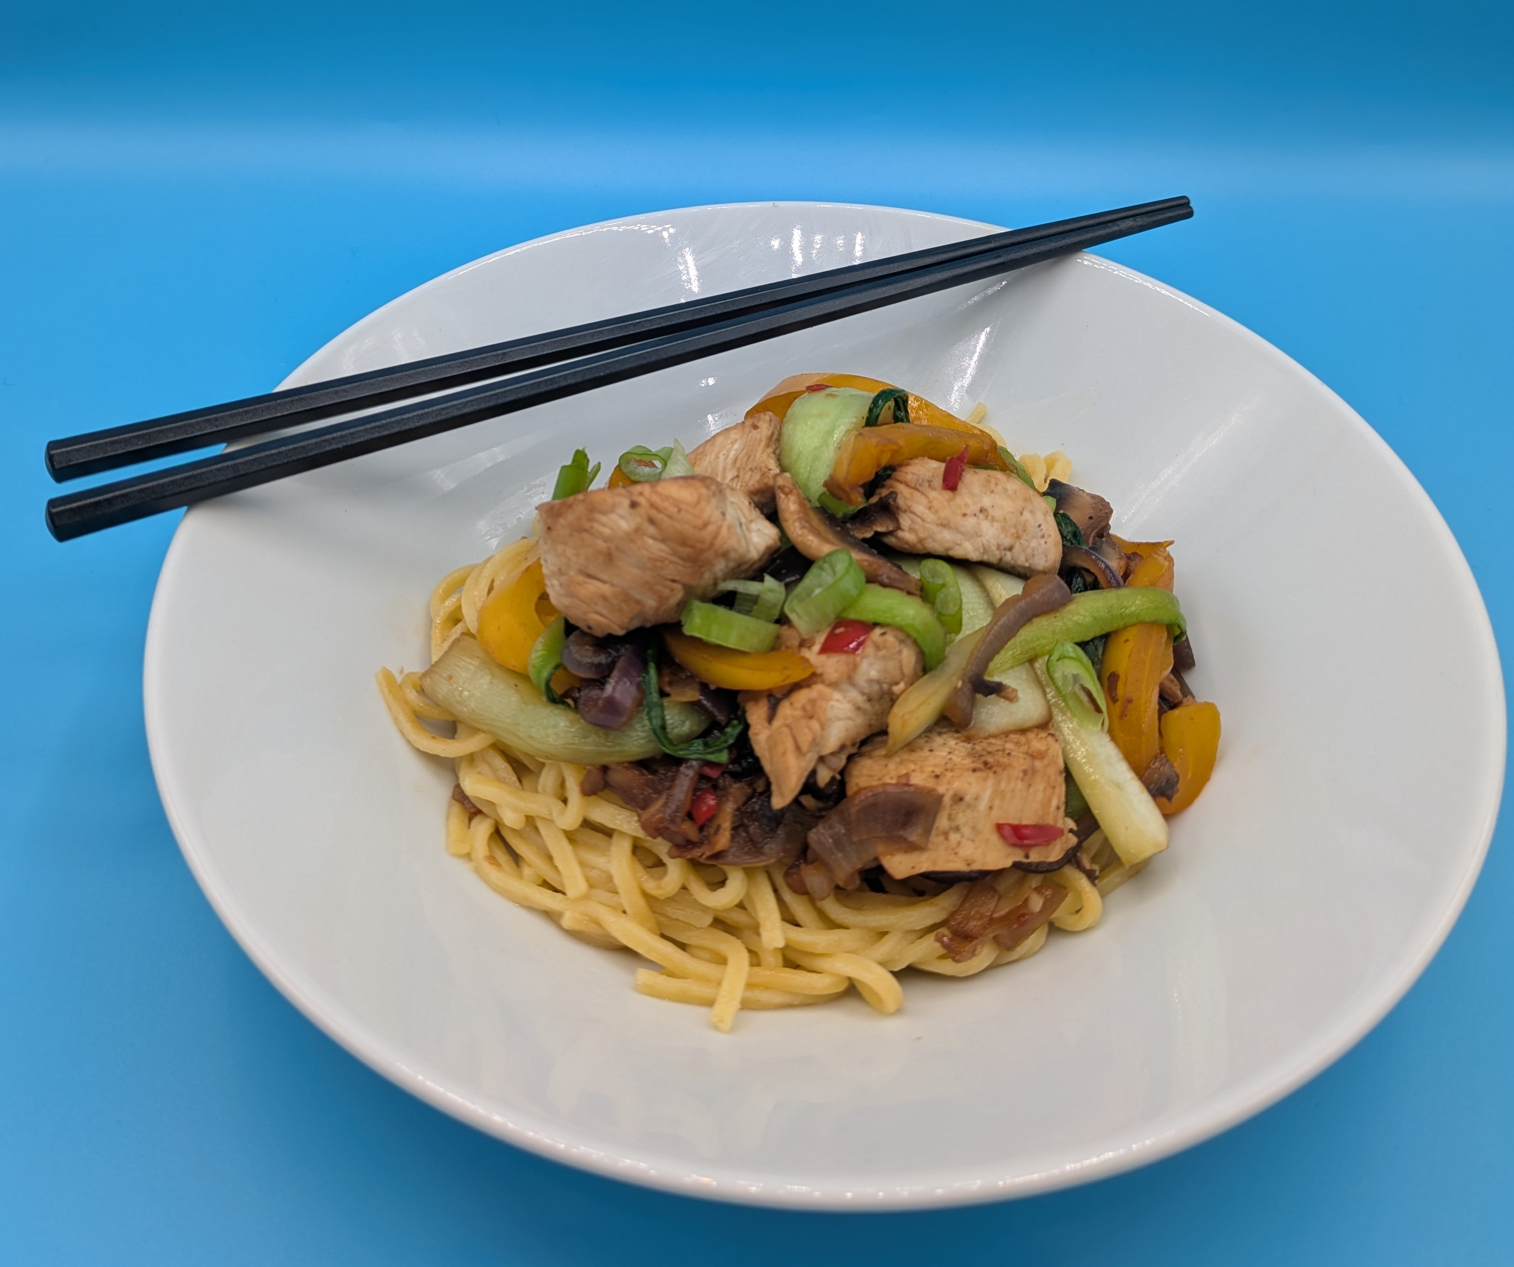
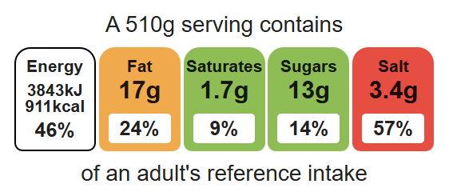
Complexity: medium- high

Ingredients (serves 1-2)

Equipment

Weighing scales

Saucepan

2 Chopping boards

Sharp knife

Garlic press

Wok or frying-pan

Heat resistant spoon

Colander

Measuring spoons

80g noodles
1 x chicken breast (or 3-4 thighs)
1 clove garlic
½ chilli
1cm fresh ginger
½ red onion
½ pepper
3 mushrooms
1 pak choi
1 x 15ml spoon oil or spray oil
1 x 10ml spoon reduced-salt soy sauce
Top tips
- Reduce food waste: Add any leftover vegetables, such as, courgette, carrots or leeks to your stir-fry.
- Vegetarian alternative: Replace the chicken with tofu beans or pulses for a vegetarian alternative.
- Vary your protein: Try this recipe with prawns or thin strips of beef or pork.
- Mix in ready cooked noodles or rice for a quick main meal.

Method
- Cook the noodles in boiling water. Check the packet for details.
- On a red chopping board, remove any gristle from the chicken and cut into strips. Thoroughly wash and dry hands after touching raw chicken.
- Prepare the vegetables with a fresh knife on a clean chopping board:
- peel and crush the garlic;
- deseed and slice the chilli;
- peel and slice the ginger;
- peel and slice the onion;
- deseed and slice the pepper;
- slice the mushrooms;
- shred the pak choi.
- Heat the oil in the wok or frying pan.
- Add the onion, garlic, chilli and ginger. Cook for 1 minute.
- Add the chicken and stir-fry for 3-4 minutes. Check that the chicken is cooked and no pink remains.
- Add the pepper, mushrooms, pak choi and soy sauce and continue to cook for a further 2 minutes.
- Drain the noodles into a colander in the sink.
- Stir in the cooked noodles and cook for 2 minutes until hot.

Food skills
Weigh, measure, crush, chop, slice, dice, trim, drain, peel, stir-fry, melt, boil, simmer, mix, stir and combine.

