Chunky bean mole with

homemade salsa

Ingredients
Complexity: medium
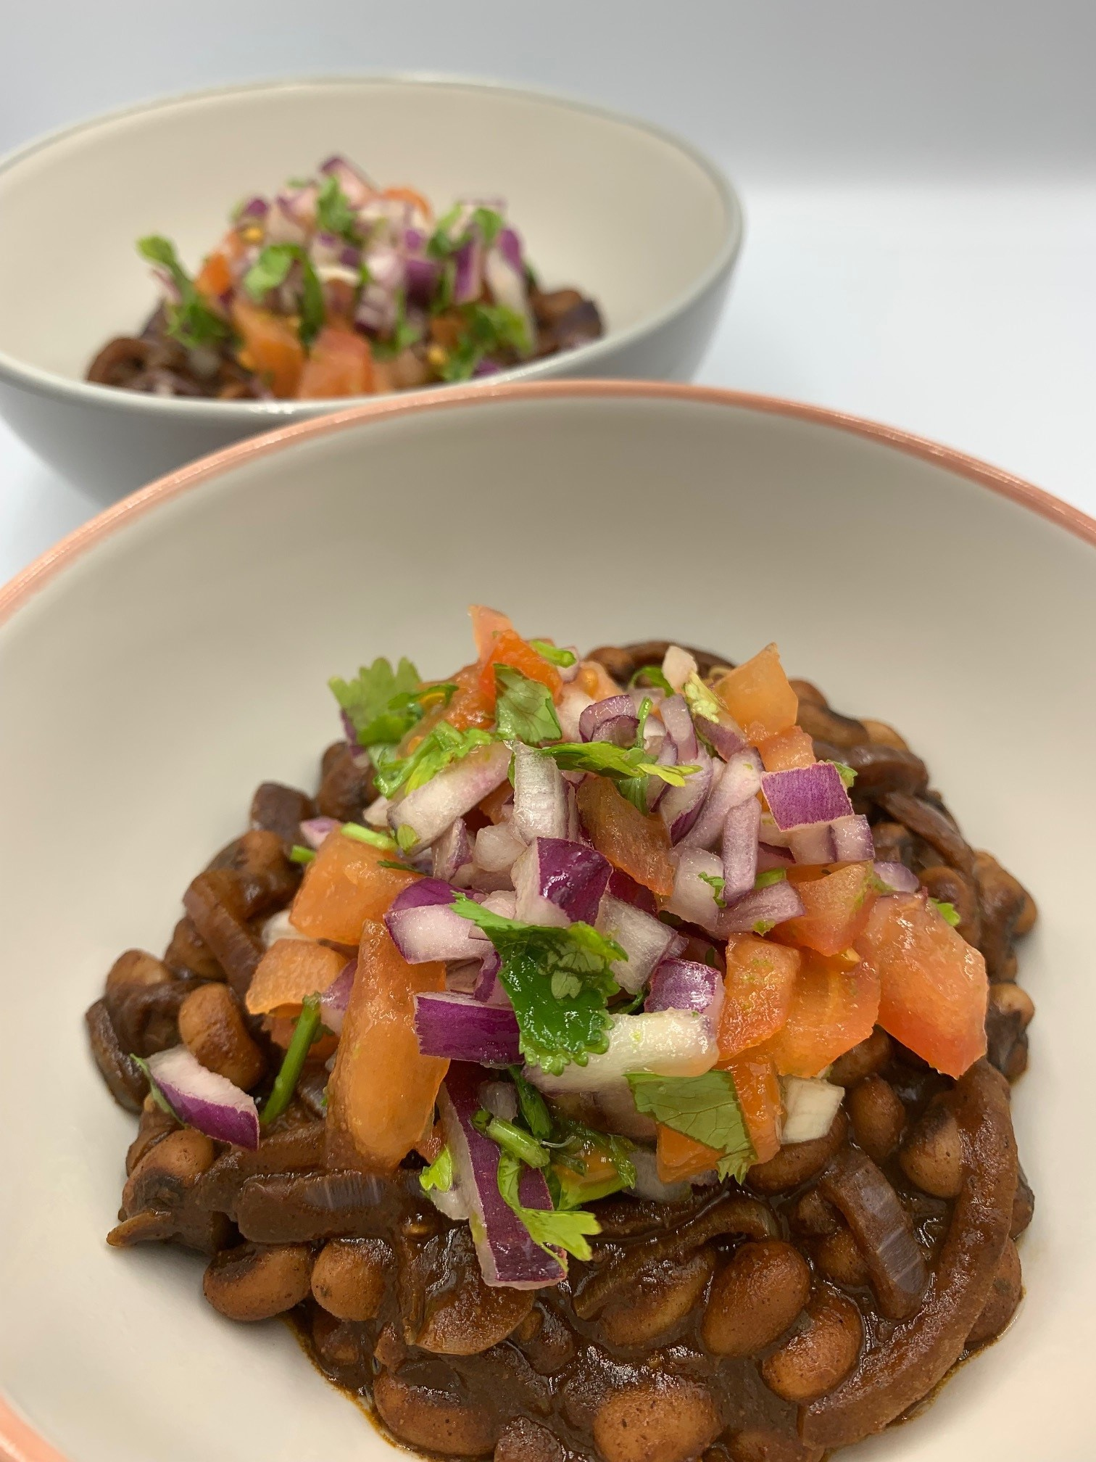
1 red onion
1 garlic clove
400g can black-eyed beans in water
Spray oil
1 x 5ml spoon ground coriander
1 x 5ml spoon mild chilli powder
½ x 5ml spoon ground cinnamon
1 x 15ml spoon tomato purée
2 x 5ml spoon cocoa powder
1 vegetable stock cube

For the salsa
1 medium red onion
1 large tomato
1 x 15ml spoon fresh coriander
1 lime

Equipment
Chopping board, vegetable knife, garlic press, colander/sieve, medium-sized saucepan, wooden spoon, measuring spoons, zester/grater, juicer, small bowl, mixing spoon.

Method
- Prepare the ingredients:
  - peel and slice the onion;
  - peel and chop or crush the garlic;
  - drain and rinse the black-eyed beans.
- Spray a saucepan with oil and add the onion and garlic. Fry gently until softened, approximately 3-4 minutes.
- Add the ground coriander, chilli powder and ground cinnamon. Cook for 1 minute.
- Add the black-eyed beans, cocoa powder, tomato purée and 200ml boiling water to the pan.
- Crumble over the stock cube and stir well.
- Cook, stirring frequently, until the sauce has reduced to a thick consistency, approximately 10 minutes.
- Make the salsa:
  - peel and finely chop the onion;
  - chop the tomato;
  - chop the coriander;
  - zest the lime, cut in half and juice one half;
  - mix all the ingredients together in a small bowl.
- Spoon the mole into bowls and top with the salsa.

Food skills
- Measure
- Peel
- Slice
- Chop
- Crush
- Fry/sauté
- Boil
- Simmer
- Zest
- Juice
- Mix

Top tips
- Serve with homemade tortilla chips: Cut a tortilla wrap into triangles. Place on a baking tray and spray with oil. Bake in the oven until crisp.
- Fill wraps with the cooked mole and wrap into a parcel. Place in an oven proof dish, sprinkle over grated reduced fat cheese and bake in the oven.
- Serve with a mixed salad on the side.

Did you know?
Mole, pronounced mol-lay, is a rich Mexican sauce made from dried or fresh chilies, nuts or seeds, and can range in colour from green to yellow to red and all the way to black.

Mole negro, or black mole, gets its deep dark colour from smoked black chilies, prunes (or raisins) and chocolate.

Dark, or semi-sweet, chocolate is added to balance out the flavours in moles and some chilli recipes, especially if tomatoes are used. It provides a deep colour and a surprisingly savoury flavour.

