Cost and sensory evaluation

Your teacher will provide you with three differently priced version of the same product, labelled A, B and C in plastic containers.

- Choose 8 attributes that describe the characteristics of the product, e.g. smooth, salty, crunchy, bland, chewy, golden, dry, nutty.
- Taste the food sample. Decide on an intensity for each attribute, using a scale from 0-10 (the higher the number, the greater the intensity).
- Use the information to draw a star chart/diagram of the product’s attributes. Use a coloured pen and create a key at the bottom of the diagram to record what product (A, B or C) you tested.
- Taste the other two samples, recording the information on the same star diagram but using different coloured pens to differentiate them.
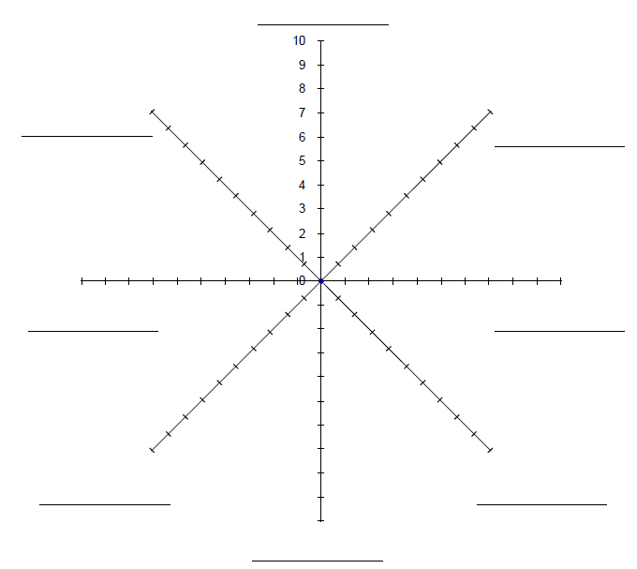

Based on your sensory evaluation, explain which product you think should be most expensive.

___________________________________________________________________________

_________________________________________________________________________

_________________________________________________________________________

Your teacher will tell you the product prices at the end of the activity. Were you correct?

_________________________________________________________________________

