Session 15: Stir fry crazy

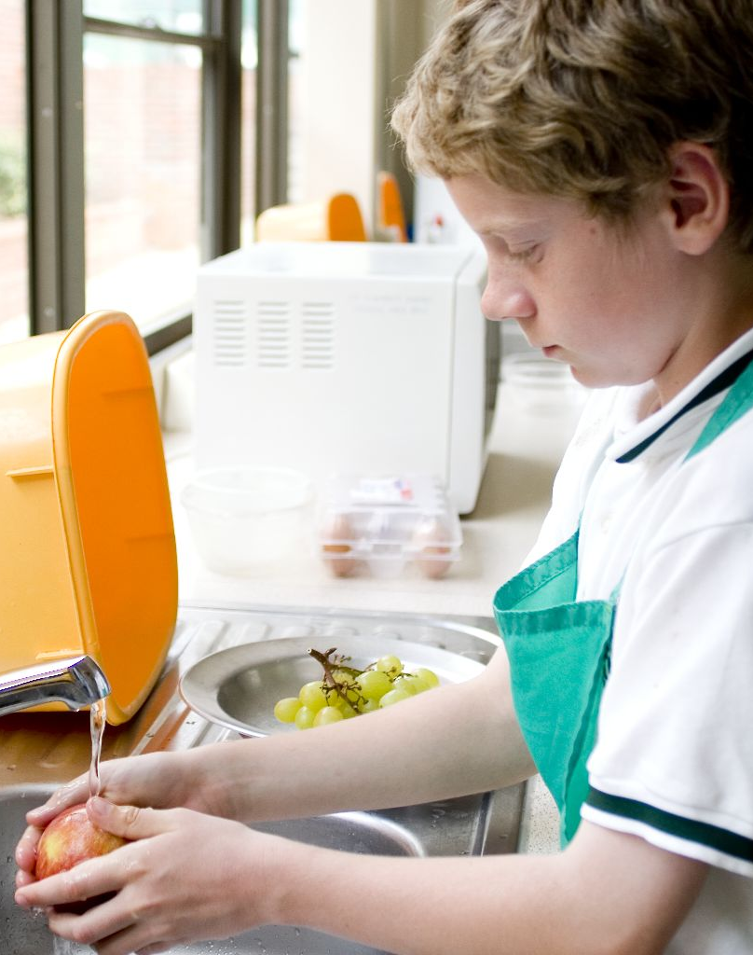
Welcome
This module of sessions aims to build on this confidence and independence, offering students the opportunity to learn new skills and techniques which lead to preparing and cooking a range of main meals. It also provides you with the opportunity to assess students’ practical capability for the end of this block of sessions. You could use the practical observation sheet to help.
During this session, students will make either a sizzling stir-fry or fajitas. These have been chosen as they improve essential knife skills, act as a reminder for the safe use of the cooker and can be cooked by students easily at home for lunch or dinner. If you have students who do not eat meat, then use an alternative, such as tofu, beans or myco-protein.
There is lots of room for students to be creative, selecting different types of ingredients that could be combined into the dishes. You could get your students to use the sizzling stir-fry or fajitas recipe writing frames before cooking to develop their own ideas. The students’ own recipe creations could then be used in this session.
If you have an established lesson plan and/or recipe, which supports the aims and objectives of this session, feel free to use it instead. Look at the support materials provided within this session as they support this activity and may well be useful in your own lessons, e.g. worksheets, PowerPoint presentations.
This session can act as a stand-alone lesson, focusing on knife skills and stir-frying. Alternatively, it could be integrated into a series of lessons, e.g. exploring authentic cooking methods and ingredients in Chinese or Mexican cooking.

Aims and objectives
Aim
For students to:
- become more confident preparing and cooking more ambitious main dishes.
Objectives
Students should be able to:
- demonstrate the bridge-hold and claw-grip knife skills confidently;
- prepare a range of ingredients, e.g. de-seeding chillies, grating fresh ginger;
- use hob safely to stir-fry ingredients;
- make a stir-fried dish, e.g. sizzling stir-fry or fajitas.

Cooking session
Two cooking session plans, based on the Licence to Cook recipes, are supplied within this session.

If you have your own tried and tested stir-fry or fajitas recipe, feel free to use it instead. In addition, you may wish to make other types of dishes, such as Pad Thai.
Each plan refers to aspects of healthy eating, wise food shopping and food safety and hygiene which are themes which run through each session.
Before the cooking session
There are a number of factors that you need to consider before the cooking session. More detailed guidance is available in the Cooking session guide.

You will need to consider:
- Ingredients: who will be providing the ingredients and where will they be stored? The recipes call for a little oil for stir-frying. It may be easier for the school to provide the oil for students to share.
- Recipe: are pupils going to use a printed-out copy or follow instructions on an interactive whiteboard?
- Equipment: is all the equipment needed for the session available, clean and in good working order? Check that all the hobs are in good working order and clean. Students will require the use of a wok or a frying pan - check that there are enough. You may ask students to share a wok or frying pan. It might be easier for each student to use 2 wooden spoons to stir-fry the ingredients, as they will have more control. If making fajitas, a microwave oven is useful to help warm the tortillas.
- Aprons: do you have enough and are they clean?
- Hair: do you have ties/bands for long hair?
- Containers: will students be able to take away the dishes they make? If so, in what?
- Waste: do you have adequate disposal facilities, including recycling or composting?
- Cooking area: is it clean and ready to use?

Differentiation and inclusion
Before this practical session, you will need to consider the age, ability, previous experience and any special requirements of your students. This will determine recipe selection, any advanced ingredient preparation and equipment used.
Do any of your students need:
- pre-prepared ingredients, such as 'lazy' garlic, chilli or fresh ginger?
- to use pre-cooked rice or noodles, due to time limitations?
- support using the wok to stir-fry?
- to follow different recipes? The fajitas recipe is slightly easier than the sizzling stir-fry, and good for making in pairs.
- to be challenged, perhaps allowing them to prepare and cook a separate noodle and rice dish?
- vegetarian alternatives, such as tofu, beans or myco-protein?

Demonstration
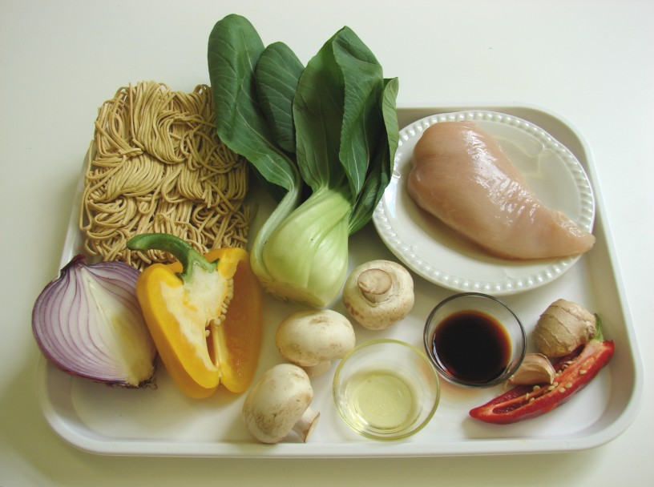
During the session you will be demonstrating how to use a wok safely. Show students how to prepare a clove of garlic (either using a garlic crusher or knife), de-seed a chill and peel and grate fresh ginger. You may also need to remind students on the bridge-hold and claw-grip knife techniques. Comment on the vegetables being of a similar size to ensure even cooking.

Ensure that you have all the ingredients and equipment you need before the session, perhaps on trays for ease, for your demonstration.

Think about:
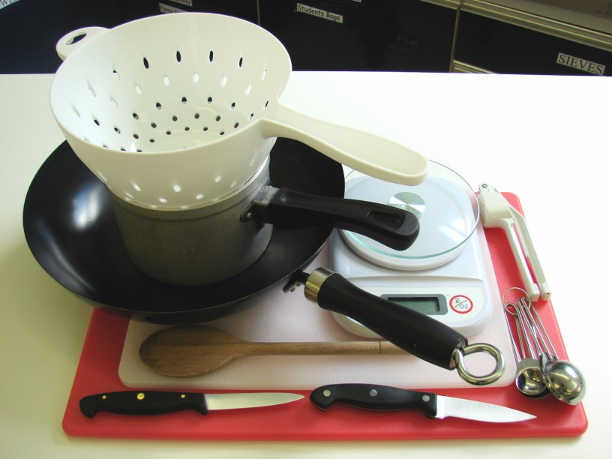
- describing the ingredients and equipment used;
- highlighting the technique of crushing garlic and de-seeding chillies;
- showing how to use a wok;
- ensuring that students have followed and understood the method.

More detailed guidance is available in the Demonstrating guide.
Risk assessment

The two cooking session plans and recipes highlight a number of different hygiene and safety issues which need to be considered before, during and after the cooking session.

Before the cooking session, you will need to assess these risks in relation to the number of students being taught, as well as their experience, and consider measures that can be put into place to manage the risk. Below are examples of potential risks, along with preventative measures.

Sizzling stir-fry
Potential risk | Measure | Likelihood
Cuts from using knife unsafely | Demonstrate safe use of knives and monitor students’ use | Low
Cross-contamination from raw chicken | Cut raw chicken on a separate chopping board (ideally red) with a clean knife  Thoroughly wash and dry hands after touching the raw meat  Do not wash raw meat or poultry before using | Low/Med

Fajitas
Potential risk | Measure | Likelihood
Dirt or food poisoning bacteria present on raw food, causing cross contamination | Wash vegetables before use | Low
Cross-contamination from raw chicken | Cut raw chicken on a separate chopping board (ideally red) with a clean knife  Thoroughly wash and dry hands after touching the raw meat  Do not wash raw meat or poultry before using | Low/Med

Time
The session plans are based on a 60 minute session.

If you have less time available, you will need to modify the session plan to better suit your circumstances. For example, within this session you might:
- demonstrate the safe use of the hob and wok another time;
- demonstrate key aspects from the recipe, rather than every stage;
- have ingredients pre-measured;
- use pre-cooked chicken or noodles;
- use pre-prepared ingredients, such as 'lazy' garlic, chilli or fresh ginger
- allow students to work with a partner – sharing a wok or frying pan.

Time (mins) | Activity: Sizzling stir-fry | Equipment/ Resources
0 | Registration.  Explain to the students that they will be making sizzling stir-fry. Go through the aims and objectives for the lesson. | PowerPoint Sizzling stir fry  recipe
5 | Gather the students around a demonstration area, with your tray of ingredients and equipment. Ensure that all students have their apron on, hair tied back, and hands washed.  Briefly talk through the recipe – note your expectations, for example:  * preparing the ingredients carefully and accurately;  * crushing the garlic, de-seeding the chilli and peeling and grating the fresh ginger;  * handling and preparing raw meat, e.g. slicing chicken;  * cooking noodles to add to the stir-fry (drain carefully);  * using a wok (or frying-pan) to stir-fry;  * using the hob safely;  * being hygienic and safe when preparing food.  Demonstration  * Place out the chopping board, vegetable knife, garlic press and grater.  * Explain that you will be showing how to crush garlic, de-seed a chilli and grate fresh ginger.  * Demonstrate a garlic press in action. Note how the clove of garlic must be peeled first. Explain that garlic can also be chopped into small pieces using a knife. Next show students how to de-seed the chilli. Stress to the students that they should not touch their face (e.g. lips and eyes) when preparing a chilli. Cut the chilli in half, using the Bridge hold, then use the knife (or a small spoon) to gently push the seeds onto the chopping board. Wash your hands. Lastly, use the vegetable knife to cut away the peel of the fresh ginger. Then grate the ginger on the chopping board.  * Show students how to prepare the raw chicken. Use a different chopping board (ideally red) and knife. Remind students about washing their hands before and after touching raw meat. Using the Claw grip, cut the chicken into strips and place these onto a plate (or in a bowl). Immediately after cutting the chicken, remove the chopping board and knife (and place in the sink) and wash your hands. Cover the raw chicken with some cling film and refrigerate.  * If time, you may wish to explain how to prepare the vegetables. Stress the importance of using the Bridge hold and Claw grip technique. | Aprons  Demonstration ingredient and equipment tray
 | Explain how to use a wok – it is a quick method of cooking. Place the wok on the hob and turn on the heat (you may need to remind students about using different types of hobs and temperature control). Add the oil and allow to heat for 20 seconds. It is important for students not to over heat the oil as it will start to burn and, produce flames. Gently add the onion, garlic, chilli and ginger. Use the wooden spoons (or spatula) to show the stir-frying technique. Keep the wok handle away from the front of the hob.  * If time, add the chicken and cook. The chicken is cooked when the meat is completely white throughout, not just on the outside. | Fire blanket
 | * Remind students that they will need to cook noodles to add to their stir-fry – these need to be boiled and drained safely. (You may need to remind students that noodles should be drained in a colander which is in the sink. The colander should rest on the saucepan after draining to prevent water spilling on to the floor.)
15 | Ensure that all students wash their hands. Allow them to start making their sizzling stir-fry.  During this time, circulate the room to ensure that students are preparing ingredients and using the hob and wok safely. In this time, students should:  * prepare their ingredients;  * crush the garlic, de-seed the chilli and peel and grate the fresh ginger;  * slice the raw chicken carefully, preventing cross-contamination;  * cook and drain noodles safely;  * use a wok (or frying pan) to stir-fry – heat the oil and cook the ingredients;  * combine the cooked noodles to the main stir-fry. | Basic equipment  Wok or saucepan  Ingredients
40 | All noodles for the sizzling stir-fry should be cooked. During the remaining time students should be washing up, cleaning work surfaces and putting away equipment.
50 | Give a 5 minute time warning. Remind students that all washing-up should be completed, work surfaces should be clean, and their sizzling stir-fry should be placed in a container. Circulate the room, ensuring that sinks are clean, and equipment is put away properly.
55 | Plenary  Pose the following questions to the students:  * What were the main skills demonstrated today?  * Name 5 different coloured vegetables that could be added.  * What other types of meat, fish or alternatives would work well in a stir-fry?
60 | Finish
After the session
Check that the room is clean and tidy. Students should leave the room as they find it.

The sizzling stir-fries may need to be refrigerated until the end of the school day, if so, ensure that each container is covered and clearly labelled with the student’s name and group. The refrigerator should be between 0-5ºC.

If time, you may wish for the students to eat the stir-fry as part of the lesson.

Alternatively, students may wish to reheat the stir fry at home. To microwave, place in a suitable container and cover loosely. Cook for full power for 3-4 minutes. Alternatively, place in a preheated oven (200ºC or gas mark 6) for 15-20 minutes. Ensure that the dish is piping hot before eating.

If the same students are with you for another cooking session in the next few days or week, remind them of the ingredients and/or containers they need to bring, if appropriate. You may wish to provide students with recipes or writing frames.

During the lesson
Time (mins) | Activity: Fajitas | Equipment/ Resources
0 | Registration.  Explain to the students that they will be making fajitas. Go through the aims and objectives for the lesson. | PowerPoint Fajitas  recipe
5 | Gather the students around a demonstration area, with your tray of ingredients and equipment. Ensure that all students have their apron on, hair tied back and hands washed.  Briefly talk through the recipe – note your expectations, for example:  * preparing the ingredients carefully and accurately;  * making the marinade with the lime, garlic, chilli, coriander and oil;  * handling and preparing raw meat, e.g. slicing chicken;  * using a wok (or frying pan) to stir-fry;  * using the hob safely;  * being hygienic and safe when preparing food. | Aprons  Demonstration ingredient and equipment tray
Demonstration
* Place out the chopping board, vegetable knife, garlic press and juice squeezer.
* Explain that you will be showing how to crush garlic, de-seed a chilli and squeeze a lime (to make a marinade).
* Demonstrate a garlic press in action. Note how the clove of garlic must be peeled first. Explain that garlic can also be chopped into small pieces using a knife. Next show students how to de-seed the chilli. Stress to the students that they should not touch their face (e.g. lips and eyes) when preparing a chilli. Cut the chilli in half, using the Bridge hold, then use the knife (or a small spoon) to gently push the seeds onto the chopping board. Wash your hands. Lastly, use the vegetable knife to cut the lime in half and squeeze. Show how to make the marinade, i.e. mix the lime, garlic, chilli, coriander and oil together.
* Show students how to prepare the raw chicken. Use a different chopping board and knife. Remind students about washing their hands before and after touching raw meat. Using the Claw grip, cut the chicken into strips and place these onto a plate (or in a bowl). Immediately after cutting the chicken, remove the chopping board and knife (and place in the sink) and wash your hands. Cover the raw chicken with some cling film and refrigerate.
* If time, you may wish to explain how to prepare the vegetables. Stress the importance of using the Bridge hold and Claw grip technique.

* Explain how to use a wok – it is a quick method of cooking. Place the wok on the hob and turn on the heat (you may need to remind students about using different types of hobs and temperature control). Add the oil and allow to heat for 20 seconds. It is important for students not to over heat the oil as it will start to burn and produce flames. Gently add the marinated chicken. Use the wooden spoons (or spatula) to show the stir-frying technique. Keep the wok handle away from the front of the hob. The chicken is cooked when the meat is completely white throughout, not just on the outside.
* If time, add the onion and green pepper slices.
 | Explain that the tortillas need to be filled with a range of ingredients to make fajitas. Demonstrate how to fill and roll up a tortilla – the exact way of layering ingredients will be the choice of the students.
15 | Ensure that students all wash their hands. Allow them to start making their fajitas.  During this time, circulate the room to ensure that students are preparing ingredients and using the hob and wok safely. In this time, students should:  * make the marinade;  * slice the chicken, then add it to the marinade;  * prepare the other ingredients, e.g. onion, cheese;  * use a wok (or saucepan) to stir-fry;  * assemble their fajitas. | Basic equipment  Wok or saucepan  Ingredients
40 | Students should be assembling the tortillas to make their fajitas. (Check that the chicken is thoroughly cooked – it should be a white colour throughout.)  During the remaining time students should be washing up, cleaning work surfaces and putting away equipment.
50 | Give a 5 minute time warning.  Remind students that all washing-up should be completed, work surfaces should be clean, and their fajitas should be placed in a container.  Circulate the room, ensuring that sinks are clean, and equipment is put away properly.
55 | Plenary  Pose the following questions to the students:  * What were the main skills demonstrated today?  * Name 5 different coloured vegetables that could be added.  * What other types of meat, fish or alternatives would work well in fajitas?
60 | Finish

After the session
Check that the room is clean and tidy. Students should leave the room as they find it.

The fajitas may need to be refrigerated until the end of the school day, if so, ensure that each container is loosely covered and clearly labelled with the student’s name and group. The refrigerator should be between 0-5ºC.

If time, you may wish for the students to eat the fajitas as part of the lesson.

Alternatively, students may wish to reheat the fajitas at home. To microwave, place in a suitable container and cover loosely. Cook for full power for 2-3 minutes. Ensure that the dish is piping hot before eating.

If the same students are with you for another cooking session in the next few days or week, remind them of the ingredients and/or containers they need to bring, if appropriate. You may wish to provide students with recipes or writing frames.

Areas of learning
Healthy eating
- Try to reduce the oil further - use 1 x 5ml spoon.
- Go for reduced salt soy sauce, or use other flavourings, e.g. fresh herbs.
- Serve with plenty of salad, plus either rice or noodles, preferably brown/wholemeal.

Wise food shopping
- Dried noodles are cheaper than ready cooked. They can also be easily stored at home and are very versatile.
- Use left over cooked chicken (from the night before) in these dishes. If left overs are used, the stir fry should be eaten straight away and not-reheated.

Food safety and hygiene
- When getting ready to cook, always wear an apron, tie back long hair, roll up long sleeves, remove any jewellery and wash your hands.
- Use a different chopping board and knife after preparing raw meat to avoid cross contamination.
- Handle raw meat carefully. Wash hands and surfaces after handling.
Ensure that the chicken pieces are completely cooked.

Extending this activity
This session provides a great opportunity to be integrated into existing lessons or be developed into a mini-scheme of work.
For example, students could:
- explore different types of cooking techniques and ingredients used in Chinese, Thai and Mexican food;
- plan, generate, model and create a range of stir-fry based dishes that could be cooked by hungry teenagers for dinner with their mates;
- evaluate different types of side dishes that can be served with a stir-fry and fajitas, testing these for ease of making and student appeal.

Appropriate aspects of ICT could also be integrated, including:
- recording sensory data;
- creating a recipe plan or flow-chart;
- modelling recipe costs, looking at the use of more pre-prepared ingredients versus prepared from scratch;
- exploring the internet for authentic stir-fry and fajitas recipes, including video demonstrations.

Shopping list
Sizzling stir-fry
Ingredient | x 1 | x 10 | x 20
Noodles, dried | 100g | 1kg | 2kg
Chicken (breast) | 1 | 10 | 20
Red chillis (each) | ½ | 5 | 10
Garlic (cloves) | 1 | 10 | 20
Ginger, fresh | 1 x 2cm cube | large piece | 2 large pieces
Oil | 1 x 10ml spoon | 100ml | 200ml
Red onion (each) | 1/2 | 5 | 10
Bok choi (each) | 1 | 10 | 20
Yellow pepper | 1/2 | 5 | 10
Mushrooms (each) | 3 | 30 | 60
Soy sauce (reduced salt) | 1x10ml spoon | 100ml | 200ml

Fajitas
Ingredient | x 1 | x 10 | x 20
Limes (each) | 1 | 1kg | 2kg
Green chillies | 1/2 | 500g | 1kg
Coriander | 1x15ml spoon | 1 bunch | 2 bunches
Oil | 1 x 10ml spoon | 100ml | 200ml
Chicken (breast) | 1 | 20 | 40
Onion | 1 | 1.25 litres | 2.5 litres
Green pepper | 1 | 500g | 1kg
Tortillas (each) | 2 | a few twists | a few twists
Tomato (each) | 1 | 10 | 20
Cheese | 25g | 250g | 500g
Guacamole (or salsa),  optional | 1 x15ml spoon | a tub | 2 tubs

Equipment list

Sizzling stir-fry
Chopping boards, knives, garlic press, grater, wok or frying-pan, wooden spoon, saucepan, colander, measuring spoon, serving dish.

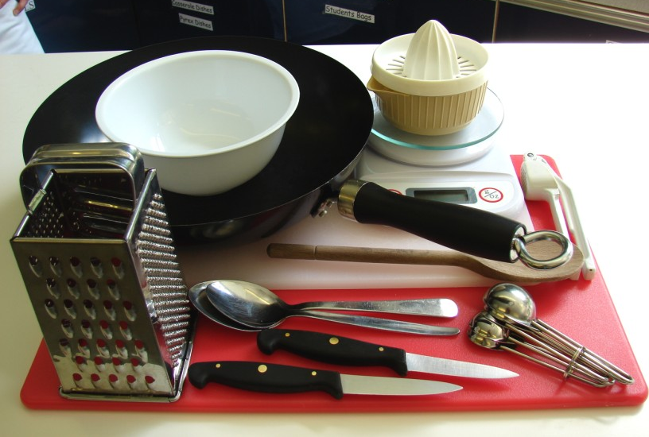
Fajitas

Chopping boards, knives, juice squeezer, garlic press, mixing bowl, grater, wok or saucepan, measuring spoon.

Containers

If students take their dishes, they will need to bring (or be provided with by the school) a suitable container, such as a foil container with a lid.

