Pizza (yeast dough)
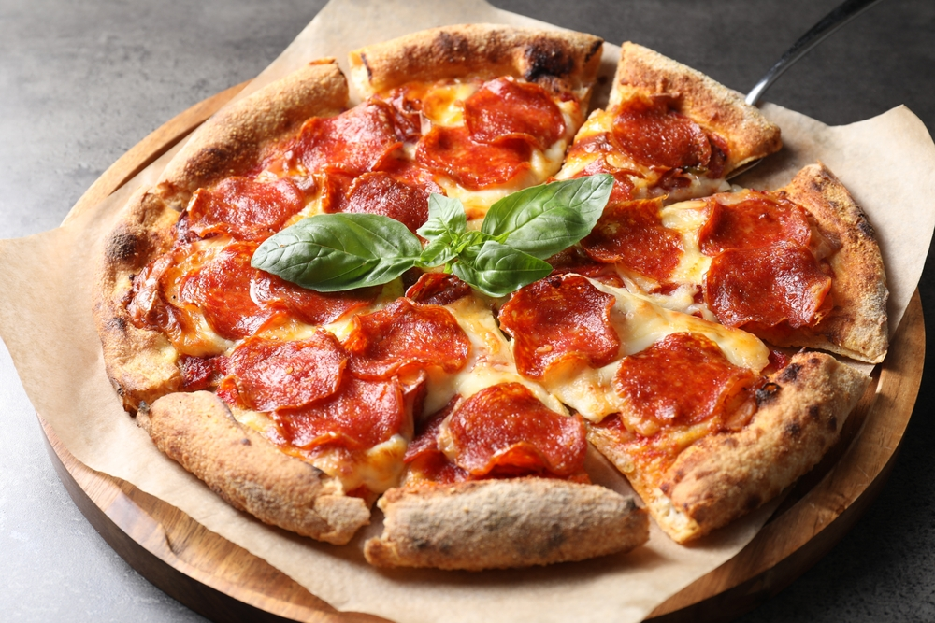
Complexity: medium

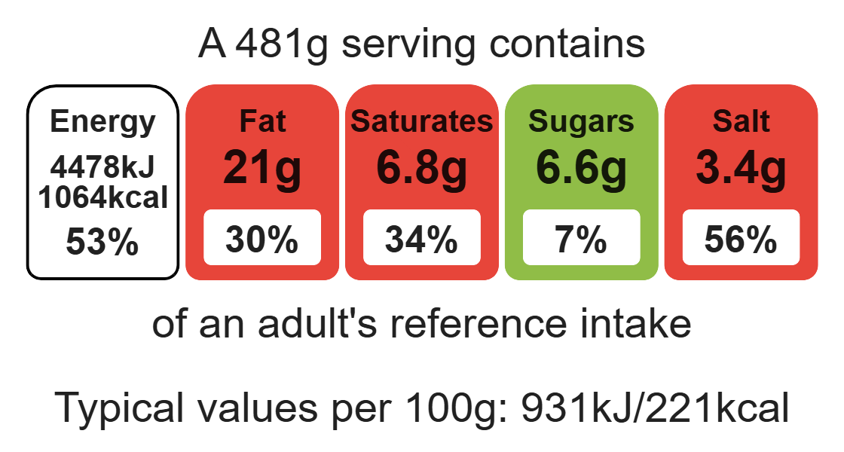

Ingredients (serves 2)
500g strong wholemeal flour
1 x5m spoon salt
1x7g packet fast action dried yeast

Equipment

Weighing scales

Baking trays

Mixing bowl

Sieve

Measuring spoons

Measuring jug

Flour dredger (optional)

Rolling pin

Sharp knife

Chopping board

Palette knife

300ml warm water
1x15ml spoon oil

Method
- Preheat the oven to 200 ºC or gas mark 6.
- Grease or line two baking trays.
- Sift together the flour and salt into a mixing bowl.
- Stir in the yeast.
- Add the oil and warm water to mix into a soft dough (you may need additional water as this recipe is using wholemeal flour).
- Knead the dough for 5-10 minutes on a lightly floured work surface.
- Place the dough in a bowl, cover and allow to prove for 20 minutes.
- Divide the dough in half.
- Roll out and shape the dough into two round disks.
- Place the dough bases onto baking trays.
- Spread the pizza sauce over the base.
- Slice the mozzarella cheese.
- Arrange the slices of cheese over the tomato sauce.
- Place the pepperoni over the cheese.
- Chop the basil and sprinkle over the pizza.
- Place in the oven and bake for 10-15 minutes until golden brown.

Top tips
- Turn up the flavour: Try different combinations of toppings including vegetables such as spinach, peppers, mushrooms or onions.
- 5 A DAY: Serve with a seasonal side.
- Try a calzone, which is a folded pizza.

Food skills
Weigh, measure, mix, stir and combine, knead, prove, portion/divide, roll out, spread, cut, chop, slice, dice and trim, decorate and garnish, bake.

