Shortening

Learning
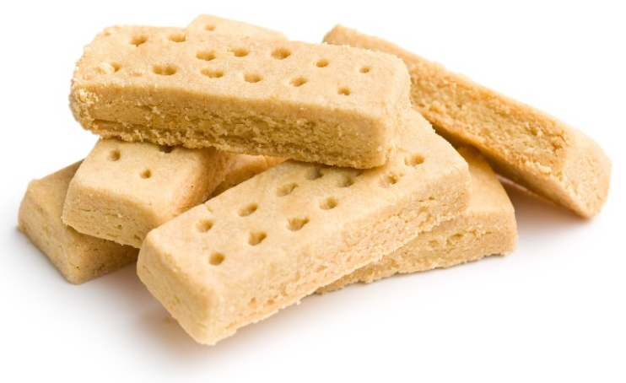
The aim of this session is to:
- demonstrate shortening;
- observe why some fats are not suitable for use as shortenings.

You will need:
- 110g butter;
- 150g sugar;
- 525g plain flour;
- 110g soft vegetable spread;
- 110ml vegetable oil (e.g. sunflower);
- 3 mixing bowls;
- 3 baking trays.

Instructions:
- Preheat the oven to 150°C.
- Soften 110g of butter to a creamy consistency (without melting it).
- Mix in 50g of sugar.
- Sift 175g plain flour and mix it in, firstly with a wooden spoon and then with your hands to make a paste. Do not overwork this mixture, as this will toughen the final product.
- Shape into 1cm thick oblong-shaped pieces and arrange on a greased oven tray.
- Repeat the above, but replace the butter with soft vegetable spread.
- Repeat the above, but replace the butter with a vegetable oil.
- Cook for about 30 minutes, or until the shortbread is a pale golden colour.
- What are the differences between the three shortbreads?

Questions
Think about these questions after you have completed the experiment:
- What do the different shortbreads look like?
- What does their texture feel like?
- How do they taste different from each other?
- Which of the three shortbreads do you think is the best tasting? Explain why.
- Why do you think that some of the shortbread fingers looked, felt and tasted better than others?

