Session 5: Batch bake
Welcome
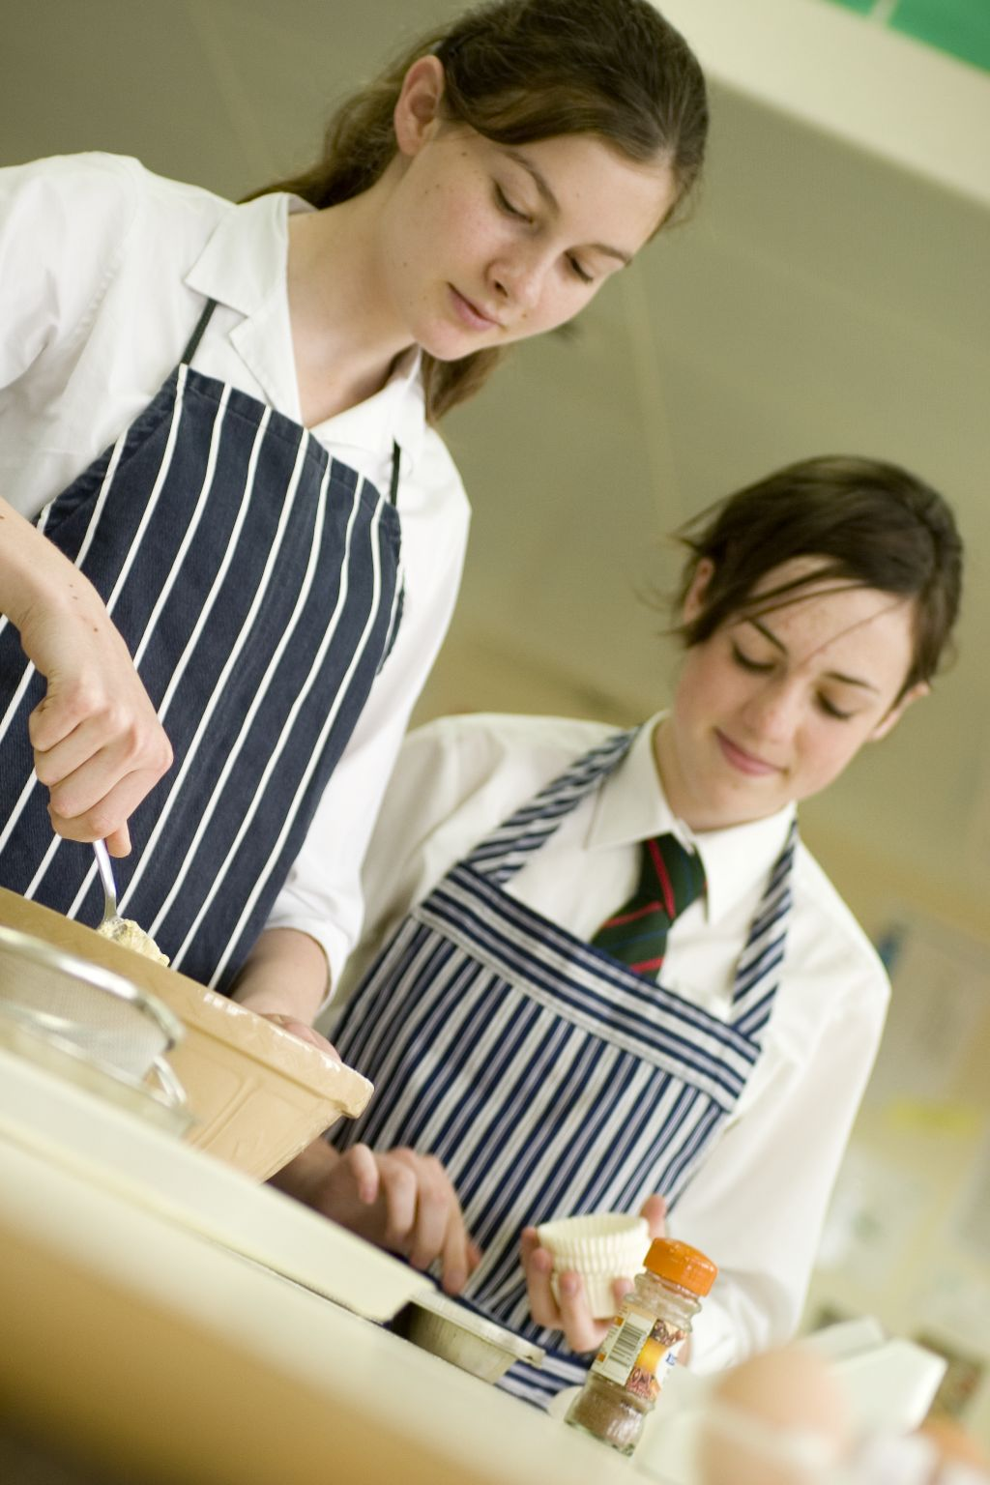
This is the final session in this block, i.e. sessions 1 – 5. By this stage pupils should be familiar with the cooking area, equipment use and storage and general rules. During this session, pupils consolidate their safe use of the oven, as well as making an all-in-one mixture and dividing it equally.

You may wish to observe pupils practical work using the observation sheet. The result of this observation, along with their previous practical work, goes towards their ‘licence to cook’.

During this session, pupils will make courgette and cheese muffins, fruit muffins or mini fruit cakes. These have been chosen as they demonstrate combining ingredients (e.g. all-in-one method), accurate weighing and measuring and using the oven.

There is lots of room for pupils to be creative, selecting different types of ingredients that could be combined into the dishes. You could get your pupils to use the courgette and cheese muffins, fruit muffins or mini-fruit cakes recipe writing frames before cooking to develop their own ideas. The pupil’s own recipe creations could then be used in this session.

If you have an established lesson plan and/or recipe, which supports the aims and objectives of this session, feel free to use it instead. Look at the support materials provided within this session as they support this activity and may well be useful in your own lessons, e.g. worksheets, presentations.

This session can act as a stand-alone lesson, focusing on all-in-one method and the safe use of the oven. Alternatively, it could be integrated into a series of lessons, e.g. exploring and tasting different types of muffins, both sweet and savoury.

Aims and objectives

Aim
For pupils to:
- demonstrate their newly acquired confidence and competence in the cooking area.

Objectives
Pupils should be able to:
- weigh and measure ingredients accurately;
- combine ingredients into a uniform mixture;
- divide the mixture equally between cases;
- use the oven safely;
- make a baked item, e.g. courgette and cheese muffins, fruity muffins or mini-fruit cakes.

Cooking session
Two session plans, based on the Licence to Cook recipes are supplied within this session.

If you have your own tried and tested courgette and cheese muffin, fruity muffin or mini-fruit cake recipe, feel free to use it instead. In addition, you may wish to make other types of baked items, such as blueberry and apple muffins or mini-carrot cakes.

Each plan refers to aspects of healthy eating, wise food shopping and food safety and hygiene which are theme which run through each session.

Before the cooking session
There are a number of factors that you need to consider before the cooking session. More detailed guidance is available in the Cooking session guide.

You will need to consider:
- Ingredients: who will be providing the ingredients and where will they be stored?
- Recipe: are pupils going to use a printed-out copy or follow instructions on an interactive whiteboard?
- Equipment: is all the equipment needed for the session available, clean and in good working order? Check that all the ovens have two shelves available, plus oven gloves are at hand. Weighing scales should also be out for pupils use. Make sure you have enough muffin trays or patty tins for all the pupils, each requiring 12 paper cases.
- Aprons: do you have enough and are they clean?
- Hair: do you have ties/bands for long hair?
- Containers: will pupils be able to take away the –muffins/cakes they make? If so, in what?
- Waste: do you have adequate disposal facilities, including recycling or composting?
- Cooking area: is it clean and ready to use?

Differentiation and inclusion
Before this practical session, you will need to consider the age, ability, previous experience and any special requirements of your pupils. This will determine recipe selection, any advanced ingredient preparation and equipment used.

Do any of your pupils need:
- ingredients pre-measured, to allow them time to complete the recipe?
- ingredients pre-prepared, e.g. grated courgettes?
- an electric mixer to mix the ingredients together?
- to follow different recipes? The mini-fruit cakes recipe is easier.
- modified recipes, introducing other ingredients?

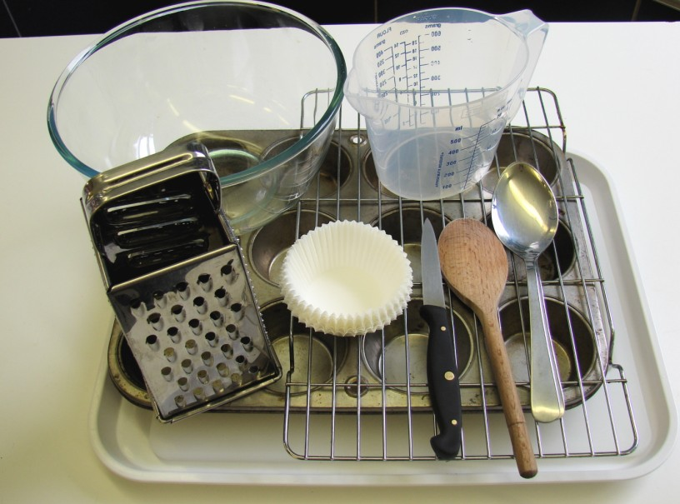
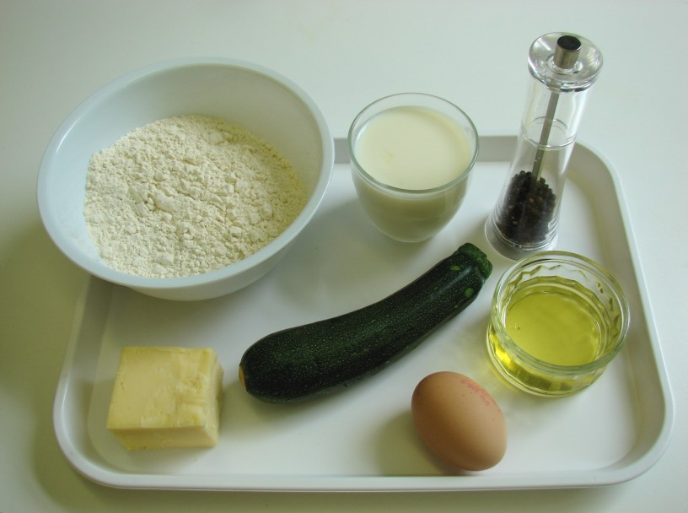
Demonstration
During the session you will be demonstrating the all-in-one method and dividing the mixture equally between cases. You will also be showing pupils how to pre-heat the oven and how to use it safely.

Ensure that you have all the ingredients and equipment you need ready before the session, perhaps on trays for ease, for your demonstration.

Think about:
- describing the ingredients and equipment used;
- highlighting the combining of all the ingredients together;
- showing how to turn on the oven and set the temperature;
- ensuring that pupils have followed and understood the method.

Risk assessment

The two cooking session plans and recipes highlight a number of different hygiene and safety issues which need to be considered before, during and after the cooking session.

Before the cooking session, you will need to assess these risks in relation to the number of pupils being taught, as well as their experience, and consider measures that can be put into place to manage the risk. Below are examples of potential risks, along with preventative measures.

Courgette and cheese muffins
Potential risk | Measure | Likelihood
Cheese past its date marks | Check all date marks before purchase and use | Low
Knuckles cut and bruised from using the grater | Demonstrate safe use of the grater and monitor pupils’ use | Med
Burn from placing and removing muffins in oven | Demonstrate safe use of the oven, promote the use of oven gloves and monitor pupils’ use | Low/Med

Mini-fruit cakes
Potential risk | Measure | Likelihood
Contamination from egg shell in mixture | Crack egg into a separate bowl to check for shell, then add to main bowl | Low
Salmonella from raw egg | Do not eat raw egg or raw cake mixture – remind and monitor pupils | Low/Med
Burn from placing and removing mini fruit cakes in oven | Demonstrate safe use of the oven, promote the use of oven gloves and monitor pupils’ use | Low/Med

Time
The session plans are based on a 60 minute session.

If you have less time available, you will need to modify the session plan to better suit your circumstances. For example, within this session you might:
- demonstrate the safe use of the oven at another time;
- teach weighing and measuring techniques before this session;
- demonstrate key aspects from the recipe, rather than every stage;
- have ingredients pre-measured;
- allow pupils to work with a partner.

During the lesson
Time (mins) | Activity: courgette and cheese muffins | Equipment/ Resources
0 | Registration.  Explain to the students that they will be making courgette and cheese muffins. Go through the aims and objectives for the lesson. | Courgette and cheese muffins  recipe
5 | Gather the students around a demonstration area, with your tray of ingredients and equipment. Ensure that all students have their apron on, hair tied back and hands washed.  Briefly talk through the recipe – note your expectations, for example:  * preheating the oven;  * measuring accurately;  * sifting the flour into the mixing bowl;  * checking the egg;  * combining ingredients together to make a mixture;  * dividing the mixture equally between 12 muffin cases;  * being hygienic and safe when preparing food. | Aprons  Demonstration ingredient and equipment tray
 | Demonstration  * Place out the mixing bowl, sieve, wooden spoon, muffin tin, muffin cases, 2 metal spoons and a small bowl.  * Remind students about pre-heating the oven. If you have electric and gas ovens, you will need to show them both types. Remind students that when placing and removing items from the oven they must always wear oven gloves.  * If time, you may wish to remind students about the safe use of a grater. Grate on the chopping board or a plate, highlighting the use of the full length of the grater – talk about the pressure applied. Ensure that students do not grate their knuckles.  * Demonstrate the all-in-one method. Add all the ingredients into the mixing bowl, except the egg. Crack the egg into a separate bowl – this is to check that it is fresh and that no bits of shell fall into the main mixture.  * Add the egg and mix together carefully, ensuring that you are not so fast that flour and sugar is pushed over the edge of the bowl. Show students the consistency of a uniform mixture, e.g. not traces of flour around the bottom of the bowl. | Aprons  Demonstration ingredient and equipment tray

* Divide mixture equally between cases, using 2 spoons. Use one spoon to scoop a small amount and another spoon to push it off into a case. Put the same amount into each case – this is so that they all cook for the same length of time. Do not get mixture on the baking tray, as it will burn and stick. Once each muffin case has one spoon of mixture, repeat the process using the remaining mix.

* The uncooked muffin mixture should not be eaten as it contains raw egg.
* Using oven gloves, place the muffins into the hot oven carefully.
15  30 | Ensure that all students wash their hands. Allow them to start making their courgette and cheese muffins.  During this time, circulate the room to ensure that students are preparing ingredients and using the oven safely. In this time, students should:  * preheat their oven;  * measure their ingredients;  * grate the courgette and cheese;  * check their egg;  * combine all the ingredients together to make a uniform mixture.  Check that most students have reached this stage. Students should then:  * divide the mixture equally between cases, using two spoons;  * place the muffin tray in the preheated oven using oven gloves. | Basic equipment  Oven gloves  Ingredients
35 | All muffins should be baking, as they take 20 minutes in the oven.
50 | Give a 5 minute time warning.  Remind students that all washing-up should be completed, work surfaces should be clean and their courgette and cheese muffins should be served in a container.  Circulate the room, ensuring that sinks are clean and equipment is put away properly.
55 | Plenary  Pose the following questions to the students:  * What were the main skills demonstrated today?  * Name 3 other types of cheeses that could be used.  * What different types of vegetable could be used?
60 | Finish
After the session
Check that the room is clean and tidy. Pupils should leave the room as they find it.

The courgette and cheese muffins will need to be stored after the lesson, due to their heat, and may need to be kept until the end of the school day. If so, ensure that each container is loosely covered and clearly labelled with the pupil’s name and group. If time, the muffins should be cooled on cooling racks.

If the same pupils are with you for another cooking session in the next few days or week, remind them of the ingredients and/or containers they need to bring, if appropriate. You may wish to provide pupil’s with recipes or writing frames.
During the lesson
Time (mins) |  | Activity: mini-fruit cakes | Equipment/ Resources
0 |  | Registration.  Explain to the pupils that they will be making mini-fruit cakes. Go through the aims and objectives for the lesson. | Mini fruit cakes recipe
5 |  | Gather the pupils around a demonstration area, with your tray of ingredients and equipment. Ensure that all pupils have their apron on, hair tied back, and hands washed.  Briefly talk through the recipe – note your expectations, for example:  * preheating the oven;  * measuring accurately;  * sifting the flour into the mixing bowl;  * checking the egg;  * combining ingredients together to make a smooth mixture;  * dividing the mixture equally between 12 cake cases;  * being hygienic and safe when preparing food. | Aprons  Demonstration ingredient and equipment tray
 |  | Demonstration  * Place out the mixing bowl, sieve, wooden spoon, patty tin, cake cases, 2 metal spoons and a small bowl.  * Remind pupils about pre-heating the oven. If you have electric and gas ovens, you will need to show them both types. Remind pupils that when placing and removing items from the oven they must always wear oven gloves.  * Demonstrate the all-in-one method. Add all the ingredients into the mixing bowl, except the egg. Crack the egg into a separate bowl – this is to check that it is fresh and that no bits of shell fall into the main mixture.  * Add the egg and mix together carefully, ensuring that you are not too fast that flour and sugar is pushed over the edge of the bowl. Show pupils the consistency of a uniform mixture, e.g. not traces of flour around the bottom of the bowl.  * Divide mixture equally between cases, using 2 spoons. Use one spoon to scoop a small amount and another spoon to push it off into a case. Put the same amount into each case – this is so that they all cook for the same length of time. Do not get mixture on the baking tray, as it will burn and stick. Once each cake case has one spoon of mixture, repeat the process using the remaining mix.  * The uncooked cake mixture should not be eaten as it contains raw egg.  * Using oven gloves, place the cakes into the hot oven carefully. | Aprons  Demonstration ingredient and equipment tray
15  30 | Ensure that pupils all wash their hands. Allow them to start making their mini-fruit cakes.  During this time, circulate the room to ensure that pupils are preparing ingredients and using the oven safely. In this time, pupils should:  * preheat their oven;  * measure their ingredients;  * check their egg;  *combine all the ingredients together to make a uniform mixture.  Check that most pupils have reached this stage. Pupils should then:  * divide the mixture equally between cases, using two spoons;  * place the patty tin in the preheated oven using oven gloves. |  | Ingredients  Basic equipment
35 | All mini-fruit cakes should be baking, as they take 15-20 minutes.
50 | Give a 5 minute time warning.  Remind pupils that all washing-up should be completed, work surfaces should be clean, and their mini-fruit cakes should be served in a container. If time, the cakes should be cooled on a cooling rack.  Circulate the room, ensuring that sinks are clean, and equipment is put away properly.
55 | Plenary  Pose the following questions to the pupils:  * What were the main skills demonstrated today?  * Why was the egg cracked into a separate bowl?  * Name 5 different ingredients that could be added to the cake mixture.
60 | Finish

After the session
Check that the room is clean and tidy. Pupils should leave the room as they find it.

The mini fruit cakes will need to be stored after the lesson, due to their heat, and may need to be kept until the end of the school day. If so, ensure that each container is loosely covered and clearly labelled with the pupil’s name and group.

If the same pupils are with you for another cooking session in the next few days or week, remind them of the ingredients and/or containers they need to bring, if appropriate. You may wish to provide pupils with recipes or writing frames.

Extending this activity
This session provides a great opportunity to be integrated into existing lessons or be developed into a mini-scheme of work.

For example, pupils could:
- explore the range of muffins and/or cakes products available to inspire creativity;
- plan, and create new recipe ideas for muffins or mini-fruit cakes,
- evaluate their own, and class friends’ recipes, suggesting possible modifications in relation to healthy eating.

Appropriate aspects of ICT could also be integrated, including:
- recording making with a digital camera;
- creating a recipe plan;
- modelling sensory data for their class mates;
- exploring the internet for local or seasonal ingredients for use in recipes.

Shopping list

Courgette and cheese muffins
Ingredient | x 1 | x 10 | x 20
Self raising flour | 225g | 2.25kg | 4.5kg
Oil | 50ml | 500ml | 1 litre
Semi-skimmed milk | 175ml | 1.75 litres | 2.5 litres
Cheddar cheese | 100g | 1kg | 2kg
Courgette (each) | 1 | 10 | 20
Black pepper | a few twists | a few twists | a few twists

Mini-fruit cakes
Ingredient | x 1 | x 10 | x 20
Self raising flour | 100g | 1kg | 2kg
Caster sugar | 100g | 1kg | 2kg
Butter or soft baking spread | 100g | 1kg | 2kg
Eggs (each) | 2 | 20 | 40
Dried fruit, e.g. sultanas | 50g | 500g | 1kg

Equipment list

Courgette and cheese muffins

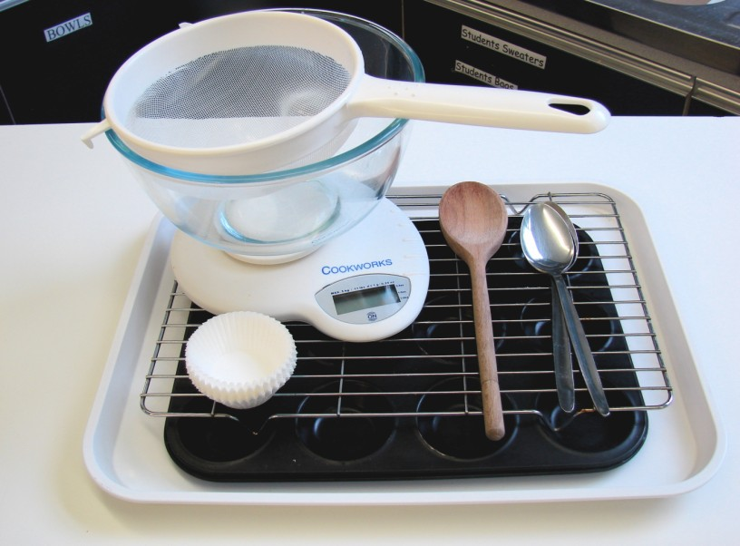
Weighing scales
Measuring jug
Chopping board
Vegetable knife
Grater
Mixing bowl
Wooden spoon
2 metal spoons
12 muffin cases
Muffin tin
Cooling rack

Mini fruit cakes

Weighing scales
Mixing bowl
Sieve
12 cake cases
Patty tin
Wooden spoon
2 metal spoons
Cooling rack

Other
You may wish to have small bowls available for the egg.

Containers

If pupils take their baked items home, they will need to bring (or be provided with by the school) a suitable container, such as a plastic tub and lid, or a paper bag.

