Meat alternatives

- Define the term ‘meat alternatives’.

______________________________________________________________________

______________________________________________________________________

- Name three examples of meat alternatives:
  - _________________________________
  - _________________________________
  - _________________________________

- Match the meat alternatives (left) to how they are made (right).
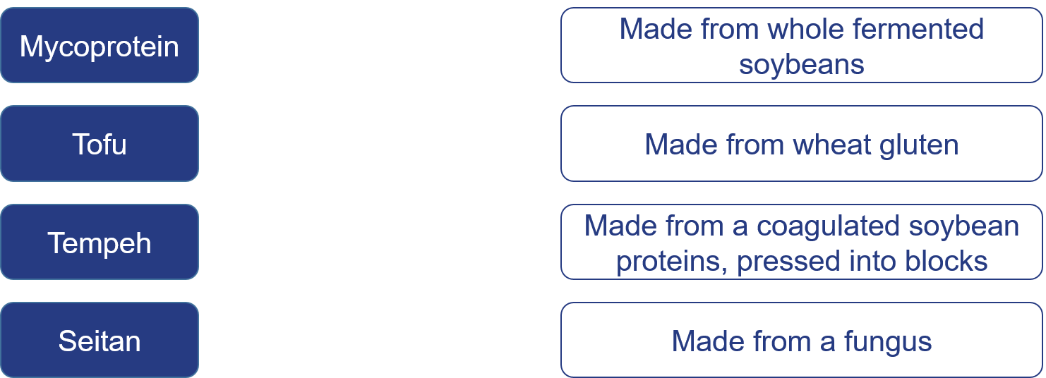

- Suggest two ways in which plain meat alternatives could be made more appetising.

______________________________________________________________________

______________________________________________________________________

______________________________________________________________________

- Name three plant sources of protein:
  - _________________________________
  - _________________________________
  - _________________________________
- Describe how textured vegetable protein (TVP) is produced.
______________________________________________________________________

______________________________________________________________________

______________________________________________________________________

- Suggest two reasons why an individual might choose a meat alternative over meat.

  - _____________________________________________________________
_____________________________________________________________
  - _____________________________________________________________
_____________________________________________________________

