Quick bread buns

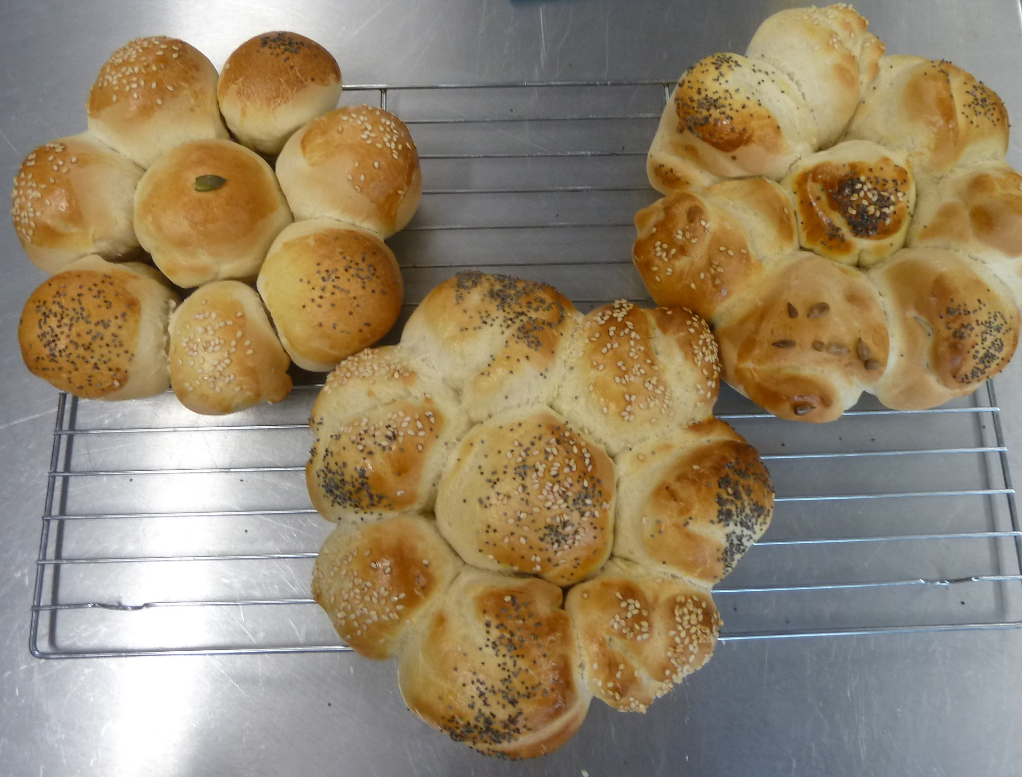
Ingredients
250g strong white, brown or wholemeal flour
1 x level 5ml spoon (1tsp) salt
1 sachet of quick acting dried yeast
150ml warm water
1 x 15ml spoon (1tbs) oil
1 x 5ml spoon (1tsp) sugar
Egg, milk, poppy seeds, pumpkin seeds for topping/ glazing

Equipment
Weighing scales, sieve, mixing bowl, measuring spoons, measuring jug, mixing spoon, greaseproof paper, Victoria sandwich tin or round tin foil dish

Method
1. Collect ingredients and equipment. Weigh out ingredients.
It is vital that the weighing is accurate. Liquid measurement in particular.
2. Sieve flour and salt into bowl. Add the sugar.
Sieve to aerate and remove lumps. Disperse ingredients throughout mixture. Salt strengthens the GLUTEN but take care, it can destroy the YEAST. Gluten forms the framework of the bread.
3. Add yeast.
Use QUICK ACTING DRIED YEAST it reduces the PROVING time and is almost fool proof. Any additions, such as sundried tomatoes, cheese, dried fruit, should be added at this point.
5. Add oil to warm liquid (150ml) and add enough to flour mixture to make a soft dough. Mix with a spoon at first and then use one hand to bring together as a dough. Use the other hand to hold onto the bowl.
Any added fat gives a richer dough, can extend the shelf life, but can also slow down fermentation. If a very quick product is required the fat can be omitted. Bring the ingredients together by hand, feel what is happening. The dough must be soft but not sticky. The water should be quite warm (37C) for the quickest rise.
6. Knead the dough firmly for ten minutes.
This makes the GLUTEN (protein) elastic. The dough will become stretchy. The kneading action also distributes the yeast evenly throughout the mixture.
7. Cut the dough into eight equal pieces. Shape each into a bread bun and arrange in the lightly greased tin.
In industry, it is essential that each roll is the same weight, if not the consumer will not be satisfied and in the cooking process some will cook quicker than others.
8. Glaze with beaten egg or milk, sprinkle with poppy seeds or similar and place in a COLD oven and turn up the temperature immediately.
As the temperature rises the mixture grows in size. This is a shortened PROVING but it does work. Traditionally, the dough would be covered in a large polythene bag and left to rise until doubled in size.
9. Remove from oven after approximately 15 – 20 minutes and cool on a cooling rack.
The high cooking temperature destroys the yeast and expands the gas. Traditionally, the temperature is reduced to allow time for the gluten to set, to allow the starch to absorb the liquid and to create the colour of the crust.
10. Test for readiness by tapping the bottom. It should sound hollow.
Indicates gluten framework is set.
11. Allow to cool out of tins.
This allows the moisture to evaporate and avoids a soggy product.

