Session 9: Pasta mania

Welcome
This session is about making a savoury sauce and combining it with pasta to make a simple dish. Students start to prepare and cook items simultaneously, learning about timing and kitchen organisation. The session gets the students to use the hob and the grill, as well as other pieces of familiar equipment. If your students have not covered session 7 layered pasta salad, then this session will be more challenging. This session also provides you with the opportunity to assess student practical capability. You could use the practical observation sheet to help.

During this session, students will make either tuna and broccoli pasta bake or macaroni cheese. These have been chosen as they involve making a roux sauce. In addition, both recipes involve the safe use of the hob to cook pasta and the preparation of other ingredients. If you have students who do not eat fish, the tuna in the tuna and broccoli pasta can be replaced with an alternative or with extra vegetables.

There is lots of room for students to be creative, selecting different types of ingredients that could be combined into the dishes. You could get your students to use the tuna and broccoli pasta bake or macaroni cheese recipe writing frames before cooking to develop their own ideas. The students’ own recipe creations could then be used in this session.
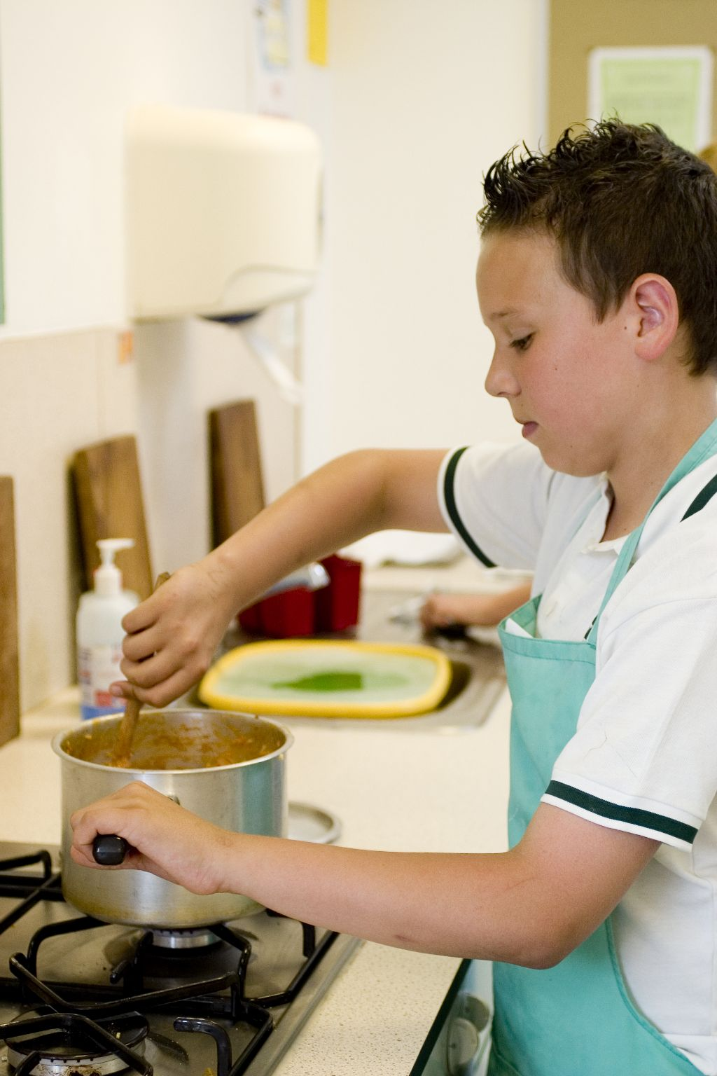
If you have an established lesson plan and/or recipe, which supports the aims and objectives of this session, feel free to use it instead. Look at the support materials provided within this session as they support this activity and may well be useful in your own lessons, e.g. worksheets, PowerPoint presentations.

This session can act as a stand-alone lesson, focusing on preparation of pasta and sauce making, as well as the safe use of the hob and grill. Alternatively, it could be integrated into a series of lessons, e.g. exploring uses for roux sauces in a range of dishes or different types of pasta that are available.

Aims and objectives

Aim
For students to:
- become more confident preparing and cooking several items at the same time.

Objectives
Students should be able to:
- measure ingredients;
- cook and drain pasta safely;
- make an all-in-one savoury white sauce;
- prepare cheese and vegetables, e.g. grating, slicing;
- combine the savoury sauce, pasta and other ingredients;
- gratiné the pasta dish, using a grill;
- make a pasta dish, e.g. tuna and broccoli pasta or macaroni cheese.

Cooking sessions
Two cooking session plans, based on the Licence to Cook recipes are supplied within this session.

If you have your own tried and tested tuna and broccoli pasta bake or macaroni cheese recipe, feel free to use it instead. In addition, you may wish to make other types of dishes which use a savoury white sauce, such as cauliflower cheese or fish pie.

Each plan refers to aspects of healthy eating, wise food shopping and food safety and hygiene which are themes which run through each session.

Before the cooking session
There are a number of factors that you need to consider before the cooking session. More detailed guidance is available in the Cooking session guide.

You will need to consider:
- Ingredients: who will be providing the ingredients and where will they be stored?
- Recipe: are pupils going to use a printed-out copy or follow instructions on an interactive whiteboard?
- Equipment: is all the equipment needed for the session available, clean and in good working order? Check that all the cooker hobs and grills are clean and in good working order. Students will need 2 saucepans each, 1 to boil pasta and another to make the savoury sauce. If you do not have enough saucepans, get 2-3 students to boil their pasta in 1 pan. Alternatively, get students to boil their pasta in the saucepan, then drain it and reuse the same saucepan to prepare the sauce. Students will also require colanders to drain the pasta. Both pasta dishes need to be cooked in oven-proof dishes – ensure that you have enough for each student or ask them to bring in one from home. You may wish to use disposal foil trays for simplicity and remove the need for washing it up.
- Aprons: do you have enough and are they clean?
- Containers: will students be able to take away the pasta they make? If so, in what?
- Waste: do you have adequate disposal facilities, including recycling or composting?
- Cooking area: is it clean and ready to use?

Differentiation and inclusion
Before this practical session, you will need to consider the age, ability, previous experience and any special requirements of your students. This will determine recipe selection, any advanced ingredient preparation and equipment used.

Do any of your students need:
- ingredients pre-measured to allow them time to complete the recipe?
- ready cooked pasta, due to problems of draining the hot water from the pasta?
- to omit some vegetable ingredients to make the recipe easier?
- to follow different recipes? The macaroni cheese recipe is easier than the tuna and broccoli pasta.
- to gratiné the pasta dish at home?
- to be challenged, such as making a traditional roux sauce instead of the all-in-one?

Demonstration
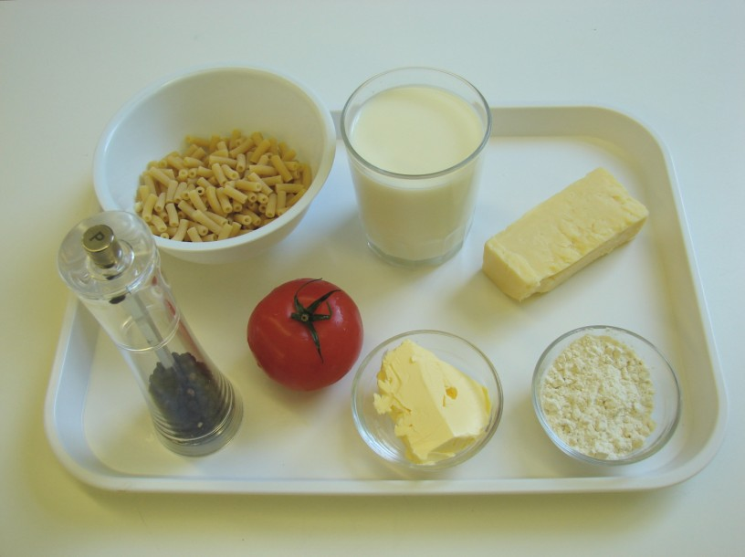
During the session you will be demonstrating how to make an all-in-one savoury sauce. In addition, it will be important to show students how to drain away the boiling water safely from the saucepan. You may wish to have a saucepan ready to demonstrate this aspect. You may wish to remind students of the Bridge hold and Claw grip cutting techniques or grating.

Ensure that you have all the ingredients and equipment you need before the session, perhaps on trays for ease, for your demonstration.

Think about:
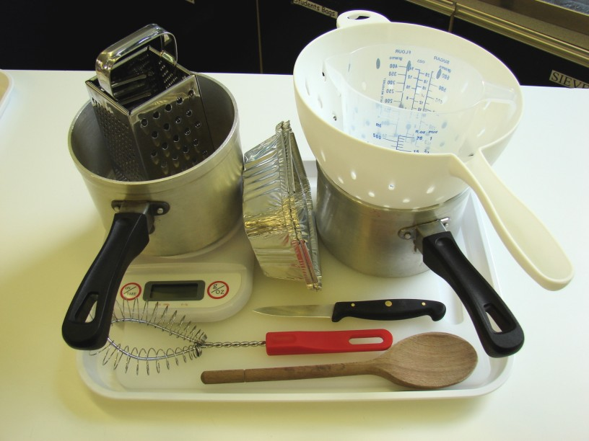
- describing the ingredients and equipment used;
- highlighting the all-in-one savoury sauce method;
- showing how to drain boiling water away from pasta safely;
- ensuring that students have followed and understood the method.

More detailed guidance is available in the Demonstrating guide.

Risk assessment

The two cooking session plans and recipes highlight a number of different hygiene and safety issues which need to be considered before, during and after the cooking session.

Before the cooking session, you will need to assess these risks in relation to the number of students being taught, as well as their experience, and consider measures that can be put into place to manage the risk. Below are examples of potential risks, along with preventative measures.

Tuna and broccoli pasta bake
Potential risk | Measure | Likelihood
Using dented cans or damaged packages | Ensure that all cans and packed food is in good order | Low
Cuts from using a knife unsafely | Demonstrate safe use of knives and monitor students’ use | Med
Scalds from hot water while draining pasta | Demonstrate how to drain hot water away from pasta and monitor students’ use | Low/Med
Burns to hands and arm while using the grill | Demonstrate safe use of the grill and monitor students’ use | Low/Med

Macaroni cheese
Potential risk | Measure | Likelihood
Burn to hand while using the hob | Demonstrate safe use of the hob and monitor students’ use | Low
Scolds from hot water while draining pasta | Demonstrate how to drain hot water away from pasta and monitor students’ use | Low/Med
Burns to hands and arm while using the grill | Demonstrate safe use of the grill and monitor students’ use | Low/Med

Time
The session plans are based on a 60 minute session.

If you have less time available, you will need to modify the session plan to better suit your circumstances. For example, within this session you might:
- demonstrate key aspects from the recipe, rather than every stage;
- have ingredients pre-measured and/or pre-prepared, e.g. butter blocks or pre-grated cheese;
- use canned or frozen vegetables;
- use ready cooked pasta;
- allow students to work with a partner;
- gratiné the pasta dish at home.

During the lesson
Time (mins) | Activity: Tuna and broccoli pasta bake | Equipment/ Resources
0 | Registration.  Explain to the students that they will be making tuna and broccoli pasta. Go through the aims and objectives for the lesson | PowerPoint Tuna and broccoli pasta recipe
5 | Gather the students around a demonstration area, with your tray of ingredients and equipment. Ensure that all students have their apron on, hair tied back and washed their hands.  Briefly talk through the recipe – note your expectations, for example:  * measuring accurately;  * cooking and draining pasta carefully;  * making an all-in-one savoury sauce, without lumps;  * using the hob and grill safely;  * combining the pasta, sauce, vegetables and tuna together;  * placing the pasta dish under the grill to gratiné;  * being hygienic and safe when preparing food.  Demonstration  * Remind students how to switch on the hob. If you have electric and gas hobs, you will need to show them both types.  * Bring a saucepan of water (3/4 full) to the boil. You may wish to use boiling water from a kettle for speed. When rapidly bubbling, add the pasta. Adding the pasta will reduce the temperature of the water, and the boiling with subside. Allow the water to rapidly boil once more, then reduce the heat allowing the pasta to simmer.  * While the pasta is cooking, demonstrate how to make an all-in-one savoury sauce. Place the fat, flour and milk into the saucepan. Turn on the hob high and start to whisk the mixture. Continue to whisk – as the mixture gets hotter, it will start to thicken. When it is rapidly bubbling around the edge, turn down the heat and allow it to simmer.  * Remind students how to preheat the grill. If you have electric and gas grills, you will need to show both. Electric grills can take longer to preheat.  * Check that the pasta is cooked – it should have changed colour and be plump and soft to the touch (with a spoon). | Aprons  Demonstration ingredient and equipment tray
 | * Demonstrate how to safely drain the hot water away from the pasta. Place a colander in a sink, removing the washing-up bowl first. Using two hands, carefully start to pour the water and then the pasta slowly into the colander – this helps to avoid splashes. Keep the saucepan steady as your pour. Place the colander on top of the saucepan so that water does not drip on the floor when you move it. Rest the saucepan on a trivet (pan stand) or on the hob.  * If you have time, mix the pasta and sauce together (along with the tuna, sweetcorn and broccoli) and pour into an ovenproof dish or foil container.  * Place the dish/tray on the grill pan, and using oven gloves, place under the preheated grill. Watch carefully, removing it to check that it has browned. | Aprons  Demonstration ingredient and equipment tray
15 | Ensure that all students wash their hands. Allow them to start making their tuna and broccoli pasta bake.  During this time, circulate the room to ensure that students are preparing ingredients and using the oven safely. In this time, students should:  * measure their ingredients;  * cook and drain the pasta;  * make an all-in-one savoury sauce;  * combine the pasta, sauce, vegetables and tuna together;  * grate and sprinkle cheese over the bake;  * gratiné the bake under the grill. | Ingredients  Basic equipment  Trivets (pot stands)  Colanders  Saucepans
40 | All bakes should be already, or about to go, under the grill. During this time students should be washing up, cleaning work surfaces and putting away equipment.
50 | Give a 5 minute time warning.  Remind students that all washing up should be completed, work surfaces should be clean, and their tuna and broccoli pasta bake should be placed in a container.  Circulate the room, ensuring that sinks are clean, and equipment is put away properly.
55 | Plenary  Pose the following questions to the students:  * What were the main skills demonstrated today?  * Name 3 other types of pasta that could be used?  * What other ingredients could be used in a tuna and broccoli pasta?
60 | Finish

After the session
Check that the room is clean and tidy. Students should leave the room as they find it.

The tuna and broccoli pasta bake may need to be refrigerated until the end of the school day, if so, ensure that each container is covered and clearly labelled with the student’s name and group. The refrigerator should be between 0-5ºC. Only place in the refrigerator when cool.

Students may wish to reheat the pasta bake at home. To microwave, place the bake in a suitable container and cover loosely. Cook for full power for 3-4 minutes. Alternatively, place in a preheated oven (200ºC or gas mark 6) for 15-20 minutes. Ensure that the dish is piping hot before eating.

If the same students are with you for another cooking session in the next few days or week, remind them of the ingredients and/or containers they need to bring, if appropriate. You may wish to provide students with recipes or writing frames.

During the lesson
Time (mins) | Activity: Macaroni cheese | Equipment/ Resources
0 | Registration. Explain to the students that they will be making macaroni cheese. Go through the aims and objectives for the lesson. | PowerPoint Macaroni cheese recipe
5 | Gather the students around a demonstration area, with your tray of ingredients and equipment. Ensure that all students have their apron on, hair tied back and hands washed.  Briefly talk through the recipe – note your expectations, for example:  * measuring accurately;  * cooking and draining pasta carefully;  * making an all-in-one savoury sauce, without lumps;  * using the hob and grill safely;  * combining the pasta and sauce together;  * slicing a tomato and grating cheese;  * placing the bake under the grill to gratiné;  * being hygienic and safe when preparing food.  Demonstration  * Remind students how to switch on the hob. If you have electric and gas hobs, you will need to show them both types.  * Bring a saucepan of water (3/4 full) to the boil. You may wish to use boiling water from a kettle for speed. When rapidly bubbling, add the macaroni. Adding the macaroni will reduce the temperature of the water, and the boiling with subside. Allow the water to rapidly boil once more, then reduce the heat allowing the macaroni to simmer.  * While the macaroni is cooking, demonstrate how to make an all-in-one savoury sauce. Place the fat, flour and milk into the saucepan. Turn on the hob high and start to whisk the mixture. Continue to whisk – as the mixture gets hotter, it will start to thicken. When it is rapidly bubbling around the edge, turn down the heat and allow it to simmer. Stir in the grated cheese.  * Remind students how to preheat the grill. If you have electric and gas grills, you will need to show both. Electric grills can take longer to preheat.  * Check that the macaroni is cooked – it should have changed colour and be plump and soft to the touch (with a spoon). | Aprons  Demonstration ingredient and equipment tray
 | * Demonstrate how to safely drain the hot water away from the macaroni. Place a colander in a sink, removing the washing-up bowl first. Using two hands, carefully start to pour the water and then the macaroni slowly into the colander – this helps to avoid splashes. Keep the saucepan steady as your pour. Place the colander on top of the saucepan so that water does not drip on the floor when you move it. Rest the saucepan on a trivet (pan stand) or the hob.  * If you have time, mix the macaroni and sauce together pour into an ovenproof dish or foil container.  * Explain, or show if you have time, that sliced tomato and grated cheese should be placed on top before placing under the grill.  * Place the dish/tray on the grill pan, and using oven gloves, place under the preheated grill. Watch carefully, removing it to check that it has browned. | Aprons  Demonstration ingredient and equipment tray
15 | Ensure that students all wash their hands. Allow them to start making their macaroni cheese.  During this time, circulate the room to ensure that students are preparing ingredients and using the oven safely. In this time, students should:  * measure their ingredients;  * cook and drain the pasta;  * make an all-in-one savoury sauce;  * combine the pasta and sauce and together;  * slice the tomato and grate the cheese;  * arrange tomato slices and sprinkle cheese over the dish;  * gratiné the dish under the grill. | Ingredients  Equipment  Colanders  Saucepans  Trivets (pot stands)
40 | All macaroni cheeses should be already, or about to go, under the grill. During this time students should be washing up, cleaning work surfaces and putting away equipment.
50 | Give a 5 minute time warning.  Remind students that all washing up should be completed, work surfaces should be clean, and their macaroni cheese should be placed in a container.  Circulate the room, ensuring that sinks are clean, and equipment is put away properly.
55 | Plenary  Pose the following questions to the students:  * What were the main skills demonstrated today?  * Name 3 other types of pasta that could be used?  * What other ingredients could be added to macaroni cheese?
60 | Finish

After the session
Check that the room is clean and tidy. Students should leave the room as they find it.

The macaroni cheese may need to be refrigerated until the end of the school day, if so, ensure that each container is covered and clearly labelled with the student’s name and group. The refrigerator should be between 0-5ºC. Only place in the refrigerator when cool.

Students may wish to reheat the macaroni cheese at home. To microwave, place in a suitable container and cover loosely. Cook for full power for 3-4 minutes. Alternatively, place in a preheated oven (200ºC or gas mark 6) for 15-20 minutes. Ensure that the dish is piping hot before eating.

If the same students are with you for another cooking session in the next few days or week, remind them of the ingredients and/or containers they need to bring, if appropriate. You may wish to provide students with recipes or writing frames.
Areas of learning

Healthy eating
- Go for canned tuna in water rather than brine (salt water) or oil.
- Use wholemeal pasta, as it provides more fibre.
- Use a reduced fat cheese.

Wise food shopping
- Add plenty of pasta to make the bake go further.
- Make 2 bakes and freeze one for another time.
- Dried pasta can be kept for long periods – so check its date mark before use (same applies for all ingredients used).

Food safety and hygiene
- When getting ready to cook, always wear an apron, tie back long hair, roll up long sleeves, remove any jewellery and wash your hands.
- Wash hands frequently.
- Do not use dented cans.

Extending this activity
This session provides a great opportunity to be integrated into existing lessons or be developed into a mini-scheme of work..

For example, students could:
- explore the range of pasta shapes available, perhaps making some using a pasta machine;
- plan and create new tuna and broccoli pasta bake dishes for primary school aged children;
- evaluate their own tuna and broccoli pasta bakes, identifying how it could be modified to better meet current healthy eating guidelines.

Appropriate aspects of ICT could also be integrated, including:
- recording sensory data;
- creating a recipe plan or flow-chart;
- modelling the nutritional profile of their tuna and broccoli pasta bake;
- exploring the internet for online videos of pasta and sauce making.

Shopping list

Tuna and broccoli pasta
Ingredient | x 1 | x 10 | x 20
Rigatoni | 100g | 1kg | 2kg
Cheese | 25g | 250g | 500g
Broccoli | 50g | 500g | 1kg
Butter/soft spread | 25g | 250g | 500g
Plain flour | 25g | 250g | 500g
Semi-skimmed milk | 250ml | 2.5 litres | 5 litres
Oregano | 1 x 5ml spoon | 10 x 5ml spoons | 20 x 5ml spoons
Tuna, canned in water | 100g | 1kg | 2kg
Sweetcorn | 50g | 500g | 1kg
Black pepper | a few twists | a few twists | a few twists

Macaroni cheese
Ingredient | x 1 | x 10 | x 20
Macaroni | 100g | 1kg | 2kg
Cheese | 100g | 1kg | 2kg
Tomato | 1 | 10 | 20
Butter/soft spread | 25g | 250g | 500g
Plain flour | 25g | 250g | 500g
Semi-skimmed milk | 250ml | 2.5 litres | 5 litres
Black pepper | a few twists | a few twists | a few twists

Equipment list

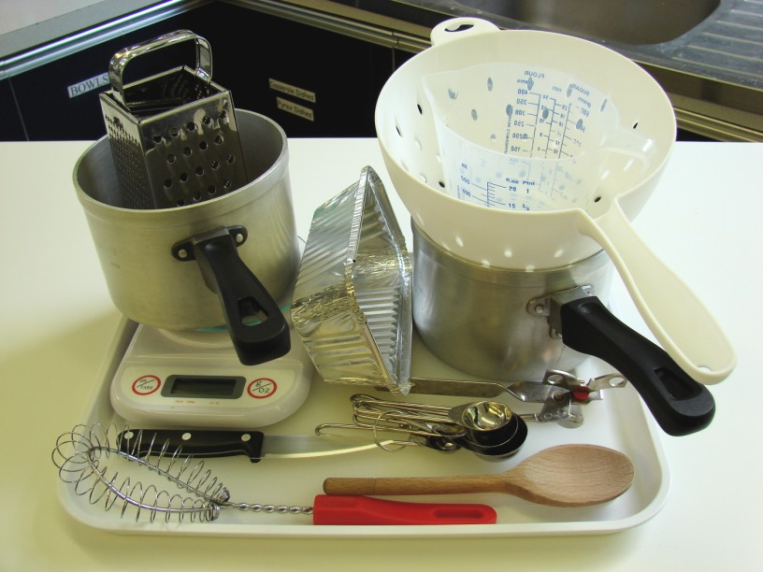
Tuna and broccoli pasta

Two saucepans, weighing scales, grater, chopping board, knife, colander, measuring jug, wooden spoon, measuring spoons.

Macaroni cheese
Two saucepans, weighing scales, grater, chopping board, knife, colander, measuring jug, wooden spoon, measuring spoons.

Other
You will also need pot stands (trivets).

Containers

If students take their pasta home, they will need to bring (or be provided with by the school) a suitable container, such as a foil container with a lid.

